

MULTI-DISEASE PREDICTION USING MACHINE LEARNING
(An Intelligent Health Assistant for Diabetes, Heart, Liver and Kidney Risk)
A risk-screening web application: Intelligent Health Assistant
A project report submitted in partial fulfilment of the requirements for the award of the degree of
BACHELOR OF TECHNOLOGY
in
COMPUTER SCIENCE AND ENGINEERING
Submitted by
AJMEERA HARINI | 23K91A0507
BANDI LIKITHA | 23K91A0526
CHINTHAKINDI SWATHI | 23K91A0555
BADROJU SRI HANSIKA | 23K91A0524

Batch A3 (CSE-A)
Under the esteemed guidance of
B. SRUTHI
Faculty Project Guide, Department of CSE
DEPARTMENT OF COMPUTER SCIENCE AND ENGINEERING
TKR COLLEGE OF ENGINEERING AND TECHNOLOGY (AUTONOMOUS)
Academic year [ACADEMIC YEAR]

CERTIFICATE
This is to certify that the project report entitled "Multi-Disease Prediction Using Machine Learning" is a bonafide record of the work carried out by AJMEERA HARINI (23K91A0507), BANDI LIKITHA (23K91A0526), CHINTHAKINDI SWATHI (23K91A0555), BADROJU SRI HANSIKA (23K91A0524), in partial fulfilment of the requirements for the award of the degree of Bachelor of Technology in Computer Science and Engineering, during the academic year [ACADEMIC YEAR], under my supervision.

Project Guide | Head of the Department | Principal
B. SRUTHI | [HOD NAME] | [PRINCIPAL NAME]
Faculty Project Guide, Department of CSE | Department of Computer Science and Engineering | TKR College of Engineering and Technology (Autonomous)

External Examiner: [NAME AND SIGNATURE]
Place: [PLACE]
Date: [DATE]

DECLARATION
We hereby declare that the project report entitled "Multi-Disease Prediction Using Machine Learning", submitted to the Department of Computer Science and Engineering, TKR College of Engineering and Technology (Autonomous), in partial fulfilment of the requirements for the award of the degree of Bachelor of Technology in Computer Science and Engineering, is a record of original work carried out by us under the guidance of B. SRUTHI, Faculty Project Guide, Department of CSE. The results embodied in this report have not been submitted to any other university or institution for the award of any degree or diploma.

AJMEERA HARINI 23K91A0507
BANDI LIKITHA 23K91A0526
CHINTHAKINDI SWATHI 23K91A0555
BADROJU SRI HANSIKA 23K91A0524

Place: [PLACE]
Date: [DATE]

ACKNOWLEDGEMENT
We express our sincere gratitude to our project guide, B. SRUTHI, Faculty Project Guide, Department of CSE, for valuable guidance, encouragement and constructive suggestions throughout this project.
We thank [HOD NAME], Head of the Department of Computer Science and Engineering, for providing the facilities and support needed to complete this work, and [PRINCIPAL NAME], Principal, TKR College of Engineering and Technology (Autonomous), for the encouragement given to us.
We thank the project coordinators and all faculty and staff members of the department for their help, and our families and friends for their constant support.
We also acknowledge the authors of the base paper and of the related work we studied, the maintainers of the public UCI Machine Learning Repository and of the Pima diabetes data used in our supplementary check, and the developers of the open-source software used in this project (Python, scikit-learn, pandas, NumPy, Flask, FastAPI, React and Vite).

AJMEERA HARINI
BANDI LIKITHA
CHINTHAKINDI SWATHI
BADROJU SRI HANSIKA

ABSTRACT
Chronic diseases such as diabetes, heart disease, liver disease and kidney disease are often found late, and the tools that exist usually screen for one condition at a time. This project builds an Intelligent Health Assistant that screens four conditions from routine clinical values through one web interface. For each condition, Logistic Regression, a Decision Tree, a Random Forest and an RBF Support Vector Machine are trained on standardised inputs, compared on a stratified 80/20 hold-out split with accuracy, precision, recall and F1-score, and the model with the highest F1 is saved and served. The models are exposed through a FastAPI service with seven routes and a React interface with a prediction form for each disease, a model-comparison page and a dataset page; an earlier Flask version of the same models is kept.
The four training datasets (2,000 rows each) are synthetic: they were generated from a hand-written linear risk rule with 8% of the labels flipped, because the original build environment had no access to public data. On the 400-row test sets the selected models reach accuracies of 89.5% (diabetes, SVM), 88.5% (heart, Logistic Regression), 91.8% (liver, Logistic Regression) and 88.3% (kidney, Logistic Regression), close to the 92% ceiling that the label noise allows; they measure how well the pipeline recovers a known rule, not clinical performance. Cross-validation and ten random splits show that Logistic Regression is the best model for every disease, including diabetes where SVM was shipped, and that Random Forest over-fits the noisy labels.
A supplementary check on real public data (Pima diabetes, UCI Cleveland heart, UCI ILPD liver and UCI chronic kidney disease) gives accuracies of 77%, 84%, 72% and 99% for the best algorithm, and shows that the shipped models transfer only partly (for liver the accuracy of 54% is below the 71% majority-class baseline). The application does not show per-prediction explanations, does not impute missing values and has no clinical range validation; the API passed 41 of 41 functional, validation and consistency checks. The system is a demonstration of a multi-disease screening pipeline and not a diagnostic tool.
Keywords: multi-disease prediction, healthcare analytics, machine learning, random forest, support vector machine, decision tree, logistic regression, early diagnosis, medical risk assessment.

TABLE OF CONTENTS
CERTIFICATE i
DECLARATION ii
ACKNOWLEDGEMENT iii
ABSTRACT iv
TABLE OF CONTENTS v
LIST OF FIGURES viii
LIST OF TABLES x
LIST OF ABBREVIATIONS xii
CHAPTER 1: INTRODUCTION 1
1.1 Background 1
1.2 Motivation 1
1.3 Problem Statement 2
1.4 Objectives 3
1.5 Scope of the Project 3
1.6 Proposed System in Brief 4
1.7 Contributions 4
1.8 Relation to the Base Paper 5
1.9 Data Used and a Caution 5
1.10 Limitations and Assumptions 6
1.11 Organisation of the Report 6
CHAPTER 2: LITERATURE SURVEY 8
2.1 Overview and Approach 8
2.2 Base Paper Analysis 8
2.3 Related Work by Theme 9
2.4 Datasets and Algorithms Used in the Literature and in This Project 11
2.5 Summary of the Surveyed Work 12
2.6 Strengths and Limitations of Existing Approaches 13
2.7 Research Gap 13
2.8 Items Listed in the Batch Survey but Not Verified 14
CHAPTER 3: FEASIBILITY STUDY 15
3.1 Technical Feasibility 15
3.2 Economic Feasibility 15
3.3 Operational Feasibility 16
3.4 Schedule Feasibility 16
3.5 Legal, Ethical and Data-Protection Feasibility 16
3.6 Risk Analysis 17
3.7 Advantages and Constraints 17
3.8 Conclusion of the Feasibility Study 18
CHAPTER 4: SYSTEM REQUIREMENTS AND ANALYSIS 19
4.1 Existing System and its Limitations 19
4.2 Proposed System and its Advantages 19
4.3 Functional Requirements 20
4.4 Non-Functional Requirements 20
4.5 Hardware Requirements 21
4.6 Software Requirements 21
4.7 Data Requirements 22
4.8 Analysis of the Data 23
4.9 User Roles, Use Cases and Constraints 24
CHAPTER 5: SYSTEM DESIGN 25
5.1 Design Principles 25
5.2 System Architecture 25
5.3 High-Level Workflow 26
5.4 Module Design 27
5.5 Data Flow 27
5.6 Class, Sequence and Use-Case Design 29
5.7 Database Design (Logical Data Model) 31
5.8 Algorithm Design 32
5.9 API Design 33
5.10 State and Persistence Design 34
5.11 Security Design 34
5.12 User-Interface Design 35
CHAPTER 6: METHODOLOGY AND SOFTWARE IMPLEMENTATION 36
6.1 Overview of the Methodology 36
6.2 Data: Four Synthetic Datasets 37
6.3 Preprocessing 38
6.4 Choice of Algorithms and Why 38
6.5 Mathematical Formulation 39
6.6 Model Architecture and Training Configuration 41
6.7 Evaluation Protocol 41
6.8 Application Architecture 42
6.9 API Design with Real Requests and Responses 43
6.10 Security and Error Handling 43
6.11 Installation and Execution 44
CHAPTER 7: SYSTEM TESTING 46
7.1 Test Strategy 46
7.2 Unit-Level Checks 46
7.3 Integration Testing 47
7.4 Functional, Consistency and Validation Tests 47
7.5 Security Testing 48
7.6 Performance Testing 48
7.7 Interface Testing and Acceptance 49
7.8 Findings from Testing 50
7.9 What Was Not Tested 50
7.10 Conclusion on Testing 50
CHAPTER 8: RESULTS AND OUTPUT SCREENS 52
8.1 Experimental Setup 52
8.2 Hold-out Results for the Four Diseases 52
8.3 Confusion Matrices and ROC Curves 54
8.4 Stability of the Model Choice 55
8.5 Over-fitting and Hyper-parameter Sensitivity 56
8.6 Decision-threshold Analysis 57
8.7 Which Inputs Matter 58
8.8 Supplementary Check on Real Public Data 58
8.9 Testing and Performance 60
8.10 Comparison with the Base Paper 61
8.11 Success and Failure Cases 62
8.12 Output Screens 62
8.13 Objectives versus Outcomes 65
8.14 Discussion and Threats to Validity 66
CHAPTER 9: CONCLUSION 67
9.1 Summary of the Work 67
9.2 Objectives Revisited 67
9.3 Key Findings 68
9.4 Practical Applications 68
9.5 Known Limitations 69
9.6 Concluding Remarks 69
CHAPTER 10: FUTURE SCOPE 70
REFERENCES 72
APPENDIX A: IMPORTANT CODE 74
A.1 Data generation (generate_data.py) 74
A.2 Training and model selection (train_models.py) 74
A.3 Model loading and the Flask prediction handler (app.py) 75
A.4 FastAPI service (backend/main.py) 76
A.5 Form validation and submission (frontend/src/pages/Predict.jsx) 77
A.6 Real-data recoding and metrics (scripts/real_data_check.py) 77
APPENDIX B: INSTALLATION AND USER GUIDE 79
B.1 Prerequisites 79
B.2 One-command start 79
B.3 First five minutes 79
B.4 The pages 80
B.5 Calling the API directly 80
B.6 Reproducing the numbers in this report 80
B.7 Troubleshooting 81
APPENDIX C: ADDITIONAL SCREENS 82

LIST OF FIGURES
Figure 1: High-level workflow of a prediction in the Intelligent Health Assistant 4
Figure 2: System architecture of the Intelligent Health Assistant 26
Figure 3: High-level workflow of the system 26
Figure 4: Data flow diagram, level 0 (context) 28
Figure 5: Data flow diagram, level 1 28
Figure 6: Data flow diagram, level 2: process 4.0 (predict risk) expanded 29
Figure 7: UML class diagram (modules, tuples and scikit-learn classes of the project) 29
Figure 8: Sequence diagram: predict the risk of one patient record 30
Figure 9: Use-case diagram 31
Figure 10: Entity-relationship diagram (logical data model) 31
Figure 11: Flowchart of the core algorithm: offline training and online prediction 33
Figure 12: Median and 95th-percentile latency of the API (200 calls per request type, single client) 49
Figure 13: Hold-out metrics of the four algorithms for each disease (outlined bars: the model served by the application; dashed line: 92% noise ceiling) 53
Figure 14: Confusion matrices of the served model for each disease (rows: actual label; columns: prediction) 54
Figure 15: ROC curves of the four algorithms for each disease on the test split 55
Figure 16: Accuracy on the seed-42 hold-out split, in 5-fold cross-validation and on ten random splits (error bars: one standard deviation; dashed line: 92% noise ceiling) 56
Figure 17: Training and test accuracy of the four algorithms for each disease 56
Figure 18: Test accuracy against decision-tree depth, forest size and SVM C, for the four diseases 57
Figure 19: Precision, recall and F1 against the decision threshold for the four served models (dashed line: 0.5) 57
Figure 20: Permutation importance of the six strongest inputs for each served model (drop in test accuracy when the input is shuffled) 58
Figure 21: Accuracy on synthetic data (CV), on real data (CV) and of the shipped models on real records, with the majority-class baseline 59
Figure 22: Median and 95th-percentile latency of the API routes 61
Figure 23: Overview page: four conditions, 43 clinical inputs, 16 models trained, best accuracy 91.8% (liver, Logistic Regression) and the test accuracy of the selected model for each condition 63
Figure 24: Diabetes prediction for a positive sample: Positive (High Risk), confidence 90.71%, SVM, test accuracy 89.5% 63
Figure 25: Heart disease prediction for a positive sample (Logistic Regression) 63
Figure 26: Liver disease prediction for a positive sample (Logistic Regression) 63
Figure 27: Kidney disease prediction for a positive sample (Logistic Regression) 63
Figure 28: Diabetes prediction for a negative sample classified Negative (Low Risk) 63
Figure 29: Heart disease prediction for a negative sample classified Low Risk 64
Figure 30: Liver disease prediction for a negative sample classified Negative (Low Risk) 64
Figure 31: Kidney disease prediction for a negative sample classified Low Risk 64
Figure 32: Failure case: a heart record labelled low-risk in the data that the model classifies Positive (High Risk) with 99.53% confidence 64
Figure 33: Models page: metric bars and sortable score table for the four algorithms (diabetes tab) 64
Figure 34: Datasets page: row counts and class balance of the four CSV files, with the warning that they are synthetic 64
Figure 35: Validation: pressing Predict on an empty diabetes form marks all eight fields as required and does not call the API 65
Figure 36: Out-of-range warning: a glucose of 900 mg/dL is outside the training range (60-229.7) and the form warns that the estimate may be less reliable 65
Figure 37: Phone layout (390 x 844 px): the heart form with a sample loaded and the sidebar collapsed into a menu 65
Figure 38: Landing page (dark theme) 82
Figure 39: Landing page (light theme) 82
Figure 40: Landing page, how-it-works section: the F1-score of the four algorithms for the diabetes example, with SVM marked as the selected model 82
Figure 41: About page: what the system does, the tech stack and the medical disclaimer, which states that the training data are synthetically generated 82
Figure 42: Not-found page shown for an address that does not exist 82

LIST OF TABLES
Table 1: Abbreviations used in this report xii
Table 2: Organisation of the report 6
Table 3: The base paper compared with this project 9
Table 4: Summary of the surveyed work (results as reported by the authors; the studies are not comparable with one another) 12
Table 5: Gap and the response of this project 14
Table 6: Technical feasibility: measured evidence 15
Table 7: Project phases 16
Table 8: Project risks and mitigation 17
Table 9: Limitations of the existing approaches 19
Table 10: Existing approaches compared with the proposed system 19
Table 11: Functional requirements 20
Table 12: Non-functional requirements and how they are met 20
Table 13: Hardware 21
Table 14: Software 21
Table 15: Input fields and training ranges (read from data/*.csv) 22
Table 16: Class balance of the four data sets 23
Table 17: Main use cases 24
Table 18: Modules and what each is responsible for 27
Table 19: Entities of the logical data model 31
Table 20: The seven routes of backend/main.py 34
Table 21: Sampling of the features (generate_data.py) 37
Table 22: Risk score of each disease (the label rule) 37
Table 23: The four algorithms and the reason each is included 39
Table 24: Hyper-parameters exactly as used in train_models.py 41
Table 25: Feature counts and the model that is served 41
Table 26: Pinned Python packages (requirements.txt) 44
Table 27: Test layers actually run 46
Table 28: Checks of scripts/api_tests.py 47
Table 29: Recorded observations 48
Table 30: API latency on the project machine (milliseconds) 48
Table 31: What the testing and the measurements revealed 50
Table 32: Experimental setup 52
Table 33: Diabetes: test-split metrics (400 rows, 162 high-risk) 52
Table 34: Heart disease: test-split metrics (400 rows, 292 high-risk) 53
Table 35: Liver disease: test-split metrics (400 rows, 112 high-risk) 53
Table 36: Kidney disease: test-split metrics (400 rows, 239 high-risk) 53
Table 37: Confusion matrices of the served models on the 400-row test split 54
Table 38: 5-fold cross-validation and ten random splits (mean ± standard deviation) 55
Table 39: Effect of the decision threshold (served model, test split) 57
Table 40: Real data sets used in the supplementary check 58
Table 41: (a) Algorithms trained and cross-validated on the real data (5-fold, repeated 3 times) 59
Table 42: (b) The shipped (synthetic-trained) models applied to every real record 59
Table 43: API checks (41 of 41 passed in scripts/api_tests.py) 60
Table 44: Measured API latency on 127.0.0.1 (200 calls after 10 warm-up calls) 60
Table 45: Base paper compared with this project 61
Table 46: Objectives of the project against what was measured 65
Table 47: Outcome against the six objectives 67
Table 48: Pages of the web application 80
Table 49: Common problems 81

LIST OF ABBREVIATIONS
Table 1: Abbreviations used in this report
Abbreviation | Expansion
AI | Artificial Intelligence
ALT / AST | Alanine / Aspartate Aminotransferase
API | Application Programming Interface
AUC | Area Under the Curve
BMI | Body Mass Index
CKD | Chronic Kidney Disease
CORS | Cross-Origin Resource Sharing
CSV | Comma-Separated Values
CV | Cross-Validation
DFD | Data Flow Diagram
DT | Decision Tree
ECG | Electrocardiogram
ER | Entity-Relationship
FN / FP | False Negative / False Positive
HTTP | Hypertext Transfer Protocol
ILPD | Indian Liver Patient Dataset
JSON | JavaScript Object Notation
LR | Logistic Regression
ML | Machine Learning
RBF | Radial Basis Function
RF | Random Forest
REST | Representational State Transfer
ROC | Receiver Operating Characteristic
SHAP | SHapley Additive exPlanations
SMOTE | Synthetic Minority Over-sampling Technique
SPA | Single-Page Application
SVM | Support Vector Machine
TN / TP | True Negative / True Positive
UCI | University of California, Irvine (Machine Learning Repository)
UI | User Interface
UML | Unified Modeling Language
XAI | Explainable Artificial Intelligence

CHAPTER 1: INTRODUCTION

1.1 Background
Diabetes, heart disease, liver disease and kidney disease are among the chronic conditions that develop slowly and often give few symptoms until they are advanced. By the time a patient is referred to a specialist the condition may already need expensive long-term treatment. The early signals are, however, usually present in tests that are cheap and routine: blood glucose, blood pressure, cholesterol, bilirubin and liver enzymes, serum creatinine, urea and haemoglobin. A clinician reads these values against reference ranges and against each other; in a busy or understaffed health centre that reading may be delayed, or the combination of mildly abnormal values may not be noticed at all.
Machine learning offers a way of learning such combinations from past records. A supervised classifier is shown many patients whose condition is known and learns which patterns of values go with which outcome; given a new patient it returns a predicted class and a measure of how sure it is. Published work on this idea is large, but most of it treats one disease at a time, as the literature survey in Chapter 2 shows. The base paper of this project [1] is a typical strong example from the recent literature: it studies a single organ, the thyroid, on a real benchmark data set and adds explanations to its predictions.
Four conditions were chosen because they share a common kind of input and because public data on all of them exist: diabetes and heart disease are assessed from a few measurements and a history, liver disease from a panel of blood enzymes and proteins, and kidney disease from blood chemistry and urine tests. All four are tabular, numeric and low-dimensional, so classical algorithms are appropriate and no image, signal or text processing is needed. The same property keeps the system small: a saved model file is between about 1 and 60 kilobytes, a prediction takes a fraction of a millisecond, and the whole application runs on a laptop.
This project takes the multi-disease view. It puts four conditions behind one application so that a user does not have to find and learn a different tool for each, and it uses the same four classical algorithms, the same preprocessing and the same evaluation for every condition so that the results can be compared fairly.

1.2 Motivation
The motivation for the work comes from six observations that were set down at the start of the project:
• Chronic diseases are increasingly detected late, when treatment is costlier and less effective.
• Specialist consultation is scarce and expensive in rural and semi-urban regions.
• Routine laboratory parameters already contain early warning signals that go unread.
• Supervised machine learning can learn these patterns from historical patient records.
• Ensemble methods such as Random Forest are often expected to outperform single classifiers on tabular medical data; in this project's measurements the simple linear model matched or beat them.
• A unified multi-disease screen removes the need for a separate tool per condition.
The first four points explain why prediction from routine parameters is worth attempting; the last two explain why a single interface is attractive. The fifth point also turned out to be a hypothesis worth testing: Chapter 8 shows that on this project's data the simple Logistic Regression model matched or beat the Random Forest, because the Random Forest fitted the noise in the labels.
Why these four algorithms? Logistic Regression is the standard transparent baseline for a binary outcome and its coefficients can be read as effects. A Decision Tree gives rules a person can follow. A Random Forest averages many trees and usually handles interactions and mixed scales well. A Support Vector Machine with an RBF kernel is a strong general-purpose classifier for small numeric data. They are the four algorithms named in the project abstract, they are all available in scikit-learn [17], and together they span linear, rule-based, ensemble and kernel methods, so a comparison between them says something about what kind of structure the data contain.

1.3 Problem Statement
The problem as it appears in current practice has four parts:
• Patients must visit several specialists and take separate tests before any risk is identified.
• Existing prediction tools handle one disease at a time and cannot be reused across conditions.
• Rural health centres lack specialists to interpret routine test reports early.
• Late diagnosis raises both treatment cost and mortality for chronic conditions.
Need. A single machine learning system that screens multiple diseases from routine clinical parameters and flags risk early.
Formal statement. Given the routine clinical values of one patient (for example glucose, blood pressure, cholesterol, bilirubin, creatinine, haemoglobin), estimate for each of four chronic conditions - diabetes, heart disease, liver disease and kidney disease - whether the patient falls in the high-risk or the low-risk class, report how confident the model is, and do so through one interface that a non-programmer can use. The classifier for every condition must be chosen by comparing several algorithms on held-out data with metrics that are not fooled by class imbalance.

1.4 Objectives
The project has six objectives, taken from the project proposal. Chapter 8 measures them and Chapter 9 states, for each, whether it was met, partly met or not met.
1. Collect and clean benchmark datasets covering diabetes, heart disease, liver and kidney disorders.
2. Handle missing values, outliers and feature scaling through a common preprocessing pipeline.
3. Train and compare Logistic Regression, Decision Tree, Random Forest and Support Vector Machine for each disease.
4. Select the best model per disease using accuracy, precision, recall and ROC-AUC.
5. Serve the selected models behind a single interface that accepts one patient record.
6. Present a per-disease risk indication together with the parameters that drove it.

1.5 Scope of the Project
The work covers the path from a table of clinical records to a risk indication shown to a user: generation of the training data, scaling of the inputs, training and comparison of four classifiers for each of four conditions, selection and saving of the best model per condition, a JSON API that serves the saved models, and a web interface with a prediction form for each condition, a model-comparison page and a dataset page. An earlier Flask version of the same prediction pages is kept and shares the same saved models.
The work does not cover the collection of real patient data, clinical validation, a database or user accounts, per-prediction explanations in the application, treatment recommendations, imaging or free-text records, or the diagnosis of any condition other than the four named. These limits are stated in full in the Scope and Limitations document and in Chapter 9.

1.6 Proposed System in Brief
The system, named the Intelligent Health Assistant, holds one trained model for each of four conditions. For every condition the training script splits 2,000 records 80/20 with stratification, standardises the inputs with a scaler fitted on the training part only, and trains four classifiers: Logistic Regression, a Decision Tree of depth 6, a Random Forest of 200 trees and an RBF Support Vector Machine. It evaluates all four on the 400 held-out records with accuracy, precision, recall and F1-score and saves the one with the highest F1.
A FastAPI service with seven routes loads the saved models and exposes them to a React interface. The user chooses a condition, types the clinical values (or loads a real record from the data set to pre-fill the form) and presses a button; the interface shows the predicted risk class, the model's confidence, the name of the model used and its hold-out accuracy, together with a notice that the result is not a diagnosis. The figure below shows the workflow.
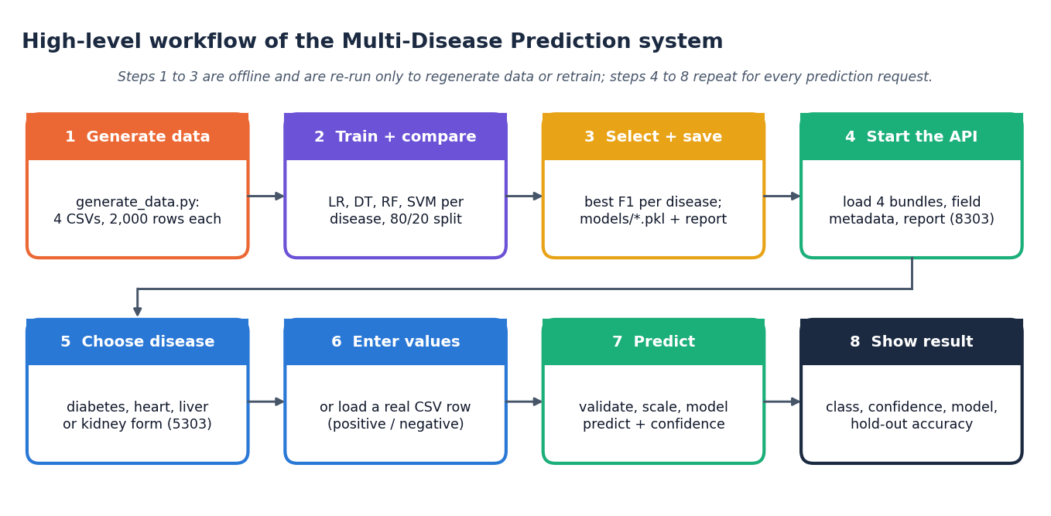
Figure 1: High-level workflow of a prediction in the Intelligent Health Assistant

1.7 Contributions
The contributions of the project, stated as precisely as the evidence allows, are:
1. A single application that screens four chronic conditions (diabetes, heart, liver and kidney disease) through one interface and one API, with a common pipeline and a common evaluation protocol.
2. A like-for-like comparison of 16 models (four algorithms for each of four conditions) on the same split and settings, with the model served for each condition chosen on F1-score.
3. A React interface and a FastAPI layer over the original Flask code, with form validation, out-of-training-range warnings, real-record pre-filling, a model-comparison page and a dataset page that states openly that the data are synthetic.
4. An evaluation that goes beyond the training script: ROC-AUC, confusion matrices, 5-fold cross-validation, ten random splits, a decision-threshold sweep, permutation importance and hyper-parameter sensitivity (Chapter 8).
5. A supplementary check on real public data (Pima diabetes, UCI Cleveland heart, UCI ILPD liver and UCI chronic kidney disease) that measures how the same algorithms and the shipped models behave outside the synthetic data.
6. A reproducible set of scripts for data generation, training, experiments, API tests, screen capture and diagrams, so that every number in this report can be regenerated.

1.8 Relation to the Base Paper
The base paper, Alam et al. [1], applies five classifiers to the UCI thyroid data set under nested cross-validation and explains the predictions with SHAP and counterfactual analysis. This project is an applied extension of its general idea, comparing several classifiers on clinical tabular data under held-out evaluation, to four other conditions behind one interface. It is not a reproduction: the data are different and synthetic, the task is binary and not three-class, the evaluation is a single split and not nested cross-validation, no hyper-parameters are tuned, and the application does not show SHAP or counterfactual explanations. Chapter 8 sets out the differences, and the metrics of the two works are not comparable.

1.9 Data Used and a Caution
The four training datasets are synthetic: generate_data.py draws 2,000 rows per disease from clipped normal, exponential and uniform distributions, computes a hand-written linear risk score, converts it to a label with a sigmoid and a 0.5 threshold, and then flips 8% of the labels at random. No classifier can therefore exceed about 92% accuracy on this data, and the reported accuracies describe how well the pipeline recovers a known rule, not how well it detects disease in patients.
Each of the four files holds 2,000 rows, with no missing values and no duplicates; the share of high-risk records is 40.6% for diabetes, 73.1% for heart disease, 28.1% for liver disease and 59.8% for kidney disease. The hold-out accuracies reported by the application (diabetes 89.5%, heart disease 88.5%, liver disease 91.8%, kidney disease 88.3%) are therefore a measure of how well the pipeline recovers a known rule from noisy labels, and not a measure of clinical performance. Every result in this report is labelled accordingly, and Chapter 8 adds the supplementary real-data check so that the reader can see how far the two differ.

1.10 Limitations and Assumptions
• The training data are synthetic, so the reported metrics cannot be read as clinical accuracy.
• Model selection used the same 400-row test set as the reported metrics, and a single split; the selection for diabetes (SVM) is not supported by cross-validation, which favours Logistic Regression.
• The application shows a class and a confidence only; the parameters that drove a prediction are not shown, and no recommendations are generated.
• No missing-value or outlier handling exists beyond scaling, and the API does not reject physiologically impossible values; the form only warns when a value lies outside the training range.
• There is no authentication, database or audit trail, and the system has not been clinically validated; it is a demonstration and must not be used for real patients.
• Assumptions: inputs are routine laboratory and examination values entered correctly in the units shown on the form, one patient at a time, and one condition is assessed per form.

1.11 Organisation of the Report
Table 2: Organisation of the report
Chapter | Content
1 | Introduction: background, motivation, problem statement, objectives, scope, contributions, limitations
2 | Literature survey: base paper, related work by theme, datasets and algorithms, research gap
3 | Feasibility study: technical, economic, operational, schedule, legal and ethical aspects, risks
4 | System requirements and analysis: existing and proposed system, requirements, hardware, software, use cases
5 | System design: architecture, data flow, UML, logical data model, database design, modules, user interface
6 | Methodology and software implementation: data, preprocessing, algorithms, formulation, training, API, security, installation
7 | System testing: strategy, unit, integration, functional, security, validation, performance, acceptance and limits
8 | Results and output screens: metrics, stability, thresholds, real-data check, base-paper comparison, screens
9 | Conclusion: summary, objectives achieved, key findings, applications, known limitations
10 | Future scope: improvements, features, deployment, further research
 | References, Appendix A (important code), Appendix B (installation and user guide), Appendix C (additional screens)

CHAPTER 2: LITERATURE SURVEY

2.1 Overview and Approach
The survey starts from the base paper designated for the batch and from the five works listed in the batch literature survey, and widens to the benchmark data sets and methods that decide the design of this project: how single diseases are predicted from routine measurements, how several diseases have been handled together, how predictions are explained, and how models should be selected and evaluated. Every work described with numbers was checked against its own page, abstract or full text; where only the title and bibliographic record could be confirmed this is said in the text, and a title that could not be confirmed at all is listed separately in Section 2.8 and is not cited.
The survey is deliberately short on claims of superiority. The surveyed papers use different diseases, data sets, splits and metrics, so their accuracies cannot be ranked against one another or against this project; they are quoted as the authors reported them.

2.2 Base Paper Analysis
The base paper, Alam et al., "Enhancing Thyroid Disease Diagnosis With Machine Learning and Counterfactual Explainable AI" (IEEE Access, vol. 14, 2026) [1], builds an interpretable classifier for three-class thyroid status (Normal, Hypothyroid, Hyperthyroid) from the UCI thyroid data set. The ann-train and ann-test files were merged into 7,200 samples with 21 clinical features (demographics, treatment history and laboratory markers such as TSH, T3, TT4, T4U and FTI); the paper reports 6,666 normal, 368 hyperthyroid and 166 hypothyroid cases.
Five classifiers are compared: Support Vector Classifier, Random Forest, Extra Trees, AdaBoost and CatBoost. Evaluation uses nested cross-validation: an outer stratified 5-fold loop gives the reported scores and an inner 3-fold grid search on accuracy selects hyper-parameters, so model selection never sees the outer test folds. Scaling is fitted on training folds only. Two feature regimes are tested, all 21 features and a TOP-10 consensus set (TSH, FTI, T3, TT4, T4U, on thyroxine, query hypothyroid, psych, thyroid surgery, sex) chosen by agreement of six ranking methods.
The results are very high: Random Forest and CatBoost reach 0.996-0.997 accuracy and F1 with AUC 0.999-1.000 under both feature sets, while SVC trails at 0.965-0.967 accuracy and 0.990-0.992 AUC. The TOP-10 set matches or slightly improves on the full set. SMOTE was tried and rejected because minority-class recall rose by less than 2% for hyperthyroid cases while precision fell. Random Forest is chosen for deployment, and SHAP plus counterfactual analysis show TSH and FTI as the main drivers, consistent with endocrine physiology.
Strengths: a real clinical data set, leakage-safe nested validation, consensus feature selection, and two complementary explanation methods. The authors acknowledge class imbalance, the absence of etiological markers and of external validation, the overhead of SHAP and counterfactuals in real-time use, and demographic imbalance that raises fairness concerns.
Relation to this project: the project adopts the base paper's central idea of comparing several classical classifiers by held-out metrics and extends the scope from one disease to four behind one interface. It does not reproduce the thyroid experiment, and it is weaker in three respects that the report states plainly: its data are synthetic rather than clinical, it uses one stratified 80/20 split with fixed settings instead of nested cross-validation, and the application shows no SHAP-style or counterfactual explanation. Because disease, data, class structure and protocol all differ, accuracy figures cannot be compared with the paper's.
Table 3: The base paper compared with this project
Aspect | Base paper [1] | This project
Disease(s) | Thyroid status (one organ) | Diabetes, heart, liver and kidney disease
Data | UCI thyroid, 7,200 real samples, 21 features, three classes | Synthetic, 2,000 rows per disease, binary high / low risk; real data only in a supplementary check
Algorithms | SVC, Random Forest, Extra Trees, AdaBoost, CatBoost | Logistic Regression, Decision Tree, Random Forest, RBF SVM
Validation | Nested cross-validation: outer stratified 5-fold, inner 3-fold grid search | Single stratified 80/20 split, fixed settings, selection by F1 on the test set; 5-fold CV and ten splits added afterwards
Feature selection | Consensus TOP-10 of six ranking methods | None; all fields of each condition are used
Imbalance | SMOTE tested and rejected | No class weights or resampling; F1 is used for selection
Explanation | SHAP and counterfactual analysis | None in the application; permutation importance offline
Deliverable | A study with a proposed decision-support direction | A working web application with API

The table shows what the project takes from the base paper (the comparison of several classical classifiers by held-out metrics, applied to routine clinical tables) and where it is weaker: data, validation protocol and explanation. These differences are the reason Chapter 8 compares the two works qualitatively and not numerically.

2.3 Related Work by Theme

Single-disease classical ML
Most published systems model one disease at a time. For diabetes, a 2024 comparison of six classifiers on the Pima data found gradient boosting best at 81.8% accuracy and warned that the result may apply only to that sub-population [5]; the data set itself goes back to a 1988 study that forecast diabetes onset in a Pima Indian cohort with 76% sensitivity and specificity [12].
For kidney disease, twelve supervised classifiers were compared on chronic-kidney-disease data and XGBoost scored best with 0.983 accuracy [6], while an earlier study on 400 individuals (250 with CKD) reported an F1-measure of 0.993 and ranked which attributes predict the disease [8]. A 2025 Springer chapter also treats kidney disease prediction with machine-learning techniques [9].
For liver disease, re-created models on the Indian Liver Patient Dataset reached about 71% (logistic regression) to about 79% (SVM) accuracy, and showed a higher false-negative rate for female patients [7].

Multi-disease and symptom-based systems
Multi-disease work tends to use symptoms rather than laboratory values. A Bangla symptoms-disease data set of 758 relations covering 85 diseases was used to compare eight classifiers; soft and hard voting ensembles reached 0.98 accuracy, Random Forest 0.97 and Decision Tree 0.78 [2]. A survey-based study predicted 11 common diseases from reported symptoms [3].
A 2025 Django application bundles three separate models (stroke, student depression, diabetes) and favours recall over accuracy, lowering the diabetes threshold to 0.2 to raise recall from 71.97% to 91.02% [4]. None of the surveyed multi-disease systems combines diabetes, heart, liver and kidney risk from routine clinical values behind one interface.
Two further 2025 chapters in the same Springer volume cover deep learning for disease prediction [10] and skin disease prediction [11]; they were confirmed as bibliographic records only.

Explainability
The base paper pairs SHAP attributions with counterfactual 'what-if' analysis for thyroid classification [1]. SHAP assigns each feature an additive contribution to a single prediction [21], and counterfactual explanations describe the smallest change to the inputs that would alter the decision without opening the model [22].
The base paper also notes that SHAP and counterfactuals add computational overhead that may hinder real-time use in resource-constrained settings [1]. This project's application shows only a class and a confidence, so explanation remains an open objective (Chapter 10 of the report).

Imbalance, validation and evaluation practice
Selecting a model on the same data used to report its error gives optimistic estimates; cross-validation used for both selection and assessment is biased [24], which is why the base paper nests its tuning inside an outer cross-validation loop [1]. This project selected a model on one hold-out split, so its reported best-model scores carry that bias.
Oversampling with SMOTE [23] was tried by the base paper and rejected because minority recall rose by less than 2% while precision fell [1]. On imbalanced data the precision-recall plot is more informative than the ROC plot [26], and the Matthews correlation coefficient is more reliable than F1 or accuracy for binary evaluation [25].
The classical algorithms used here are standard: logistic regression [20], random forests [18] and support-vector machines [19], implemented in scikit-learn [17].

2.4 Datasets and Algorithms Used in the Literature and in This Project
Four public benchmarks correspond to the four conditions of this project. They are described below as they are documented by their sources; this project did not train its shipped models on them (Chapter 6 explains why) but uses them in the supplementary check reported in Chapter 8.
• Pima Indians Diabetes: 768 female patients aged 21 or over of Pima heritage, 8 clinical features plus an outcome; origin in the 1988 ADAP study [12]; physiologically impossible zeros in glucose, blood pressure, skin thickness, insulin and BMI behave as missing values.
• UCI Heart Disease (Cleveland): 303 instances, 13 features plus a diagnosis, donated in 1988 by Janosi, Steinbrunn, Pfisterer and Detrano; CC BY 4.0 [14, 13].
• Indian Liver Patient Dataset (ILPD): 583 instances (416 liver patients, 167 non-patients), 10 features plus a selector label, from north-east Andhra Pradesh; CC BY 4.0 [16].
• UCI Chronic Kidney Disease: 400 instances (250 CKD), 24 features plus the class, with missing values, donated in 2015; CC BY 4.0 [15, 8].
Four public benchmarks match this project's four conditions: Pima Indians Diabetes [12], UCI Heart Disease (Cleveland) [14, 13], the Indian Liver Patient Dataset [16] and UCI Chronic Kidney Disease [15]. They are small (303 to 768 records) and the kidney, heart and Pima files contain missing or implausible entries that need handling.
Reported accuracies on these data sets depend heavily on preprocessing and split: the Pima comparison above gave 81.8% at best [5], whereas kidney data reached 0.983 [6].
The four algorithms of this project are standard. Logistic Regression [20] models the log-odds of the positive class as a linear function of the inputs and is the usual transparent baseline. A Decision Tree splits the inputs recursively into regions of similar outcome and yields readable rules, but a deep tree fits noise. A Random Forest [18] averages many trees grown on bootstrap samples with random feature subsets, which reduces variance. A Support Vector Machine [19] with a radial-basis-function kernel finds a maximum-margin boundary in a transformed space and returns probabilities through an extra calibration step. All four, the scaler and the metrics are taken from scikit-learn [17].
The metrics reported for every model are defined from the counts of true and false positives and negatives (TP, FP, TN, FN) on the held-out records:
Accuracy = (TP + TN) / (TP + TN + FP + FN) Precision = TP / (TP + FP) Recall = TP / (TP + FN) (1)
F1 = 2 x Precision x Recall / (Precision + Recall) (2)
ROC-AUC is the area under the curve of true-positive rate against false-positive rate over all decision thresholds. On imbalanced data the precision-recall view and the Matthews coefficient are often preferred [26, 25]; this project reports the first four metrics, as its abstract promises, and adds ROC-AUC afterwards (Chapter 8).

2.5 Summary of the Surveyed Work
Table 4: Summary of the surveyed work (results as reported by the authors; the studies are not comparable with one another)
Work | Approach | Data | Reported result | Limitation
Alam et al., 2026 (base paper) [1] | Five classifiers, nested cross-validation, full and TOP-10 feature sets, SHAP and counterfactual explanations | UCI thyroid, 7,200 samples, 21 features, 3 classes | Random Forest / CatBoost accuracy 0.996-0.997, AUC 0.999-1.000; SVC 0.965-0.967 | One disease; class imbalance; no external validation
Zannat et al., 2025 [2] | Eight classifiers plus soft and hard voting ensembles; PCA; 5-fold CV tuning | Bangla symptoms-disease set: 758 relations, 85 diseases, 172 symptoms; 607 train / 151 test | Ensembles accuracy 0.98; Random Forest 0.97; Decision Tree 0.78 | Symptom flags only, no laboratory values; small data; single 80/20 split
Al Nahian et al., 2022 [3] | Several classifiers on survey-based symptom data | Survey data for 11 common diseases (e.g. flu, migraine, heart disease, diabetes) | Abstract names a best classifier but gives no numbers | No quantitative result in the abstract; symptom survey, not clinical measurements
Kamakshamma et al., 2025 [4] | Django web app with one model per disease; recall prioritised; threshold lowered to 0.2 for diabetes | Kaggle: stroke 5,110, student depression 27,901, diabetes 100,000 records | Recall 94.73% (stroke), 88.39% (depression), 91.02% (diabetes) | Different diseases; public Kaggle data; no liver or kidney module
Sun and Sun, 2024 [5] | Six supervised classifiers compared with accuracy, precision, recall and F1 | Pima Indians Diabetes dataset | Gradient boosting best, 81.8% accuracy | Authors state results may apply only to this sub-population
Islam et al., 2023 [6] | 12 supervised classifiers after reducing 25 variables to about 30% of them | Chronic kidney disease data, 25 variables including the class | XGBoost best: accuracy 0.983, precision, recall and F1 0.98 | Single disease; one data set; no external test
Salekin and Stankovic, 2016 [8] | Classifier over 24 predictive parameters; attribute ranking; cost-accuracy trade-off | 400 individuals, 250 with CKD | F1 0.993, RMSE 0.1084; error 56% lower than CKD-EPI equation | Small cohort; kidney only
Straw and Wu, 2022 [7] | Re-created published liver-disease models; sex-stratified error analysis, 100 repeats | Indian Liver Patient Dataset | Accuracy about 71% (logistic regression) to about 79% (SVM); higher false-negative rate in women | Shows bias, does not propose a deployable fix
Smith et al., 1988 [12] | ADAP neural-network learner forecasting diabetes onset; sensitivity-specificity analysis | High-risk Pima Indian population (origin of the Pima data set) | Cut-off 0.448 gave 76% sensitivity and specificity on 192 held-out cases | Early method; one population

2.6 Strengths and Limitations of Existing Approaches
Reading the table and the themes together gives a consistent picture.
• Strengths. The single-disease studies are rigorous within their scope: real clinical data, several classifiers compared, and in the best cases leakage-safe validation and explanation (the base paper). Classical algorithms reach high scores on tabular laboratory data when the data are separable, and the benchmark data sets are public, small and easy to reproduce on.
• Limitations: scope. Almost every study addresses one disease; the multi-disease systems found use symptom flags or different conditions, and none combines diabetes, heart, liver and kidney risk from routine values.
• Limitations: data. The benchmarks are small (303 to 768 records), come from single populations, contain missing or implausible entries, and are rarely externally validated; authors of two of the surveyed studies say so themselves.
• Limitations: evaluation. Selection and reporting on the same split inflate results; a single split of a few hundred records has a spread that is rarely reported. Accuracy alone hides weak recall on the minority class.
• Limitations: delivery. Few studies deliver an application a non-programmer can run, and fewer still state openly how far the application's numbers can be trusted.

2.7 Research Gap
The surveyed papers each target one disease in isolation, or use symptom flags rather than routine laboratory values, and the one multi-disease web application found covers different conditions (stroke, depression, diabetes) [4]. The base paper offers rigorous validation and explanation for a single disease [1]. The gap is a single pipeline that screens several conditions (diabetes, heart, liver and kidney) from one set of routine clinical parameters, compares the same four classical algorithms on each, evaluates them honestly, and, ideally, explains which parameters drove each prediction.
Table 5: Gap and the response of this project
Gap in the literature | Response in this project | Status
Single disease per tool | Four conditions behind one interface and one API | Achieved
Different algorithms and protocols per study | Same four algorithms, preprocessing, split and metrics for all conditions | Achieved
Few usable applications | FastAPI service and React interface; Flask pages kept | Achieved
Optimistic selection on one split | Selection by F1 on the test set was kept; CV and ten splits added to measure the effect | Measured, not fixed
Real data | Shipped models use synthetic data; real benchmark data used only in a supplementary check | Partly addressed
Explanation of each prediction | Not in the application; permutation importance offline only | Not achieved

The honest summary is that the project fills the scope gap (several conditions, one pipeline) but not the evidence gap: its headline accuracies of 89.5%, 88.5%, 91.8%, 88.3% are on synthetic data and say little about patients.

2.8 Items Listed in the Batch Survey but Not Verified
The batch literature survey names five works. The base paper, a chapter on kidney disease prediction, a chapter on deep learning for disease prediction and a chapter on skin disease prediction were found and are listed in the references ([1, 9, 10, 11]); the three book chapters were confirmed as bibliographic records only, and their results are not quoted. The remaining title could not be confirmed and is not cited:
• Machine Learning Algorithms for Disease Prediction and Diagnosis (2025, Patient-Centric 6G): a chapter titled "Machine Learning Algorithms for Disease Prediction" appears in the contents listing of the book Patient-Centric 6G: A New Era in Smart Healthcare (Auerbach Publications, December 2025), but its authors, pages, DOI and abstract could not be confirmed.

CHAPTER 3: FEASIBILITY STUDY
A feasibility study asks whether the proposed system can be built and used with the resources at hand. The aspects below are assessed with measurements from this project wherever a measurement exists and are described qualitatively where one does not; no monetary figure is invented.

3.1 Technical Feasibility
Every component is available as free, open-source software and runs on an ordinary desktop. The measurements in the table below were taken on a single machine without a graphics processor (Intel Core i5-12500, 12 threads, 16 GB RAM, Windows 11, Python 3.11.9, scikit-learn 1.8.0).
Table 6: Technical feasibility: measured evidence
Question | Measurement
Can all 16 models be trained on a desktop CPU? | Yes. Fitting all 16 (four algorithms for each of four conditions, 1,600 training rows each) took 2.8 s in total in the experiment script; the largest single fit was a Random Forest of about 0.6 s
Is single-record inference fast? | Yes. In-process prediction takes at most 0.057 ms per row for any of the 16 models (batch of 400 rows)
Is the API fast enough for a web interface? | Yes. Over 127.0.0.1 a prediction request had a median of 13.5 ms (diabetes) and 14.4 ms (heart), 95th percentile about 25 ms; four concurrent clients sustained 416 requests per second. These timings were taken while the PC was under memory pressure and Windows timer resolution (about 15.6 ms) quantises single calls, so they are upper bounds
Is the software stack mature? | Python 3.11, scikit-learn, pandas, NumPy, Flask, FastAPI, React 19 and Vite 8 are widely used and documented
Can the system be tested? | Yes. A 27-line smoke test and a 41-check API test script exist and passed (41 of 41); there is no pytest suite or frontend unit test

The only technical difficulty met during the work was environmental: the saved models were written with scikit-learn 1.8.0 and fail on an older release when predict_proba is called, so requirements.txt pins the version.

3.2 Economic Feasibility
The software cost is zero: no commercial licence, cloud service or paid API is used, and every prediction is made by a small local model. The only hardware needed is a computer that can run Python and a web browser; the development machine was an ordinary desktop. Operating cost is limited to the time of the person who uses the application.
The benefit side, in a real deployment, would be earlier detection and fewer unnecessary specialist referrals. This project has no clinical, cost or referral data, so it does not estimate any monetary saving and makes no claim about health outcomes. Whether a screening tool of this kind is worth deploying depends on its performance on real patients, which this project could measure only partly (the supplementary check in Chapter 8), and on the cost of follow-up for false alarms, which is clinic-specific.

3.3 Operational Feasibility
• Usability. The interface needs no programming. A user picks a condition, fills a form whose labels carry units and an example value, and presses one button; empty or non-numeric fields are marked "Required." or "Enter a number.", and a value outside the training range of that field is flagged with a warning.
• Skills. A person who can read a laboratory report can use every page. The result is a risk class and a percentage, with a standing notice that it is not a diagnosis.
• Deployment. One script (run.bat) creates the virtual environment, installs the pinned packages and starts the API (port 8303) and the web interface (port 5303). The original Flask pages start with one command on port 5000.
• Data handling. Nothing is stored: values typed into the form are sent to the API, scored and discarded. The models and the training data are plain files in the project folder.

3.4 Schedule Feasibility
The work was organised in phases that depend on one another. The table lists them in order; calendar dates are not given because the batch records do not include a dated plan.
Table 7: Project phases
Phase | Activity | Output
1 | Problem definition, base paper study, literature survey | Abstract, objectives, survey
2 | Data generation and a common preprocessing step | Four CSV files, scaler per condition
3 | Training and comparison of four algorithms per condition | 16 models, training_report.json, saved best models
4 | Flask prediction pages | Original working application
5 | FastAPI layer and React interface | Seven API routes, landing, overview, prediction, models, datasets and about pages
6 | Testing, extra experiments, real-data check and documentation | API tests, metrics, screens, report, decks, paper

3.5 Legal, Ethical and Data-Protection Feasibility
The data used in this project are synthetic and contain no personal information, so no consent or anonymisation was needed. The real public data sets used in the supplementary check (Pima diabetes [12], UCI Cleveland [14], ILPD [16] and chronic kidney disease [15]) are published for research use; the UCI sets are distributed under the CC BY 4.0 licence. In real use, patient values are personal health data: processing them needs a lawful basis, access control and retention limits under the rules that apply to the health provider. The application stores nothing, but it has no authentication, so it must not be exposed to real patients in its present form.
There is also an ethical point about the output. A risk class is a ranking produced by a model trained on synthetic data and can be wrong; the application therefore carries the notice "Machine-learning estimate for education and demonstration only. It is not a medical diagnosis; consult a qualified healthcare provider." on every result.

3.6 Risk Analysis
Table 8: Project risks and mitigation
Risk | Effect | Mitigation in this project
No real patient data in the shipped pipeline | Reported accuracy is not clinical accuracy | Synthetic data declared in the README, on the Datasets page and in every document; a supplementary real-data check measures the gap
Label noise and a known generating rule | Accuracy is capped near 92% and favours linear models | The ceiling is stated; Logistic Regression is reported as best where it is, instead of promoting ensembles
Selection on the test set and one split | Optimistic metrics; diabetes model (SVM) not supported by cross-validation | 5-fold cross-validation and ten random splits reported beside the headline figures
Models do not transfer to real records | Liver accuracy 54.0% is below the 71.4% majority baseline on real ILPD data | Reported plainly; the application carries a not-a-diagnosis notice
No range validation in the API | Impossible values (for example glucose 100,000) are scored | UI warns outside the training range; listed as a limitation and as future work
Library version differences | Saved models fail on older scikit-learn | Versions pinned in requirements.txt; stated in the how-to-run guide
No authentication or persistence | Unsuitable for real patient data | Documented limitation; nothing is stored

3.7 Advantages and Constraints
The feasibility findings can be summarised as a list of what the design gains and what it has to live with.
• Advantages. No licence or cloud cost; a complete training run takes seconds on a desktop CPU, so models can be regenerated at will; one interface covers four conditions; the code is small enough (a few hundred lines of Python for training and API) for a student team to read in full; every number in the documents is produced by a script and can be reproduced.
• Constraints. The shipped models depend on one scikit-learn version; the data are synthetic; the interface and API trust the user to enter values in the right units; there is no authentication, persistence or audit log; and the evaluation is limited to a single hold-out split plus the extra experiments described in Chapter 8, with no clinical validation.
None of the constraints prevents the system from being built or demonstrated; each of them would have to be removed before any use with patients, and Chapter 10 lists the steps.

3.8 Conclusion of the Feasibility Study
The system is technically feasible (measured), feasible in terms of cost (no licences, ordinary hardware) and operationally feasible for a non-programmer. It is acceptable from a legal and ethical point of view only as a demonstration on synthetic or properly governed data. Its main risk is not the build but the evidence: the headline metrics come from synthetic data, and must be re-measured on real, clinically validated data before any decision about patients rests on them.

CHAPTER 4: SYSTEM REQUIREMENTS AND ANALYSIS

4.1 Existing System and its Limitations
In current practice a person's risk for these conditions is assessed in one of three ways. The first is clinical: a clinician reads laboratory values against reference ranges and decides what to do. This is the reference standard, but it needs a clinician for every report, and in the project's problem statement (Section 1.3) rural and semi-urban health centres often lack one. The second is a printed or online risk calculator for a single condition, which asks for a handful of values and returns a score. The third is a research prototype of a machine-learning model, typically for one disease and one data set, as the surveyed papers show (Chapter 2, [1], [2]).
Table 9: Limitations of the existing approaches
Approach | Limitation
Manual reading of reports | Depends on specialist availability; combinations of mildly abnormal values are easy to miss; no consistent, repeatable score
Single-condition calculators and prototypes | One tool per disease, each with its own inputs and interface; none reusable across conditions
Published ML studies | Usually one disease, one data set and a results table; rarely packaged as an application a non-programmer can run
Opaque scores | A class or percentage without the reasons behind it gives the user nothing to check against clinical judgement

4.2 Proposed System and its Advantages
The proposed system, the Intelligent Health Assistant, replaces the separate tools with one application. It holds a trained model for each of four conditions, applies the same preprocessing and evaluation to all of them, and serves them through one API and one interface. The architecture is described in Chapter 5 and the methodology in Chapter 6.
Table 10: Existing approaches compared with the proposed system
Aspect | Existing | Proposed
Conditions covered | One per tool | Four (diabetes, heart, liver, kidney) in one application
Algorithms | Usually one chosen in advance | Logistic Regression, Decision Tree, Random Forest and SVM compared for every condition; best by F1 served
Inputs | Different for every tool | Routine laboratory and examination values (8, 13, 10 and 12 fields), with units, examples and training ranges shown
Output | A score or a label | Risk class, confidence, model used, that model's hold-out accuracy, and a not-a-diagnosis notice
Reproducibility | Rarely scripted | Scripts regenerate the data, models, metrics, diagrams and screens
Transparency about data | Often not stated | Datasets page and README state that the data are synthetic

The advantages are therefore convenience (one place for four conditions), comparability (the same protocol everywhere), speed (a prediction returns in tens of milliseconds) and honesty about what the numbers mean. It is not an advantage in clinical accuracy: that has not been established.

4.3 Functional Requirements
The functional requirements were derived from the objectives (Section 1.4) and from the way a user of a screening tool works. Each requirement is implemented by a page of the interface and one or more API routes.
Table 11: Functional requirements
ID | Requirement | Implemented by
FR1 | Let the user choose one of four conditions | Prediction page tabs; /app/predict/:disease
FR2 | Show a form with the clinical fields of the chosen condition, with labels, units, example values and training ranges | GET /api/diseases/{d}
FR3 | Pre-fill the form with a real record of the data set, positive or negative | "Positive sample" and "Negative sample" buttons; GET /api/diseases/{d}/sample
FR4 | Validate the input: required, numeric, with a warning outside the training range | Form validation in Predict.jsx; HTTP 422 with a message from POST /api/predict/{d}
FR5 | Predict the risk class and show the confidence, the model used and its hold-out accuracy | POST /api/predict/{d}; result card
FR6 | Show a not-a-diagnosis notice with every result | Result card text
FR7 | Compare the four algorithms for each condition on accuracy, precision, recall and F1, and mark the selected one | Models page; GET /api/diseases/{d}, GET /api/report
FR8 | Show the datasets: rows, class balance, feature list and the synthetic-data warning | Datasets page; GET /api/datasets
FR9 | Report an unknown condition with HTTP 404 and an unknown route with a not-found page | _check() in backend/main.py; 404 page
FR10 | Regenerate the data and retrain the models from scripts | generate_data.py, train_models.py
FR11 | Keep the original Flask prediction pages working on the same saved models | app.py

Features that the abstract or the objectives mention but that are not implemented are deliberately absent from this table: per-prediction explanations (objective 6), health recommendations, imputation of missing values, feature selection and user accounts. They are listed as limitations in Chapter 9 and as future work in Chapter 10.

4.4 Non-Functional Requirements
Table 12: Non-functional requirements and how they are met
Quality | Requirement | Evidence
Performance | Interactive response on a desktop | Prediction requests had a median of 13.5 ms over 127.0.0.1 and a 95th percentile of about 25 ms (upper bounds; see Chapter 7)
Usability | Usable without programming; clear errors | Labelled fields with units and examples, "Required." / "Enter a number." messages, out-of-range warning, dark and light themes, layout checked at 1440 px and 390 px
Reliability | Invalid input never crashes the service | Missing, non-numeric, NaN, infinite and null values return HTTP 422; unknown disease 404; 41 of 41 API checks passed
Security | Basic protection of the service | CORS limited to localhost:5303 and 127.0.0.1:5303; no data stored. There is no authentication, so the service is not suitable for real patient data
Portability | Runs on Windows and any system with Python 3.11 | requirements.txt with pinned versions; run.bat; no GPU or external service
Maintainability | Prediction logic separate from the interface | backend/main.py imports the models and field metadata from app.py instead of copying them; training is a separate script
Reproducibility | Same numbers on re-run | Fixed seed 42 in data generation, split and models; experiment scripts write JSON files that the documents read

4.5 Hardware Requirements
Table 13: Hardware
Item | Minimum (estimate) | Used in this project
Processor | Dual-core 2 GHz | Intel Core i5-12500 (6 cores, 12 threads)
Memory | 4 GB | 16 GB
Storage | 1 GB free (Python environment, node packages, data, models) | SSD
Graphics | Not required | Not used (CPU only; the landing page uses a WebGL scene in the browser)
Display | 1280 x 720 | 1440 x 900 used for screenshots; a 390 x 844 phone layout was also checked

The minimum column is a conservative estimate for 2,000-row data sets and was not tested on smaller machines.

4.6 Software Requirements
Table 14: Software
Component | Version / note
Operating system | Windows 11 (run.bat); the Python parts are not Windows-specific
Python | 3.11.9
scikit-learn | 1.8.0 (pinned; models were saved with it)
pandas / NumPy / joblib | 3.0.2 / 2.4.4 / 1.5.3 (pinned in requirements.txt)
Flask | 3.1.3: original prediction pages, field metadata and model loading in app.py
FastAPI / uvicorn | 0.110.0 / 0.29.0: JSON API on port 8303
Node.js | 24.19.0, for the web interface
React, Vite, React Router, Recharts | React 19, Vite 8, React Router 7, Recharts 3 (declared ranges in package.json); interface on port 5303
Other front-end libraries | three.js and react-three-fiber (landing scene), framer-motion, GSAP, Lenis, lucide-react
Playwright | Used only to capture the screenshots in this report

4.7 Data Requirements
The system expects, for each condition, one value for every field in the table below. The training data are the four CSV files generated by generate_data.py; each row also carries the target column (1 = high risk, 0 = low risk). The ranges are the minimum and maximum of the generated data and are the ranges the form uses for its warning.
Table 15: Input fields and training ranges (read from data/*.csv)
Condition | Field | Meaning | Training range
Diabetes | Pregnancies | Number of pregnancies | 0 to 9
 | Glucose | Glucose level (mg/dL) | 60 to 229.7
 | BloodPressure | Blood pressure (mm Hg) | 40 to 115.2
 | SkinThickness | Skin thickness (mm) | 0 to 55.6
 | Insulin | Insulin level (mu U/ml) | 0 to 263.1
 | BMI | Body mass index | 15 to 52.1
 | DiabetesPedigreeFunction | Diabetes pedigree function | 0.05 to 1.43
 | Age | Age in years | 18 to 79
Heart disease | age | Age in years | 29 to 79
 | sex | Sex (1 = male, 0 = female) | 0 to 1
 | cp | Chest pain type (0-3) | 0 to 3
 | trestbps | Resting blood pressure (mm Hg) | 90 to 188.4
 | chol | Serum cholesterol (mg/dl) | 120 to 440.1
 | fbs | Fasting blood sugar > 120 mg/dl (1 = yes) | 0 to 1
 | restecg | Resting ECG result (0-2) | 0 to 2
 | thalach | Maximum heart rate achieved | 79.7 to 210
 | exang | Exercise-induced angina (1 = yes) | 0 to 1
 | oldpeak | ST depression | 0 to 6
 | slope | Slope of the ST segment (0-2) | 0 to 2
 | ca | Number of major vessels (0-3) | 0 to 3
 | thal | Thalassaemia code (0-2) | 0 to 2
Liver disease | Age | Age in years | 18 to 84
 | Gender | Gender (1 = male, 0 = female) | 0 to 1
 | Total_Bilirubin | Total bilirubin | 0.1 to 12.84
 | Direct_Bilirubin | Direct bilirubin | 0.1 to 5.33
 | Alkaline_Phosphotase | Alkaline phosphatase | 60 to 799.6
 | Alamine_Aminotransferase | Alanine aminotransferase (ALT) | 5 to 341.4
 | Aspartate_Aminotransferase | Aspartate aminotransferase (AST) | 5 to 383.4
 | Total_Protiens | Total proteins | 3.02 to 9
 | Albumin | Albumin | 1 to 5.5
 | Albumin_and_Globulin_Ratio | Albumin and globulin ratio | 0.2 to 3
Kidney disease | age | Age in years | 2 to 89
 | blood_pressure | Blood pressure (mm Hg) | 50 to 124.7
 | specific_gravity | Urine specific gravity | 1 to 1.02
 | albumin | Albumin in urine (0-4) | 0 to 4
 | sugar | Sugar in urine (0-4) | 0 to 4
 | blood_glucose_random | Random blood glucose | 50 to 348.2
 | blood_urea | Blood urea | 10 to 300
 | serum_creatinine | Serum creatinine | 0.3 to 13.39
 | sodium | Sodium | 112.7 to 160
 | potassium | Potassium | 2.5 to 7.57
 | hemoglobin | Haemoglobin | 4.73 to 18
 | packed_cell_volume | Packed cell volume | 15 to 55

Each file has 2,000 rows, no missing values and no duplicate rows. The target is the column Outcome (diabetes), target (heart), Dataset (liver) or classification (kidney).

4.8 Analysis of the Data
The class balance differs by condition, which matters for the choice of metric. In the heart data 73.1% of the records are high risk, so a classifier that always answered "high risk" would be 73.1% accurate and have perfect recall; in the liver data only 28.1% are high risk, so one that always answered "low risk" would be 72.0% accurate and find nobody. Accuracy alone is therefore not used to choose a model, and the selection rule of the training script is F1-score.
Table 16: Class balance of the four data sets
Condition | High risk (1) | Low risk (0) | Share high risk | Majority-class accuracy
Diabetes | 812 | 1188 | 40.6% | 59.4%
Heart disease | 1462 | 538 | 73.1% | 73.1%
Liver disease | 561 | 1439 | 28.1% | 72.0%
Kidney disease | 1195 | 805 | 59.8% | 59.8%

Because the labels were produced from a linear risk rule with 8% of them flipped at random, the most important property of the data is its noise ceiling: no model can score much above 92% accuracy on fresh data of this kind. The hold-out accuracies in Chapter 8 should be read against that ceiling.

4.9 User Roles, Use Cases and Constraints
There is a single role, the user, who may be a student, a health worker or a clinician exploring the tool. There are no accounts or permissions. A second, offline role, the developer, regenerates the data and retrains the models from the command line. The use-case diagram in Chapter 5 shows both.
Table 17: Main use cases
Use case | Precondition | Main flow | Result
Predict risk | API running | Choose a condition, fill the form (or load a sample), press Predict risk | Risk class, confidence, model and its accuracy
Load a real record | API running | Press Positive sample or Negative sample | Form filled from a random row of the data set
Compare models | API running | Open the Models page, choose a condition | Metric bars and a sortable table for four algorithms
Inspect data sets | API running | Open the Datasets page | Rows, class balance, features and the synthetic-data notice
Retrain models | Command line | Run generate_data.py then train_models.py | New CSV files, models and training report

Constraints.
• The system is a demonstration; it is not clinically validated and must not be used to make decisions about real patients.
• One record is scored at a time and for one condition at a time; there is no batch scoring and no combined four-condition result for a single patient.
• The training data are synthetic, and the feature coding (for example chest pain type 0-3, thalassaemia code 0-2) follows the generator, not any particular clinical data set.
• All inputs are required; missing values are rejected, not imputed.
• Only scikit-learn models are used; there are no deep-learning or gradient-boosting libraries, and no hyper-parameter search.

CHAPTER 5: SYSTEM DESIGN

5.1 Design Principles
• One set of models, two front doors. The trained bundles and the field metadata live in app.py. The FastAPI service imports them instead of copying them, so the React interface and the original Flask pages cannot give different answers.
• Train offline, predict online. Training is a separate script that writes files; the web application only loads them. Nothing is trained while a user waits.
• Stateless prediction. A request carries every value it needs and the answer is computed and returned; nothing about the patient is stored or logged.
• Fail early and clearly. The form checks required and numeric fields; the API rejects a missing or non-finite value with a plain message (422) and an unknown disease with 404 before any model is called.
• Say what the data is. The Datasets page, the About page and the result card state that the training data is synthetic and that the output is not a diagnosis.

5.2 System Architecture
The figure separates an offline pipeline from the online application. Offline, generate_data.py writes the four CSV files in data/, and train_models.py reads them and writes twelve pickle files (model, scaler and feature list for each disease) and training_report.json into models/. Online, run.bat starts the FastAPI service on port 8303 and the React application on port 5303; the React application calls the API with JSON over HTTP, the API imports app.py (which loads the pickles at start-up and holds the field metadata), and app.py calls scikit-learn for scaling and prediction. The API also reads the CSV files for the sample rows and dataset counts. The original Flask pages on port 5000 use the same bundles and the same arithmetic. The footnote states the main design fact: there is no SQL database, no authentication and no stored patient data.
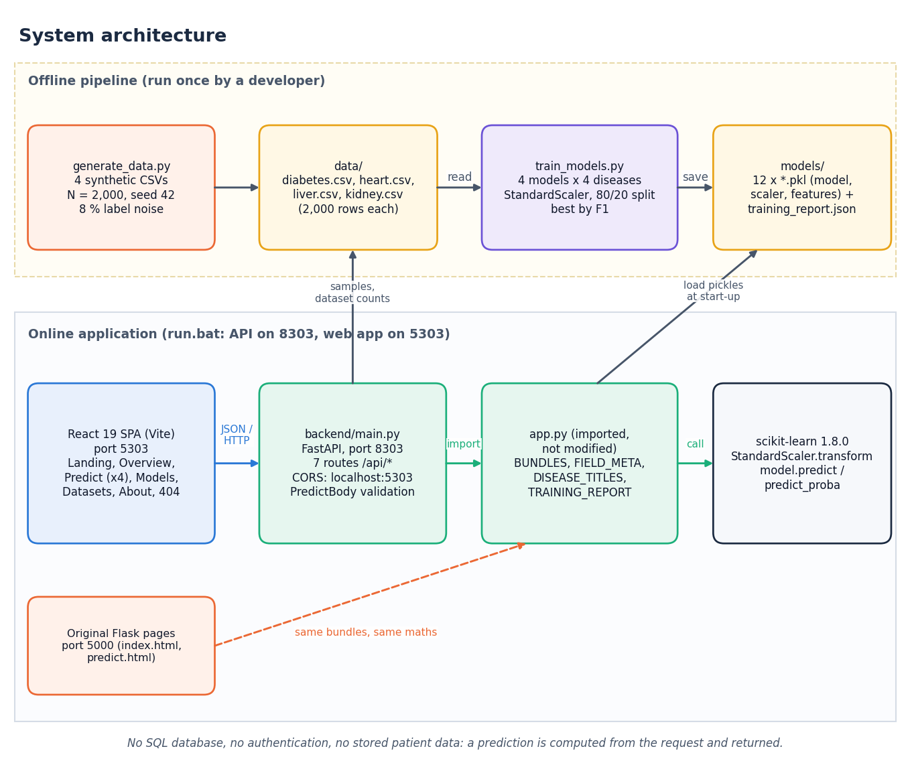
Figure 2: System architecture of the Intelligent Health Assistant
The Python code that makes the system work is small: 694 lines in the four core files (generate_data.py, train_models.py, app.py, backend/main.py), 1,849 lines in the test, measurement and documentation scripts, and about 5,487 lines in the React interface. The FastAPI layer was added for the web interface and leaves app.py unchanged.

5.3 High-Level Workflow
Eight steps in two rows. Steps 1 to 3 (generate data, train and compare, select and save) are offline and are repeated only to regenerate the data or retrain. Steps 4 to 8 happen at run time: the API loads the bundles, the user chooses a disease, enters values or loads a real sample row, the API validates, scales and predicts, and the interface shows the class, the confidence, the model and its hold-out accuracy.
Figure 3: High-level workflow of the system

5.4 Module Design
Table 18: Modules and what each is responsible for
Module | Lines | Responsibility
generate_data.py | 213 | Draws four synthetic clinical datasets (2,000 rows each, numpy seed 42): feature distributions, a linear risk score per disease, a sigmoid, a 0.5 threshold and 8% label flipping (add_noise_labels)
train_models.py | 122 | For each disease: stratified 80/20 split, StandardScaler fitted on the training part, four classifiers (MODEL_BUILDERS), accuracy / precision / recall / F1, selection of the model with the highest F1, joblib.dump of model, scaler and feature list, training_report.json
app.py | 162 | Original Flask application: loads the three pickles of each disease into BUNDLES, holds FIELD_META (label, placeholder, input type of every feature), DISEASE_TITLES and TRAINING_REPORT; routes /, /diabetes, /heart, /liver, /kidney; handle_prediction()
backend/main.py | 197 | FastAPI service that imports app.py (without modifying it) and exposes seven JSON routes; builds form metadata (_fields, _options) from FIELD_META and the CSV ranges; validates the request and predicts with the same steps as handle_prediction()
templates/ and static/ | 321 | The two Jinja2 templates (index.html, predict.html) and the stylesheet of the original Flask pages
frontend/src/ | 5,487 | React 19 single-page application: App.jsx (routes), pages/ (Landing, Overview, Predict, Models, Datasets, About, NotFound), lib/api.js (the only network layer), components/ui (design-system components), components/charts (Recharts), components/three (landing-page 3-D hero)
scripts/ | 1,849 | smoke_test.py, api_tests.py, run_experiments.py, real_data_check.py, capture_screens.py, capture_extra.py, make_diagrams.py, make_figures.py and the documentation builders in scripts/docs/

backend/main.py contains thirteen functions: seven route handlers (health, diseases, disease, sample, predict, report, datasets), the request model PredictBody, and five helpers (_best, _options, _fields, _summary, _check). _fields builds the form description of a disease from FIELD_META and from the minimum, maximum and median of each column of its CSV; _options turns labels such as "Sex (1 = Male, 0 = Female)" into drop-down options, or, for integer columns with at most six distinct values, into a list of those values.

5.5 Data Flow
One process, the Multi-Disease Prediction System, exchanges data with two external entities. The user sends a disease choice, patient values or a sample request and receives a risk class, a confidence, the model and its accuracy, and metrics and dataset facts. The developer runs the data generator and the training script and receives the training report. Two data stores are used: D1, the four CSV files, and D2, the pickle files and the training report.
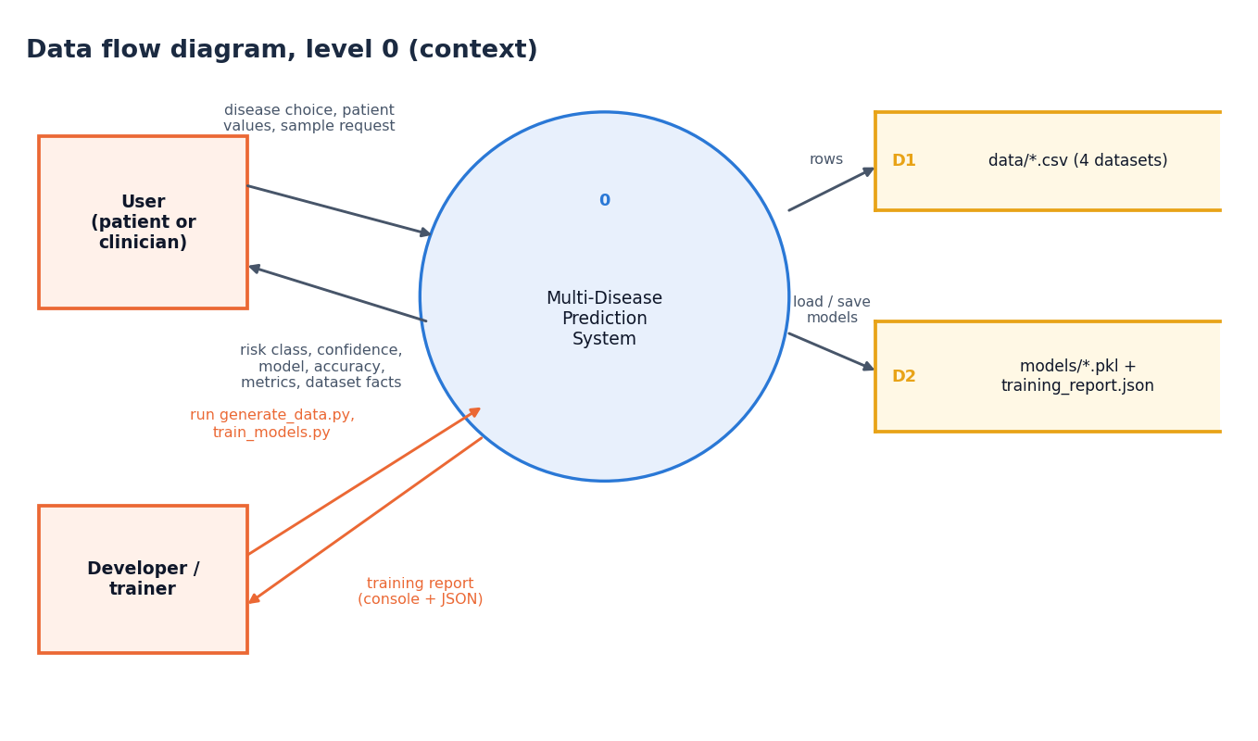
Figure 4: Data flow diagram, level 0 (context)
The system is decomposed into four processes. Process 1.0 generates the datasets and writes them to D1. Process 2.0 reads D1, trains and selects the models and writes the bundles and report to D2. Process 3.0 serves form metadata, metrics and sample rows to the user from D1 and D2. Process 4.0 receives a disease and patient values from the user, reads the bundle from D2 and returns the risk class, confidence, model and accuracy.
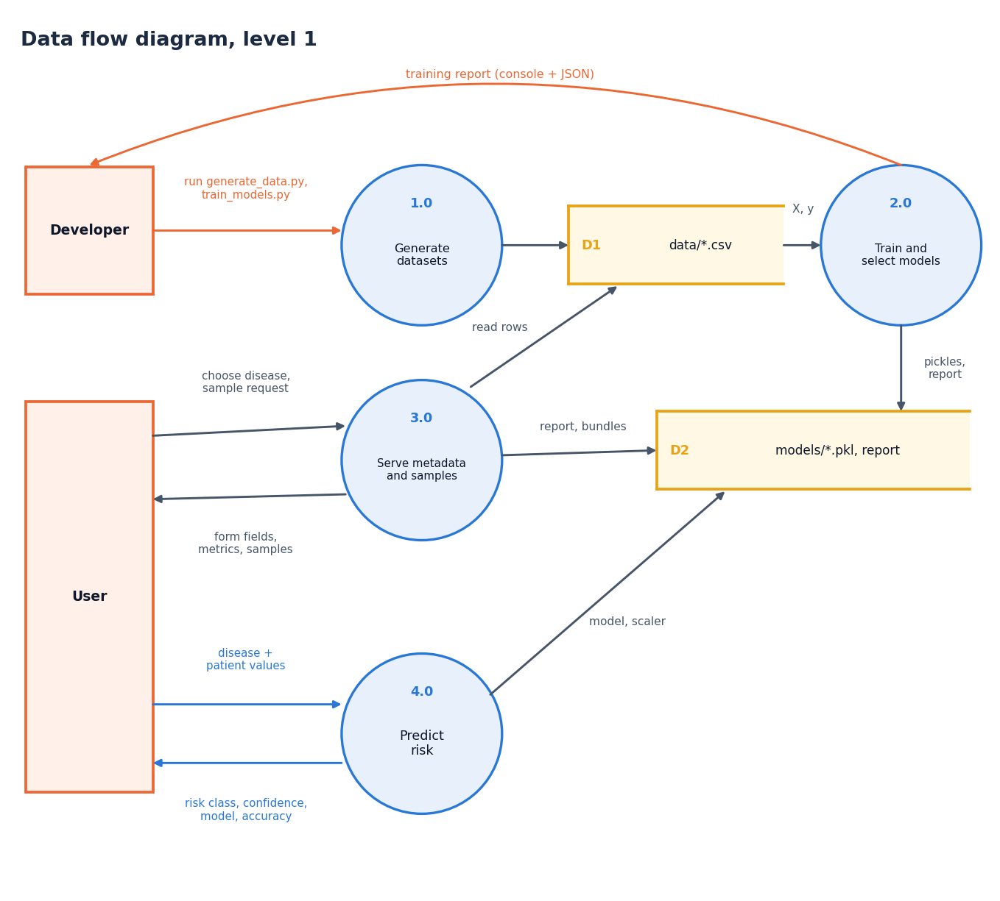
Figure 5: Data flow diagram, level 1
Process 4.0 expands into five sub-processes: 4.1 validates the disease key (an unknown key returns 404 to the user), 4.2 converts every value to a finite number in the saved feature order (a missing or non-finite value returns 422), 4.3 scales the vector with the saved StandardScaler, 4.4 predicts the class and the class probabilities with the saved model, and 4.5 formats the JSON result. Processes 4.2 to 4.4 read the feature order, the scaler and the model from the D2 bundle. The footnote records that validation happens twice: in the React form and again in the API.
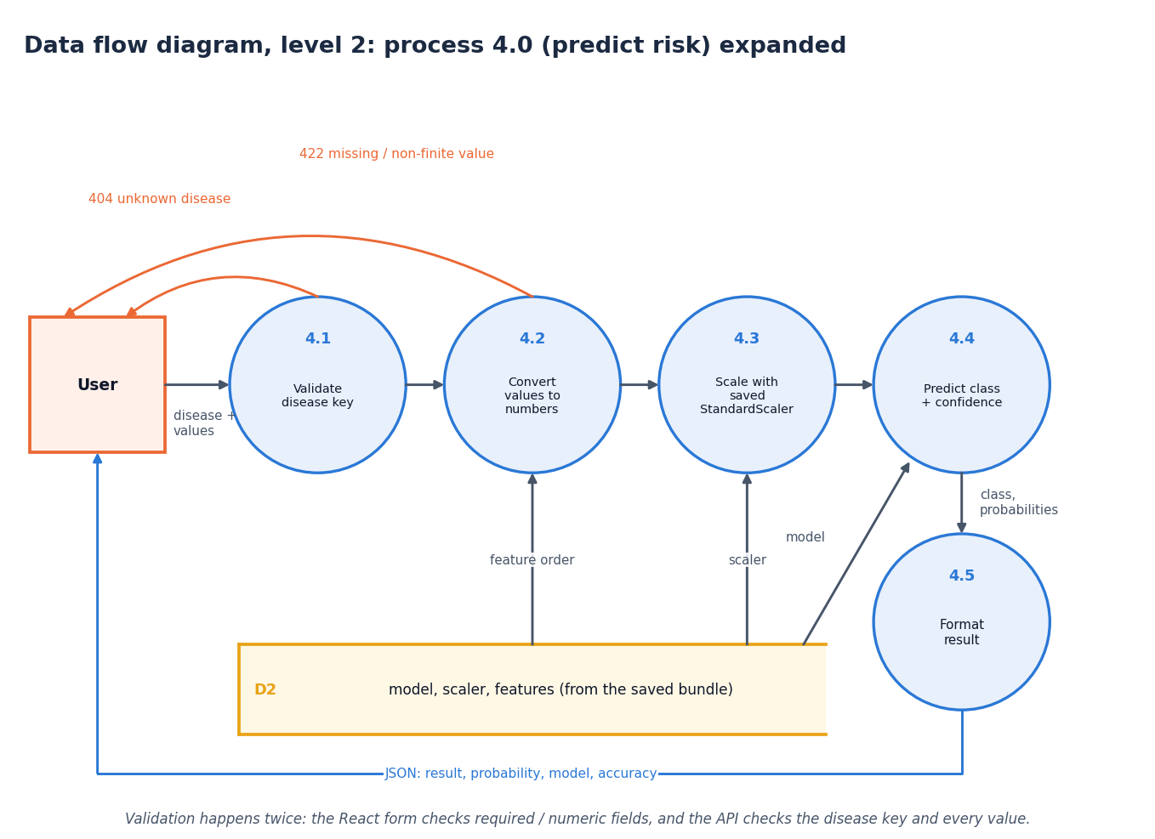
Figure 6: Data flow diagram, level 2: process 4.0 (predict risk) expanded

5.6 Class, Sequence and Use-Case Design
The code base is function-oriented, so most boxes are modules or plain data structures drawn with a stereotype: the FastAPI routes of backend/main.py (with the PredictBody pydantic model), the Flask module app.py that holds TRAINING_REPORT, BUNDLES, FIELD_META and DISEASE_TITLES, the ModelBundle tuple (model, scaler, features), the training script, the data generator, and the four scikit-learn estimator classes with their constructor settings. Solid arrows mean uses or contains; dashed arrows mean writes files. The only real classes are the pydantic PredictBody and the scikit-learn estimators; no class was invented for the diagram.
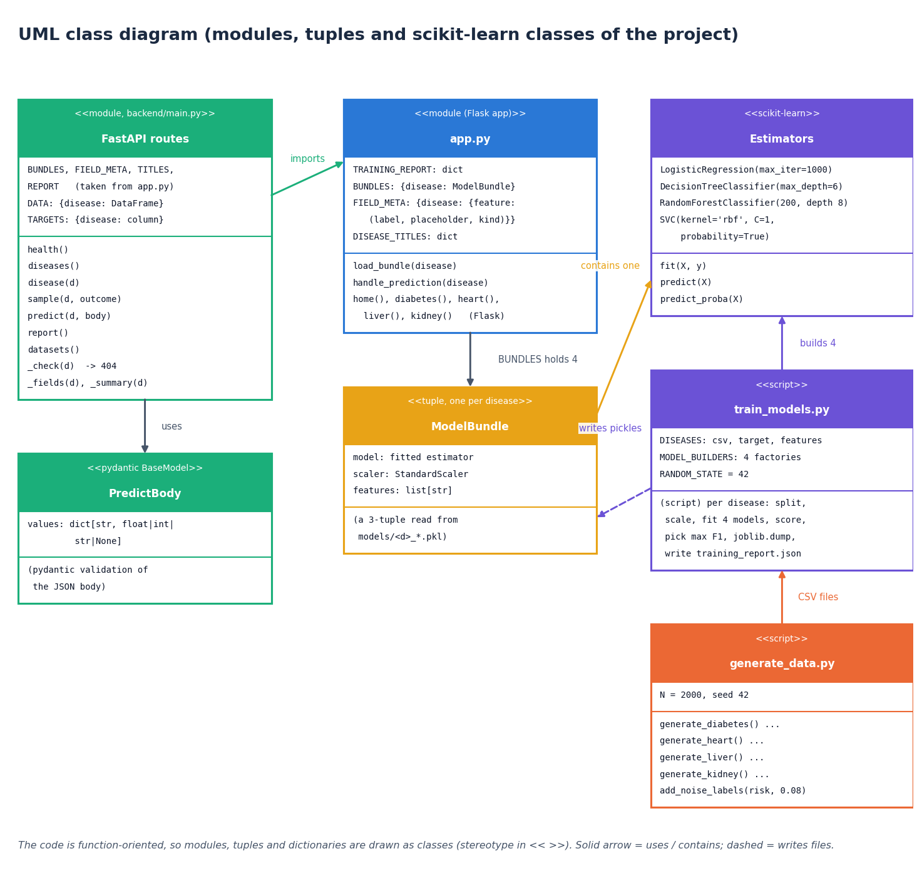
Figure 7: UML class diagram (modules, tuples and scikit-learn classes of the project)
The messages exchanged when a user opens the heart-disease page, loads a positive sample row and presses Predict risk. The React page fetches the field metadata, then the sample row, validates the form locally, and posts the values; the API checks the disease key, takes the bundle from app.py, converts the values, scales them, calls the model and returns the JSON result that the page shows as a result card. The footnote records that the API keeps no state between requests.
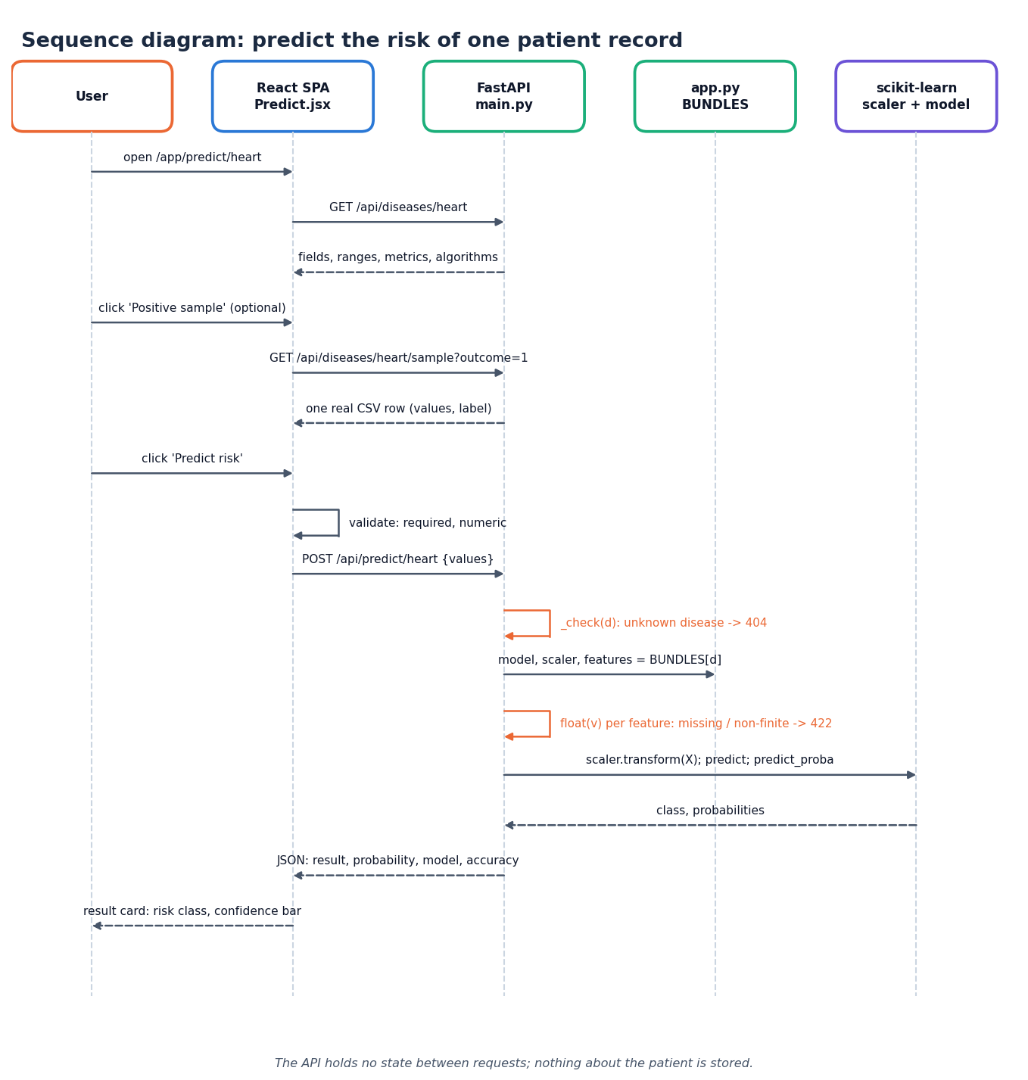
Figure 8: Sequence diagram: predict the risk of one patient record
Two actors and eleven use cases. The user can browse the landing page and overview, choose a disease, enter patient values, load a real sample record, predict disease risk (which includes validation of the input), view the model comparison, view the training datasets and read the about page. The developer can generate the synthetic datasets, train and select the best models and run the smoke test of the API. There is no sign-in: every user sees every screen, and predicting needs the models that the developer use cases create.
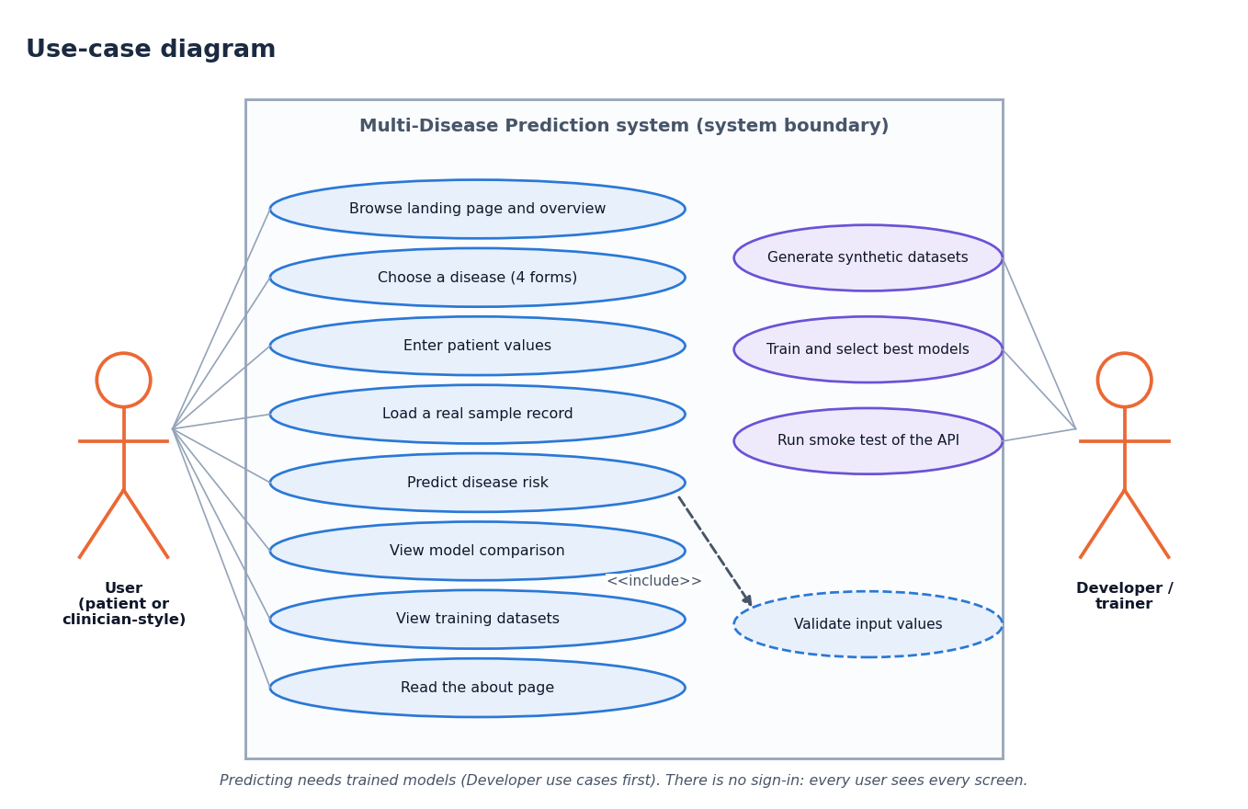
Figure 9: Use-case diagram

5.7 Database Design (Logical Data Model)
The project has no database, so this is the logical data model of the artefacts the code handles. A DISEASE has one DATASET_CSV, many FEATUREs (the form inputs), one MODEL_BUNDLE (model, scaler and feature-list pickles plus the name of the best model), four ALGORITHM_RESULTs (the metrics of the four algorithms in training_report.json) and many PREDICTIONs; a PREDICTION is transient and exists only for the duration of one request.
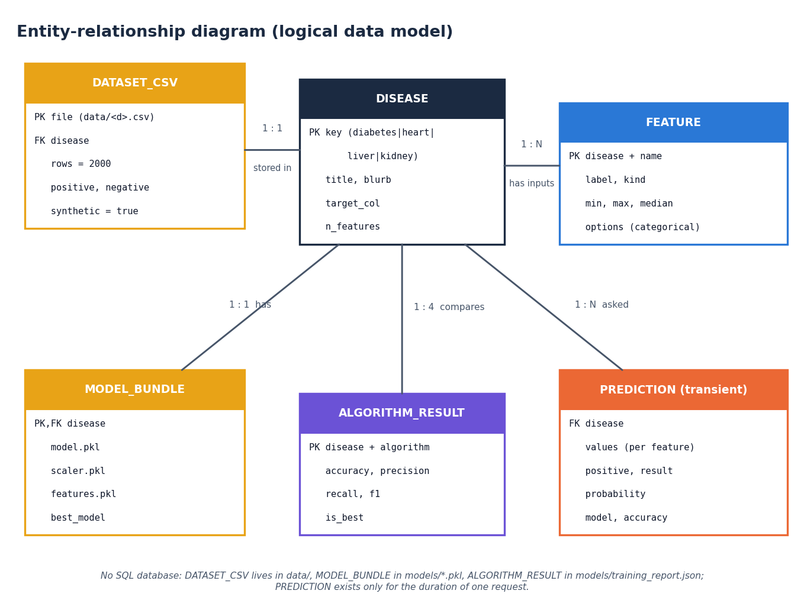
Figure 10: Entity-relationship diagram (logical data model)
Table 19: Entities of the logical data model
Entity | Where it lives | Key and content
DISEASE | Constants in train_models.py, app.py, backend/main.py | Key diabetes / heart / liver / kidney; title, blurb, target column, number of features
DATASET_CSV | data/<disease>.csv | 2,000 rows; 8, 13, 10, 12 feature columns (diabetes, heart, liver, kidney) plus a 0/1 target; synthetic
FEATURE | Headers of the CSV; FIELD_META in app.py | Name; label, placeholder and input type; minimum, maximum and median computed from the CSV; options for categorical inputs
MODEL_BUNDLE | models/<d>_model.pkl, _scaler.pkl, _features.pkl | The fitted best estimator, the fitted StandardScaler, the ordered list of feature names
ALGORITHM_RESULT | models/training_report.json | Per disease and algorithm: accuracy, precision, recall, F1 (4 decimals); name of the best model
PREDICTION (transient) | Request and response of one call | Disease, values per feature; result text, positive flag, probability, model, accuracy. Not stored

This is a file-based design chosen for simplicity: the data are small (8,000 rows in total), read-only at run time, and contain no personal information, so a database server would add operational cost and nothing else. The consequence is that nothing can be audited afterwards, because no prediction is recorded.

5.8 Algorithm Design
Panel A is the offline training loop of train_models.py: read the CSV of a disease, split 80/20 with stratification and seed 42, fit the StandardScaler on the training part, fit and score the four algorithms, keep the one with the highest F1, dump model, scaler and features, repeat for the next disease, and finally write the training report. Panel B is the online prediction of POST /api/predict/{d}: check the disease key (404), convert every feature to a float and check that it is finite (422), scale, predict, derive the class and the confidence, and return the JSON.
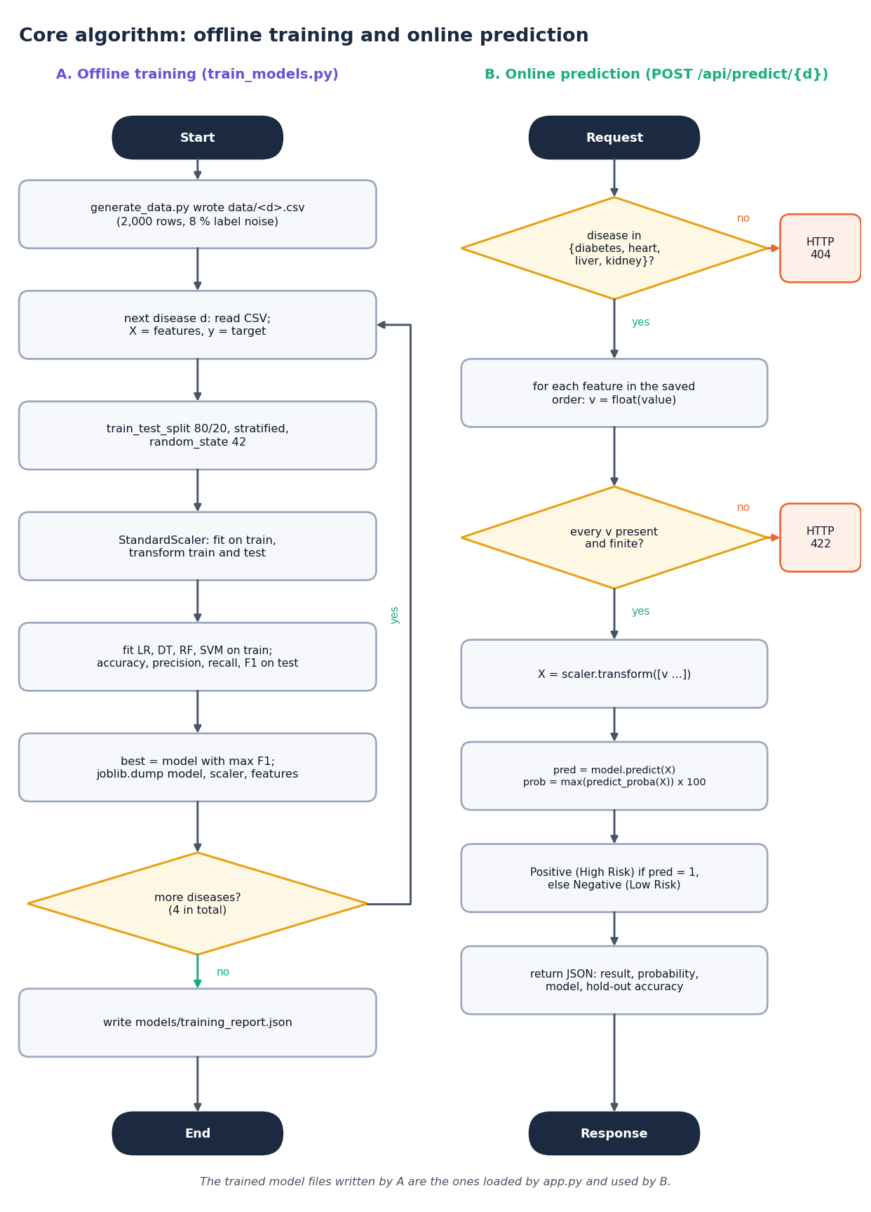
Figure 11: Flowchart of the core algorithm: offline training and online prediction
Chapter 6 gives each step in detail. Two design decisions are worth stating here. First, the model is selected on F1, not on accuracy, because several of the classes are unbalanced (for example only about 28% of the liver rows and 41% of the diabetes rows are positive). Second, the selection is made on the same 400-row test set that is then reported; this is simple but makes the reported number of the winner slightly optimistic, and Chapter 8 shows with cross-validation and ten random splits that it also picked a model for diabetes that the repeated evidence does not support.

5.9 API Design
The API follows REST conventions: nouns in paths, GET for reads and POST for the one action that computes. Responses are JSON; errors carry a plain-language detail field. FastAPI generates interactive documentation at /docs. Three status codes are used by the application code: 404 for an unknown disease, 422 for a request whose values are missing or not finite numbers (and for malformed JSON, which pydantic rejects), and 200 otherwise. Cross-origin requests are allowed only from http://localhost:5303 and http://127.0.0.1:5303, the origins of the React application.
Table 20: The seven routes of backend/main.py
Method | Path | Purpose
GET | /api/health | Liveness; returns the four disease keys
GET | /api/diseases | Summary of each condition: best model, accuracy, F1, number of features
GET | /api/diseases/{d} | Form fields (label, type, min, max, median, options), metrics of the best model, scores of all four algorithms
GET | /api/diseases/{d}/sample?outcome=0|1 | One random real row of data/<d>.csv, optionally of a given label, to pre-fill the form
POST | /api/predict/{d} | Body {"values": {...}}; returns class, confidence, model and accuracy; 422 for a missing or non-finite value, 404 for an unknown disease
GET | /api/report | The complete training_report.json
GET | /api/datasets | Rows, class balance, feature list and a synthetic: true flag for every CSV

5.10 State and Persistence Design
The API process holds four read-only structures built once at start-up: BUNDLES (the four model bundles, loaded by app.py), FIELD_META, REPORT (the parsed training report) and DATA (the four CSV files as pandas data frames, used for the sample rows, the field ranges and the dataset counts). No request changes any of them, which is why the service is safe to run with several worker threads and why a restart changes nothing. The only things written to disk are written by the training script: twelve pickle files and one JSON file.

5.11 Security Design
• There is no authentication, authorisation or session: every visitor can use every route. This is acceptable for a local demonstration of a model and would not be acceptable for a service handling real patients.
• No patient data is stored, logged by the application code or sent to any external service; the prediction is returned to the caller only.
• The API accepts only JSON bodies of the form {"values": {...}} (validated by pydantic) and converts every value with float(), rejecting nan and infinity; unknown extra fields are ignored.
• CORS is restricted to the two origins of the React application (Section 5.9).
• The original Flask application starts with debug=True and host="0.0.0.0" (app.py). That is convenient in development but exposes the Werkzeug debugger to the local network; it should not be used outside a development machine and was not changed in this project.
• Model files are unpickled with joblib.load. Pickle files from an untrusted source can execute code, so models/ must only ever contain files produced by train_models.py.

5.12 User-Interface Design
The React interface has a landing page with a three-dimensional hero, an overview page, one prediction page per disease (the four forms share one component, Predict.jsx, driven by the metadata returned by the API), a model-comparison page, a dataset page, an about page and a not-found page. It has dark and light themes, a collapsible sidebar on small screens, and a status badge that polls /api/health every 30 seconds so that the interface says honestly when the API is not running. Each prediction form offers two buttons, Positive sample and Negative sample, that load a real row of the CSV (which does not mean the model will agree with that row's label), shows the training range under every numeric field and warns when a value is outside it, and marks missing fields as Required. The result card shows the risk class, a confidence bar, the condition, the model used, that model's hold-out accuracy and a not-a-diagnosis notice.
The layout was checked at a phone width of 390 px as well as at 1440 px; the sidebar becomes a menu and the form fields stack in one column. The overview, validation-error and phone-layout screens are shown as Figures in Chapter 8 (Section 8.12).
The prediction and result screens, the model comparison and the dataset page are shown with their data in Chapter 8 and in Appendix C.

CHAPTER 6: METHODOLOGY AND SOFTWARE IMPLEMENTATION

6.1 Overview of the Methodology
The method is a supervised-learning pipeline repeated independently for four conditions. The first seven steps run once, offline, when the models are built; the last four run for every prediction request.
1. Generate the data. generate_data.py writes four CSV files of 2,000 rows each from the rules of Section 6.2.
2. Read and split. For each disease the CSV is read, the feature columns and the target are separated, and a stratified 80/20 split with random_state=42 gives 1,600 training and 400 test rows.
3. Scale. A StandardScaler is fitted on the training rows only and applied to training and test rows.
4. Train. Logistic Regression, Decision Tree, Random Forest and SVM are fitted with the settings of Section 6.6.
5. Evaluate. Accuracy, precision, recall and F1-score are computed on the 400 test rows.
6. Select. The model with the highest F1 is chosen for the disease.
7. Save. The chosen model, the scaler and the feature list are written with joblib, and the scores of all 16 models are written to training_report.json.
8. Receive a record. At run time the user enters, or loads, one value for each feature of one disease; the form checks that every field is present and numeric.
9. Validate. The API checks the disease key, converts every value to a finite number in the saved feature order and answers 422 or 404 on failure.
10. Scale and predict. The saved scaler transforms the vector; the saved model gives the class and the class probabilities.
11. Report. The class becomes "Positive (High Risk)" or "Negative (Low Risk)", the confidence is the larger class probability, and the model name and its hold-out accuracy are returned with it.
Two things are deliberately absent. The pipeline has no data-cleaning step (the generated data contains no missing values, duplicates or invalid entries, and no imputation or outlier code was written), and it has no explanation step: the application reports a class and a confidence, not the parameters that produced them. Chapter 8 measures what these omissions mean.

6.2 Data: Four Synthetic Datasets
The four datasets are not clinical records. The original build environment had no access to the public benchmark data, so generate_data.py creates data with medically plausible ranges. Each dataset has 2,000 rows (8,000 in total, numpy seed 42), no missing cells and no duplicate rows (checked). The features are drawn independently from the distributions below; the table gives the sampling of each disease.
Table 21: Sampling of the features (generate_data.py)
Disease | Feature distributions
Diabetes | age uniform integer 18-79; pregnancies uniform integer 0-9; glucose N(120, 30) clipped to 60-250; blood pressure N(72, 12) to 40-130; skin thickness N(20, 10) to 0-60; insulin N(80, 60) to 0-400; BMI N(30, 7) to 15-55; pedigree N(0.47, 0.3) to 0.05-2.5
Heart disease | age 29-79; sex, cp (0-3), restecg (0-2), slope (0-2), ca (0-3), thal (0-2) uniform integers; trestbps N(131, 17) to 90-200; chol N(246, 51) to 120-450; thalach N(150, 23) to 70-210; fbs Bernoulli(0.15); exang Bernoulli(0.33); oldpeak exponential(1) to 0-6
Liver disease | age 18-84; gender uniform 0/1; total bilirubin exponential(1.5) to 0.1-20; direct bilirubin = total x U(0.2, 0.6); alk. phosphatase N(290, 150) to 60-1200; ALT exponential(45) to 5-500; AST exponential(50) to 5-500; total protein N(6.5, 1) to 3-9; albumin N(3.2, 0.8) to 1-5.5; A/G ratio = albumin / (protein - albumin + 0.1) to 0.2-3
Kidney disease | age 2-89; blood pressure N(76, 13) to 50-180; specific gravity one of 1.005 ... 1.025; albumin and sugar uniform integers 0-4; random glucose N(148, 70) to 50-490; urea exponential(45) to 10-300; creatinine exponential(1.5) to 0.3-15; sodium N(137, 8) to 110-160; potassium N(4.4, 1) to 2.5-8; haemoglobin N(12.5, 2.5) to 3-18; packed cell volume N(38, 8) to 15-55

The label is then built in three steps. First a linear risk score is computed from some of the features; second the score is passed through the logistic function and the label is 1 if the probability exceeds 0.5 (that is, if the score is positive); third 8% of the labels are flipped at random (add_noise_labels(noise=0.08)).
risk = sum_j w_j (x_j - m_j) + b ; p = 1 / (1 + exp(-risk)) ; y = 1 if p > 0.5 else 0 ; then y is flipped with probability 0.08 (3)
Table 22: Risk score of each disease (the label rule)
Disease | Risk score | Features with no weight
Diabetes | 0.04 (glucose - 120) + 0.06 (BMI - 30) + 0.02 (age - 40) + 1.5 x pedigree + 0.03 (blood pressure - 72) - 1.4 | pregnancies, skin thickness, insulin
Heart disease | 0.035 (age - 50) + 0.9 sex + 0.5 cp + 0.02 (trestbps - 130) + 0.01 (chol - 240) + 0.8 exang + 0.5 oldpeak + 0.6 ca - 0.02 (thalach - 150) - 1.9 | fbs, restecg, slope, thal
Liver disease | 0.35 total bilirubin + 0.02 (alk. phosphatase - 290) + 0.015 (ALT - 45) + 0.01 (AST - 50) - 0.8 albumin + 0.015 (age - 45) - 0.3 | gender, direct bilirubin, total protein, A/G ratio
Kidney disease | 0.02 (age - 45) + 0.02 (BP - 76) - 40 (specific gravity - 1.015) + 0.6 albumin + 0.35 sugar + 0.01 (glucose - 148) + 0.02 (urea - 45) + 0.6 (creatinine - 1.5) - 0.35 (haemoglobin - 12.5) - 1.2 | sodium, potassium, packed cell volume

The positive rate follows from the rule and the distributions: diabetes 40.6%, heart disease 73.1%, liver disease 28.1% and kidney disease 59.8%. Three consequences matter for everything that follows.
• The label is a known linear function of the features plus noise. A linear model is therefore the correct model family, and the accuracy that any classifier can reach on fresh draws is limited to about 92% (one minus the flip rate). A hold-out accuracy of 88-92% means the pipeline recovers the rule almost as well as is possible; it does not say how well the pipeline would detect disease in patients.
• Some features carry no information. Pregnancies, skin thickness and insulin (diabetes), fasting blood sugar, resting ECG, slope and thal (heart), and sodium, potassium and packed cell volume (kidney) have zero weight in the rule, so any model that uses them is fitting noise.
• The features are independent. Real clinical variables are correlated (glucose with BMI, creatinine with urea); here they are not, which removes one of the main difficulties of real data.
Because these data are not a benchmark, a separate supplementary check (scripts/real_data_check.py) was run on public datasets with the same schemas: the Pima Indians Diabetes data [12], the UCI Cleveland heart-disease data [14], the Indian Liver Patient Dataset [16] and the UCI chronic kidney disease data [15]. That check is not part of the application and is reported in Chapter 8.

6.3 Preprocessing
Preprocessing is a single step: standardisation. For every feature j the scaler stores the mean and standard deviation of the 1,600 training rows and maps x to z = (x - mean_j) / sd_j. The scaler is fitted on the training rows only and then applied unchanged to the test rows and, at run time, to the vector entered by the user, so no test information reaches the models and training and serving use the same transformation. The scaler matters for Logistic Regression and the SVM, whose solutions depend on feature scale; trees are unaffected.
Several steps that the project objectives mention were not implemented, and the documents say so plainly: there is no imputation (no value is ever missing in the synthetic data; the real-data check imputes with the median, but the application does not), no outlier detection or capping, no feature selection, no class weighting or resampling (such as SMOTE [23]), and no encoding of categorical variables (the categorical inputs are already coded as small integers by the generator).

6.4 Choice of Algorithms and Why
The four algorithms are the ones the project objectives name. They cover four different ways of drawing a decision boundary, which is why they are a reasonable comparison on tabular data:
Table 23: The four algorithms and the reason each is included
Algorithm | Decision boundary | Why it is in the comparison | Known weakness
Logistic Regression | A single linear boundary in the scaled feature space | The simplest probabilistic baseline; fast, stable and easy to inspect through its coefficients; correct when the label is linear in the features | Cannot capture interactions or non-linear effects unless they are added by hand
Decision Tree | Axis-aligned rectangles from recursive splits | Rule-like and easy to explain; needs no scaling; handles mixed feature types | Unstable and prone to over-fitting; a depth limit is essential
Random Forest | Average of many decorrelated trees [18] | Usually the strongest default on tabular data; reduces the variance of a single tree; gives feature importances | Less smooth than a linear model; can fit label noise when trees are deep
SVM (RBF) | A maximum-margin boundary in a kernel feature space [19] | Flexible non-linear boundary with few parameters; strong on small and medium data | Sensitive to C and gamma; probabilities need an extra calibration step

The project introduction expects ensemble methods to outperform single classifiers on medical tables, and the base paper [1] found Random Forest and CatBoost to be its best classifiers on thyroid data. This project's measurements do not confirm that expectation on its own data: because the labels are linear plus noise, Logistic Regression is as good as or better than Random Forest for all four diseases, and the Random Forest over-fits the noisy labels (Chapter 8). That result is a property of the synthetic data and should not be generalised to clinical data, where the real-data check puts Random Forest and Logistic Regression close together.

6.5 Mathematical Formulation

6.5.1 Logistic Regression
Given a scaled feature vector x, the model estimates the probability of the positive class with the logistic (sigmoid) function of a linear score. Training minimises the L2-penalised log-loss over the n training rows (scikit-learn default, C = 1):
p(y = 1 | x) = sigma(w.x + b) = 1 / (1 + exp(-(w.x + b))) (4)
min over (w, b) of (1/2) ||w||^2 + C * sum_i [ -y_i log p_i - (1 - y_i) log(1 - p_i) ] (5)
The predicted class is 1 when p exceeds 0.5, that is when w.x + b is positive. The coefficients w, measured on standardised features, indicate which inputs raise the risk and by how much.

6.5.2 Decision Tree
A tree chooses at each node the feature and threshold that minimise the weighted Gini impurity of the two child nodes, where for a node with class proportions p_k:
G = 1 - sum_k p_k^2 (6)
Splitting stops at depth 6 (max_depth=6) or when a node is pure. The predicted probability of a leaf is the share of training rows of the positive class in it.

6.5.3 Random Forest
A forest grows B = 200 trees, each of depth at most 8, on bootstrap samples of the training rows, trying a random subset of about sqrt(p) features at every split. The prediction is the average of the trees' class probabilities:
p(y = 1 | x) = (1 / B) * sum_{b = 1..B} p_b(y = 1 | x) (7)

6.5.4 Support Vector Machine
The soft-margin SVM with the radial basis function kernel solves the dual problem below, with C = 1 and gamma = 1 / (p * Var(X)) (gamma="scale"). The decision function is a weighted sum of kernel values at the support vectors:
K(x, x') = exp(-gamma ||x - x'||^2) ; f(x) = sum_i alpha_i y_i K(x_i, x) + b ; 0 <= alpha_i <= C (8)
With probability=True scikit-learn fits a sigmoid (Platt scaling) to the decision values by internal five-fold cross-validation to obtain class probabilities. Because that calibration is fitted separately from the decision function, the class given by predict can occasionally differ from the class with the larger probability.

6.5.5 Evaluation metrics and the selection rule
With TP, FP, TN and FN counted on the 400 test rows (the positive class is "high risk"):
accuracy = (TP + TN) / (TP + TN + FP + FN) ; precision = TP / (TP + FP) ; recall = TP / (TP + FN) (9)
F1 = 2 * precision * recall / (precision + recall) (10)
ROC-AUC is the probability that a randomly chosen positive row receives a higher score than a randomly chosen negative row; it needs no threshold. The training script computes accuracy, precision, recall and F1 only; ROC-AUC was added afterwards in scripts/run_experiments.py. The model served for disease d is the one with the largest F1 on the test rows:
m*(d) = argmax over m in {LR, DT, RF, SVM} of F1_m(d) on the test set (11)
F1 is used instead of accuracy because it penalises both missed cases and false alarms and is not inflated by the majority class. Selecting and reporting on the same test rows gives a slightly optimistic score for the winner [24]; the extra analyses of Chapter 8 (five-fold cross-validation and ten random splits) are the check on that.

6.5.6 Confidence, noise ceiling and permutation importance
The confidence shown to the user is the larger of the two class probabilities, so it lies between 50% and 100% and says how sure the model is of the class it chose; it is not the probability of disease and the models were not calibrated. With a flip rate of 0.08 the best achievable expected accuracy on fresh draws of the synthetic data is 1 - 0.08 = 0.92. Finally, the offline importance analysis shuffles one feature at a time and measures the loss of accuracy:
PI_j = acc(test) - (1 / R) * sum_{r = 1..R} acc(test with column j shuffled in repetition r) , R = 20 (12)

6.6 Model Architecture and Training Configuration
Table 24: Hyper-parameters exactly as used in train_models.py
Algorithm | Constructor | Remaining settings
Logistic Regression | LogisticRegression(max_iter=1000, random_state=42) | L2 penalty, C = 1, lbfgs solver (library defaults)
Decision Tree | DecisionTreeClassifier(max_depth=6, random_state=42) | Gini impurity, no pruning other than the depth limit
Random Forest | RandomForestClassifier(n_estimators=200, max_depth=8, random_state=42) | Bootstrap samples, sqrt(p) features tried per split (library default)
SVM | SVC(kernel="rbf", C=1.0, probability=True, random_state=42) | gamma = "scale"; probabilities by Platt scaling (internal 5-fold cross-validation)

All settings are fixed in the source; no grid search, random search or cross-validation was used to tune them. The training set has 1,600 rows and the test set 400 rows for every disease (stratified, random_state=42); the numbers of positive test rows are 162 for diabetes, 292 for heart disease, 112 for liver disease, 239 for kidney disease. Fitting a single model takes between 3 ms and 0.62 s on the project machine (an Intel Core i5-12500 CPU; no GPU is needed), so the 16 models are trained in a few seconds.
Table 25: Feature counts and the model that is served
Disease | Inputs | Selected model | Selection rule result (test F1)
Diabetes | 8 | SVM | 0.8636
Heart disease | 13 | Logistic Regression | 0.9241
Liver disease | 10 | Logistic Regression | 0.8406
Kidney disease | 12 | Logistic Regression | 0.9027

6.7 Evaluation Protocol
Three layers of evidence are used, each answering a different question. (1) The hold-out test of train_models.py is the number the application shows. (2) Stratified five-fold cross-validation and ten random 80/20 splits (seeds 0 to 9), run by scripts/run_experiments.py with the scaler refitted inside every fold, ask whether the choice of model depends on the particular split. (3) A decision-threshold sweep (0.20 to 0.80), permutation importance, hyper-parameter sensitivity and a train-versus-test comparison characterise the selected models. The extra script also checks that its re-computation reproduces training_report.json exactly, which it does for all 16 model-and-disease cells and for the saved pickles.
The supplementary real-data check uses the same four algorithms and settings with a median imputer in front of the scaler and three repetitions of five-fold cross-validation, and in addition applies the saved, synthetic-trained models to the real records. It is described as supplementary because the datasets, their coding and their size differ from those of the application.

6.8 Application Architecture
The application has three layers that share one set of trained models. The model layer is the offline script train_models.py and the files it writes in models/. The service layer is app.py, which loads those files once at import time into BUNDLES (a dictionary from disease key to the tuple model, scaler, features) and defines FIELD_META, and backend/main.py, a FastAPI application that imports app.py and adds the JSON routes. The presentation layer is the React application in frontend/. Because backend/main.py imports the Flask module instead of copying its objects, the API and the original Flask pages use the identical models and the identical arithmetic; importing app.py does not start the Flask server.
The React application is a single-page application built with Vite. src/App.jsx declares the routes (the landing page, then /app with an overview, predict/:disease, models, data, about and a not-found page; all but the landing page are loaded lazily). src/lib/api.js is the only place that talks to the network: it prefixes every path with the API address (VITE_API_URL, default http://127.0.0.1:8303), turns a failed fetch into the message "Cannot reach the prediction API", and turns a non-200 answer into an error carrying the detail text of the API. Predict.jsx is one component for all four diseases: it asks /api/diseases/{d} for the fields, renders a number input or a drop-down for each, validates that every field is filled with a number, posts {"values": {...}} and shows the answer. Page data are loaded with a small useAsync hook, and the connection badge uses useHealth, which polls /api/health every 30 seconds.

6.9 API Design with Real Requests and Responses
The seven routes are listed in Chapter 5. The following exchanges were captured from the running service on 127.0.0.1:8303. A prediction request carries one value for each feature, keyed by the feature name:
POST /api/predict/diabetes
{"values": {"Pregnancies": 2, "Glucose": 128.9, "BloodPressure": 71.8, "SkinThickness": 32.4,
"Insulin": 103.3, "BMI": 30.2, "DiabetesPedigreeFunction": 0.93, "Age": 54}}

200 OK
{"disease": "diabetes", "title": "Diabetes Risk Prediction", "positive": true,
"result": "Positive (High Risk)", "probability": 90.71, "model": "SVM", "accuracy": 0.895}

A request with a value that is not a number is refused before the model is called; the message names the labels of the fields that failed. Here only Glucose was sent (with the text "abc"), so all eight labels are listed:
POST /api/predict/diabetes {"values": {"Glucose": "abc"}}

422 Unprocessable Entity
{"detail": "Please enter a valid number for: Number of Pregnancies, Glucose Level (mg/dL),
Blood Pressure (mm Hg), Skin Thickness (mm), Insulin Level (mu U/ml), BMI,
Diabetes Pedigree Function, Age."}

The sample route returns a real row of the CSV and its label, which the interface uses to fill the form:
GET /api/diseases/kidney/sample?outcome=1

200 OK
{"values": {"age": 49.0, "blood_pressure": 89.7, "specific_gravity": 1.005, "albumin": 2.0, "sugar": 2.0,
"blood_glucose_random": 151.5, "blood_urea": 64.5, "serum_creatinine": 0.84, "sodium": 142.6,
"potassium": 3.48, "hemoglobin": 10.74, "packed_cell_volume": 31.5},
"label": 1}

GET /api/diseases/{d} returns the data the form needs: for each field its name, label, placeholder, input type, minimum, maximum and median in the CSV, and the options of a categorical field (for example {"value": 1, "label": "Male"}), together with the metrics of the best model and the four algorithms' scores. GET /api/datasets returns, for every disease, the row count, the positive and negative counts, the target column, the feature list and "synthetic": true, which the Datasets page turns into its warning banner.
On the project machine a prediction request takes a median of 13.5 ms and a 95th percentile of 24.9 ms (200 calls on 127.0.0.1); Chapter 7 gives the measurements and their caveats.

6.10 Security and Error Handling
The application is built as a local demonstration, and its security posture is correspondingly limited. The facts are:
• No authentication and no stored data. Every route is open; no patient value is written to disk or to a log by the application, and the result exists only in the response.
• Input validation. The pydantic model PredictBody requires a JSON object values; each value is converted with float(), and a missing key, null, an empty string, text, nan or infinity is reported with HTTP 422 and a readable message. Unknown extra keys are ignored. Physiologically impossible numbers (a glucose of 100,000 mg/dL or an age of -5) are accepted, because there is no range check in the API; the interface only warns when a value lies outside the training range of the feature.
• Error codes. 404 for an unknown disease key (also for the detail and sample routes), 422 for invalid input or malformed JSON, 405 for a wrong method, 404 for an unknown route. The React client shows the detail text; if the API cannot be reached it says so.
• CORS. Only http://localhost:5303 and http://127.0.0.1:5303 may call the API from a browser.
• Model files. joblib.load is used on the files in models/; these must come only from train_models.py because pickle files can execute code when loaded.
• Flask development server. app.py runs with debug=True on all interfaces when started directly. This is for local use only.
What is missing, and would be required before any real use, is authentication and authorisation, transport security (HTTPS), rate limiting, audit logging, range validation of clinical values, and a data-protection review.

6.11 Installation and Execution
The project needs Python 3.11 or newer and Node.js (the project was built with Python 3.11.9 and Node 24). The trained models were saved with scikit-learn 1.8.0, so the pinned requirements.txt must be used: an older scikit-learn fails on predict_proba when it unpickles the models.
Table 26: Pinned Python packages (requirements.txt)
Package | Version | Used for
scikit-learn | 1.8.0 | Models, scaler, metrics
pandas | 3.0.2 | Reading the CSVs in the API
numpy | 2.4.4 | Arrays, data generation
joblib | 1.5.3 | Saving and loading the models
Flask | 3.1.3 | The original web pages and the shared app.py
fastapi | 0.110.0 | The JSON API
uvicorn | 0.29.0 | The ASGI server

On Windows the whole application starts with one command:
run.bat # creates venv\ and installs requirements.txt on first run, installs frontend\node_modules,
# starts venv\Scripts\python -m uvicorn backend.main:api --port 8303
# and cd frontend && npm run dev (http://127.0.0.1:5303), then opens the browser

The ports come from .env (BACKEND_PORT=8303, FRONTEND_PORT=5303, VITE_API_URL=http://127.0.0.1:8303; .env.example is the template). To retrain from scratch:
venv\Scripts\python generate_data.py # writes data/*.csv (numpy seed 42)
venv\Scripts\python train_models.py # writes models/*.pkl and models/training_report.json
venv\Scripts\python -m uvicorn backend.main:api --port 8303
venv\Scripts\python scripts\smoke_test.py # 27 checks against the running API
venv\Scripts\python app.py # optional: the original Flask pages on http://127.0.0.1:5000

Appendix B gives the full installation and user guide.

CHAPTER 7: SYSTEM TESTING

7.1 Test Strategy
The system is small, stateless and has one job: turn a vector of numbers into a class and a confidence. Testing therefore concentrates on four questions: do the saved models reproduce the numbers the application reports, does the API return the right answer for valid input, does it refuse invalid input with a useful message, and does the interface show the result correctly. There is no pytest or unit-test suite in this project; the tests below are executable scripts that run against the real models and the running service. Their output was kept in docs/experiments/ so that the figures in this chapter can be re-checked.
Table 27: Test layers actually run
Layer | What it covers | Tool | Result
Model reproduction | Re-training the 16 models with the same split and settings gives the scores in training_report.json; the shipped pickles give the reported accuracy | scripts/run_experiments.py | 16 of 16 model-and-disease cells match to 4 decimals; all 4 shipped pickles match
API smoke test | Every route, two samples per disease, an invalid input and an unknown disease | scripts/smoke_test.py (standard library) | 27 checks passed, 0 failed
API functional, consistency and validation tests | Section 7.4 | scripts/api_tests.py | 41 of 41 checks passed
Performance | Latency of five request types and four concurrent clients | scripts/api_tests.py | Section 7.6
Interface | Screens captured from the running application with real data, including an empty-form error, an out-of-range warning and a phone layout | Playwright with Chrome, capture_screens.py, capture_extra.py | 20 screenshots; Section 7.7

7.2 Unit-Level Checks
Because the code is a handful of short functions around scikit-learn objects, the unit-level evidence is indirect. Two checks stand in for unit tests. First, the reproduction check retrains every model and compares accuracy and F1 with the stored report; all 16 cells agree, which shows that train_models.py, the saved report and the saved pickles are consistent with one another and that the results are repeatable. Second, the consistency check compares what the API returns with what model.predict returns when called directly on the same scaled vector. A function-level test of _options (the generator of drop-down choices), _fields (the field metadata) and _summary was not written; their output is exercised by the functional checks and appears on screen in every form.

7.3 Integration Testing
The integration points are file loading, the Flask-to-FastAPI import, and the browser-to-API call. The smoke test starts from the running service and walks through the whole path: health, the list of diseases, the training report, the dataset facts, and for each disease the form metadata, a negative and a positive sample row, and a prediction from that row. It asserts that the sample has the label that was requested, that the form has as many fields as the model has features, that a prediction contains one of the two result strings and a confidence between 0 and 100, that a text value is rejected with 422 and a message containing "valid number", and that an unknown disease gives 404. The browser-to-API call is exercised by the screen captures (Section 7.7): the React application fetched its data from the real API on port 8303 in every screenshot.

7.4 Functional, Consistency and Validation Tests
scripts/api_tests.py runs against the live service on 127.0.0.1:8303 and records every check in docs/experiments/api_tests.json. All 41 of 41 checks passed. The table groups them.
Table 28: Checks of scripts/api_tests.py
Group | Checks | Passed | What is checked
Functional | 24 | 24 | Every route, all four diseases, both classes: health, disease list, report, datasets, form metadata, sample rows with the requested label, and a prediction from every sample
Consistency | 2 | 2 | The API's class equals a direct model.predict on 40 sampled rows (5 per disease and class); the same input twice gives an identical response
Validation | 14 | 14 | Missing field, empty body, text, nan, inf, null and empty string for a field (422); numeric string accepted; unknown field ignored; unknown disease (404); malformed JSON (422); wrong method (405); unknown route (404)
Sanity | 1 | 1 | A clinically extreme low-risk diabetes input is predicted Low Risk and an extreme high-risk input is predicted High Risk
Total | 41 | 41

The functional group includes, for each disease, one prediction from a real positive sample and one from a real negative sample. The test checks that the call succeeds and that the confidence lies between 50% and 100%; it does not assert that the predicted class equals the row's label, because the models are not perfect. That is visible in the interface: for example screenshot 20 (Chapter 8) shows a heart-disease row labelled negative that the model classifies as high risk with 99.53% confidence, which is one of the 34 false positives of the heart-disease model on its test set.
Four more observations were recorded rather than counted as pass or fail, because they describe behaviour the specification does not forbid but a clinician would want to know about:
Table 29: Recorded observations
Observation | Result
Glucose = 100000 mg/dL is accepted (no range check) | HTTP 200, Positive (High Risk) 60.94%
Age = -5 is accepted (no range check) | HTTP 200, Positive (High Risk) 74.61%
Out-of-range value in the browser | Screenshot 18: a glucose of 900 shows a warning that the value is outside the training range (60 to 229.7) and the estimate may be less reliable; the form still submits
Impossible values | The API does not check physiological ranges; the models return a class and a confidence for absurd inputs

7.5 Security Testing
There is no authentication to test, no stored data to leak and no query language to inject into: every value is converted with float() and used only as a number. Within that narrow scope the following was checked:
• Malformed JSON, a missing body, text, null, nan and inf are rejected with 422 and never reach the model (validation group).
• A wrong HTTP method on the prediction route returns 405 and an unknown route returns 404.
• An unknown extra field in the body is ignored and does not change the result.
• The CORS list (two localhost origins) was reviewed in the code; no request from a different origin was sent to confirm the browser's refusal.
Not tested: authentication, authorisation, HTTPS, denial of service, rate limiting, dependency vulnerabilities, the Flask debug server and the safety of unpickling model files. No penetration test was performed.

7.6 Performance Testing
Latency was measured by scripts/api_tests.py over 127.0.0.1 with one client: 10 warm-up calls and then 200 timed calls per request type. The numbers include the HTTP client, the FastAPI routing, JSON conversion and, for the prediction requests, scaling and model inference.
Table 30: API latency on the project machine (milliseconds)
Request | Calls | Median | 95th percentile | Maximum | Mean
GET /api/health | 200 | 12.9 | 25.0 | 27.0 | 10.8
GET /api/diseases | 200 | 14.6 | 25.1 | 63.0 | 12.2
GET /api/diseases/diabetes | 200 | 16.4 | 26.9 | 29.8 | 14.9
POST /api/predict/diabetes | 200 | 13.5 | 24.9 | 27.4 | 11.4
POST /api/predict/heart | 200 | 14.4 | 25.0 | 26.2 | 11.9
POST /api/predict/diabetes, 4 concurrent clients | 200 | 5.1 | 25.1 | 29.5 | 9.5

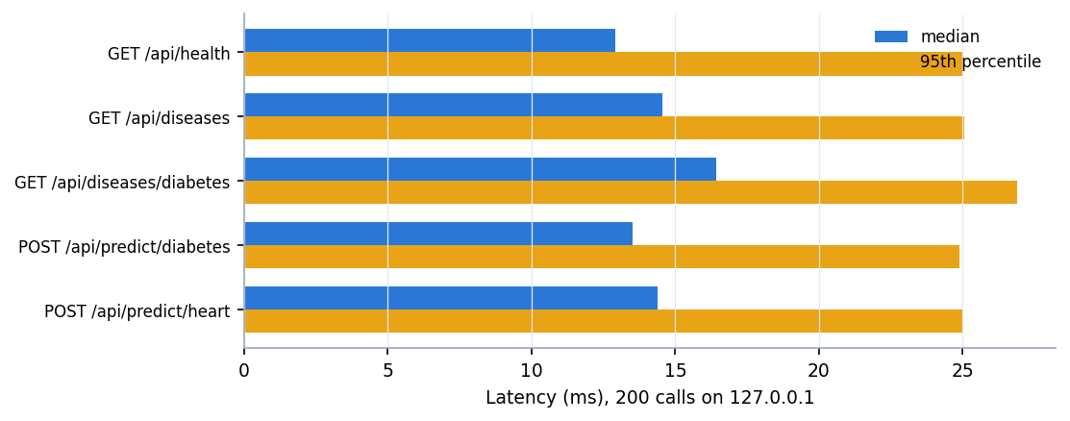
Figure 12: Median and 95th-percentile latency of the API (200 calls per request type, single client)
A prediction takes a median of 13.5 ms for diabetes and 14.4 ms for heart disease, and with four concurrent clients the service handled 416 requests per second. Model inference itself is a small part of this: in-process prediction costs between 0.0001 and 0.057 ms per row, and fitting any single model takes well under a second. Two cautions apply. The machine was under heavy memory pressure from other programs while the numbers were taken, and Windows timers have a resolution of about 15.6 ms, so single-call timings are quantised; the figures are upper bounds and are suitable only to say that a prediction needs well under 25 ms at the 95th percentile. Only localhost was used, so network latency is not included. No test with many users was run.

7.7 Interface Testing and Acceptance
The screens were captured by driving the real application with Playwright and Chrome at 1440 x 900: the landing page in both themes, the overview, the four prediction forms with a positive and with a negative real sample, the model-comparison page, the dataset page, the about page, the not-found page, an empty form submitted (screenshot 17), an out-of-range value (18), a phone-sized form of 390 x 844 pixels (19) and a false-positive case (20). capture_screens.py, written for the interface build, is designed to fail on any console error, page error, failed request or HTTP status of 400 or more; it was not re-run for this report. capture_extra.py, run for the documentation, completed all its captures against the same API, which shows that the pages render with data and respond to clicks. For those extra captures the interface was served from its production build (frontend/dist) by a static server, because the machine did not have enough free memory for the Vite development server; the code and data are the same.
User acceptance. No formal acceptance test with clinicians or other users was carried out. The walk-through captured in the screenshots is a developer's check, not an evaluation by the intended users, and it says nothing about whether a health worker would understand or trust the result card.

7.8 Findings from Testing
Table 31: What the testing and the measurements revealed
Finding | Evidence | Consequence
Impossible clinical values are accepted | Glucose 100,000 mg/dL and age -5 are accepted and classified High Risk (observations in Section 7.4) | Add range checks in the API; at present only the browser warns
The diabetes model chosen on one split is not the best in repeated tests | Logistic Regression wins F1 on 10 of 10 random splits; SVM was shipped on the seed-42 split (Chapter 8) | Select models by cross-validation, not on the reported test set
Real-looking rows can be misclassified with high confidence | Screenshot 20; heart model has 34 false positives among 108 negative test rows | The confidence is not a calibrated probability and should not be read as one
The training script never computed ROC-AUC | Objective 4 asks for it; it was measured afterwards in run_experiments.py | Add ROC-AUC to train_models.py and to the report
The shipped models transfer only partly to real data | Supplementary real-data check (Chapter 8): the liver model scores below the majority-class baseline | The application must not be used for real decisions

7.9 What Was Not Tested
• There is no automated unit-test suite, no code-coverage measurement and no test of the React components.
• No test with real clinical data inside the application; the real-data check is an offline experiment.
• No load, stress or soak test beyond four concurrent clients on one machine.
• No security or penetration test, and no accessibility audit; only Chrome was used.
• No test on a clean machine other than the project machine, and no test of the installation steps by a second person.
• No user study.

7.10 Conclusion on Testing
The evidence shows that the models and the API are consistent with each other and repeatable, that all 41 API checks and all 27 smoke checks pass, that invalid input is refused with clear messages, and that every screen renders with real data. It does not show that the predictions are clinically valid; that is a question about the data and the models, answered in Chapter 8, and the answer there is that the application is a demonstration.

CHAPTER 8: RESULTS AND OUTPUT SCREENS

8.1 Experimental Setup
All results come from the project's own scripts: train_models.py (the metrics the application shows, stored in models/training_report.json), scripts/run_experiments.py (ROC-AUC, confusion matrices, cross-validation, repeated splits, thresholds, importance, sensitivity), scripts/real_data_check.py (a supplementary check on real public data), scripts/api_tests.py (API checks and latency) and scripts/make_figures.py (charts). Re-running them reproduces the numbers below on the same software versions; run_experiments.py reproduces all 16 model-and-disease cells of the shipped report to four decimals.
Table 32: Experimental setup
Item | Value
Data | Four synthetic CSV files in data/, 2,000 rows each (8,000 in total), generated by generate_data.py (seed 42): a hand-written linear risk score, thresholded at 0.5, with 8% of the labels flipped at random
Split | Stratified 80/20, random_state 42: 1,600 training rows and 400 test rows for every disease
Models | Logistic Regression (max_iter 1000), Decision Tree (max_depth 6), Random Forest (200 trees, max_depth 8), SVM (RBF, C 1, probability on); inputs standardised with a scaler fitted on the training rows
Selection rule | Highest F1 on the test split (as in train_models.py)
Extra protocols | Stratified 5-fold cross-validation (scaler refitted per fold) and ten random 80/20 splits (seeds 0-9) for all four algorithms
Real-data check | Pima Indians Diabetes, UCI Cleveland heart, UCI ILPD liver and UCI chronic kidney disease, same algorithms and settings with median imputation (Section 8.8)
Machine | Intel Core i5-12500 (12 threads), 16 GB RAM, Windows 11, Python 3.11.9, scikit-learn 1.8.0, CPU only

Reading the numbers. The training data are synthetic. Their labels follow a known linear rule and 8% of them are flipped, so no classifier can exceed about 92% accuracy on this data (the noise ceiling) and a linear model is the correct model family. The accuracies below therefore show that the pipeline recovers a known rule; they are not clinical performance. Section 8.8 shows what the same method scores on real public data.

8.2 Hold-out Results for the Four Diseases
The tables give the four algorithms for each disease on the 400-row test split. The row marked (selected) is the model the application serves; accuracy, precision, recall and F1 are the values stored in the training report and shown on the Models page, and ROC-AUC was computed afterwards from the predicted probabilities of the same fitted models.
Table 33: Diabetes: test-split metrics (400 rows, 162 high-risk)
Model | Accuracy | Precision | Recall | F1-score | ROC-AUC
Logistic Regression | 0.8900 | 0.8882 | 0.8333 | 0.8599 | 0.9034
Decision Tree | 0.8000 | 0.7808 | 0.7037 | 0.7403 | 0.8037
Random Forest | 0.8625 | 0.8794 | 0.7654 | 0.8185 | 0.9070
SVM (selected) | 0.8950 | 0.9110 | 0.8210 | 0.8636 | 0.9077

Table 34: Heart disease: test-split metrics (400 rows, 292 high-risk)
Model | Accuracy | Precision | Recall | F1-score | ROC-AUC
Logistic Regression (selected) | 0.8850 | 0.8917 | 0.9589 | 0.9241 | 0.8455
Decision Tree | 0.7675 | 0.8241 | 0.8664 | 0.8447 | 0.7339
Random Forest | 0.8275 | 0.8195 | 0.9795 | 0.8924 | 0.8306
SVM | 0.8775 | 0.8857 | 0.9555 | 0.9193 | 0.8563

Table 35: Liver disease: test-split metrics (400 rows, 112 high-risk)
Model | Accuracy | Precision | Recall | F1-score | ROC-AUC
Logistic Regression (selected) | 0.9175 | 0.9158 | 0.7768 | 0.8406 | 0.8881
Decision Tree | 0.8600 | 0.7642 | 0.7232 | 0.7431 | 0.8072
Random Forest | 0.8825 | 0.8652 | 0.6875 | 0.7662 | 0.8880
SVM | 0.8900 | 0.9048 | 0.6786 | 0.7755 | 0.8890

Table 36: Kidney disease: test-split metrics (400 rows, 239 high-risk)
Model | Accuracy | Precision | Recall | F1-score | ROC-AUC
Logistic Regression (selected) | 0.8825 | 0.8934 | 0.9121 | 0.9027 | 0.9076
Decision Tree | 0.7450 | 0.7665 | 0.8243 | 0.7944 | 0.7540
Random Forest | 0.8150 | 0.8113 | 0.8996 | 0.8532 | 0.8805
SVM | 0.8525 | 0.8516 | 0.9121 | 0.8808 | 0.8963

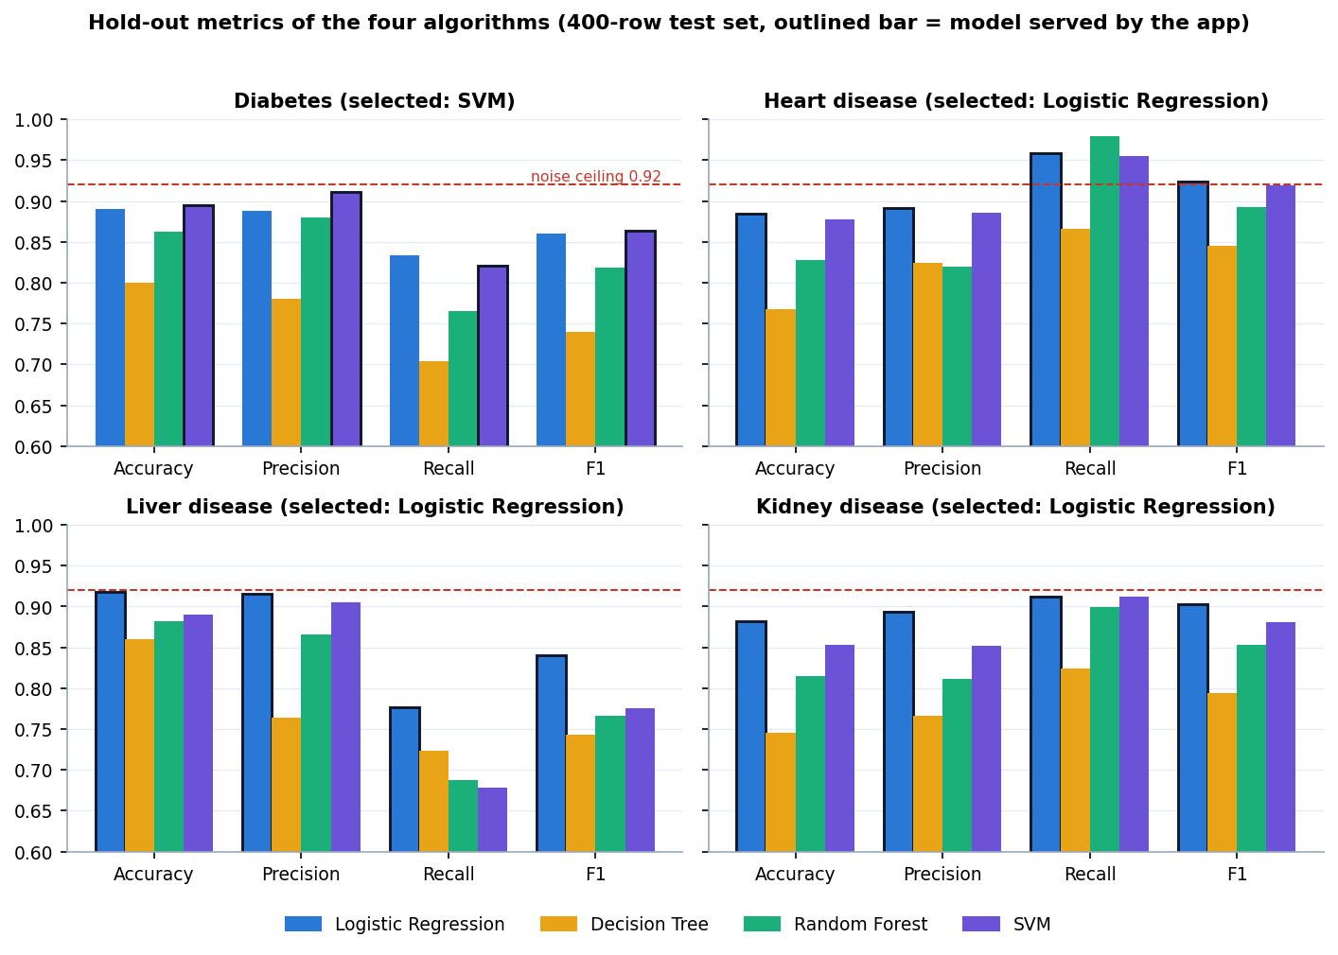
Figure 13: Hold-out metrics of the four algorithms for each disease (outlined bars: the model served by the application; dashed line: 92% noise ceiling)
Three points stand out. First, the selected models score 89.5% (diabetes), 88.5% (heart), 91.8% (liver) and 88.3% (kidney), all close to the 92% ceiling set by the label noise. Second, Logistic Regression is the selected model for three of the four diseases and is within 0.5 points of the SVM for the fourth, which is what a linear label rule predicts. Third, the Decision Tree is clearly the weakest everywhere (accuracy 0.7450 to 0.8600) and Random Forest is behind the linear model on every disease, because both fit the flipped labels (Section 8.5).
Recall matters most when a screening tool must not miss patients. Heart disease has the highest recall of the selected models (0.9589) because its data are 73.1% high-risk; liver disease has the lowest (0.7768) with 28.1% high-risk rows, so the liver model misses about one high-risk patient in four. Precision and recall are not averaged across diseases because the class balance differs (high-risk share of the 2,000 rows: diabetes {pb['diabetes']}, heart {pb['heart']}, liver {pb['liver']}, kidney {pb['kidney']}).

8.3 Confusion Matrices and ROC Curves
Table 37: Confusion matrices of the served models on the 400-row test split
Disease | Model | TN | FP | FN | TP | High-risk missed | Low-risk flagged
Diabetes | SVM | 225 | 13 | 29 | 133 | 17.9% | 5.5%
Heart disease | Logistic Regression | 74 | 34 | 12 | 280 | 4.1% | 31.5%
Liver disease | Logistic Regression | 280 | 8 | 25 | 87 | 22.3% | 2.8%
Kidney disease | Logistic Regression | 135 | 26 | 21 | 218 | 8.8% | 16.1%

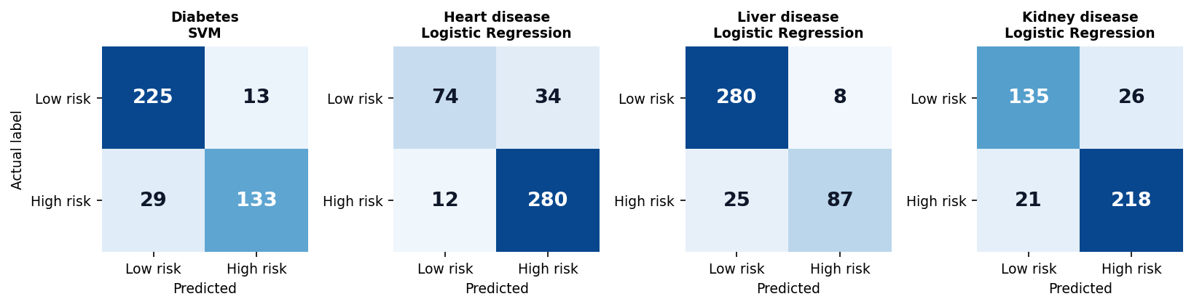
Figure 14: Confusion matrices of the served model for each disease (rows: actual label; columns: prediction)
The error types differ by disease. The diabetes model has few false alarms (13 of 238 low-risk rows) but misses 29 of 162 high-risk rows; the heart model does the opposite, flagging 34 of 108 low-risk rows and missing only 12 of 292; the liver model misses 25 of 112 high-risk rows; and the kidney model makes both kinds of error (26 false alarms, 21 misses). The heart behaviour follows from the class balance: with 73% positives, calling most records high-risk is rarely wrong.
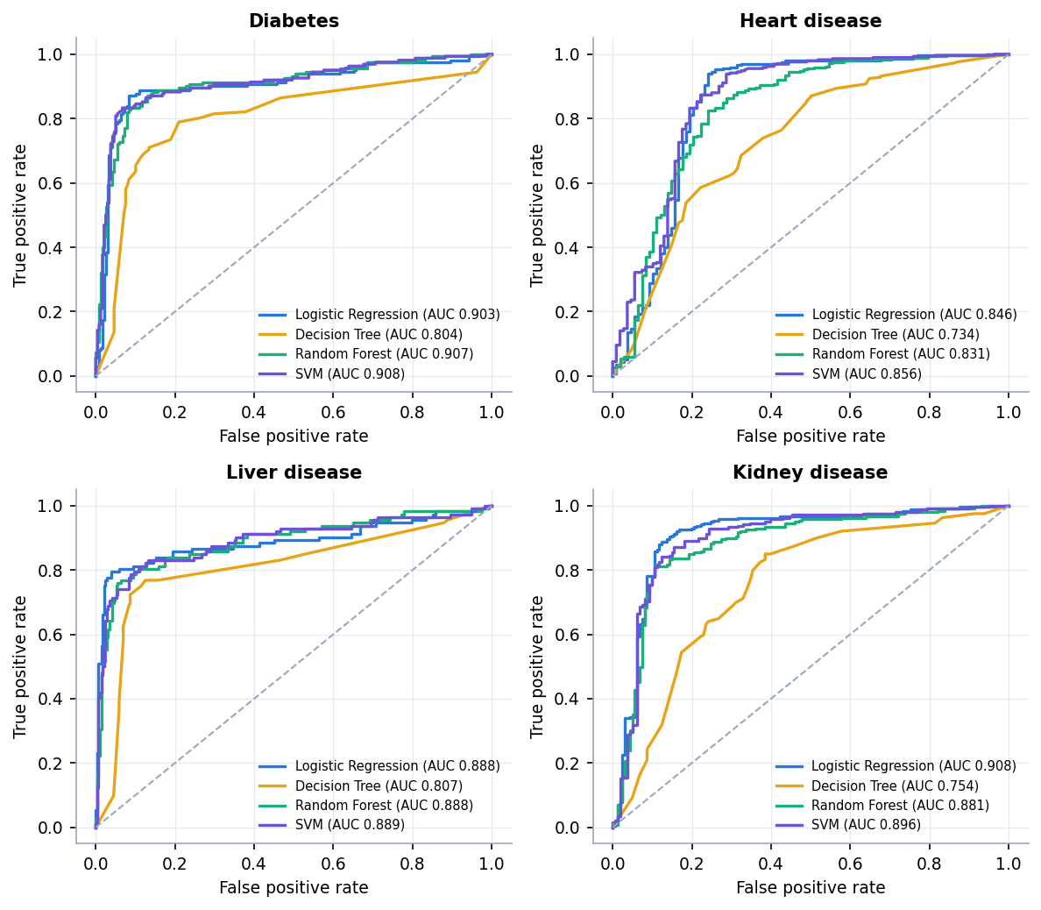
Figure 15: ROC curves of the four algorithms for each disease on the test split
ROC-AUC separates the algorithms less than accuracy does: for diabetes Logistic Regression, Random Forest and SVM have AUC 0.9034, 0.9070 and 0.9077, and for liver 0.8881, 0.8880 and 0.8890, so their ranking ability is practically the same even though Random Forest has lower accuracy and recall at the 0.5 cut-off. The Decision Tree has the lowest AUC for every disease (0.7339 to 0.8072).

8.4 Stability of the Model Choice
A 400-row test set with a single split gives noisy numbers, and the training script chooses the best model on that same test set. To see whether the choice survives, all four algorithms were re-evaluated by stratified 5-fold cross-validation and on ten further random 80/20 splits.
Table 38: 5-fold cross-validation and ten random splits (mean ± standard deviation)
Disease | Model | CV accuracy | CV F1 | CV ROC-AUC | Split accuracy | Best-F1 splits of 10
Diabetes | LR | 0.8955 ± 0.0062 | 0.8688 ± 0.0073 | 0.9083 ± 0.0116 | 0.8925 ± 0.0134 | 10
 | DT | 0.7990 ± 0.0116 | 0.7405 ± 0.0167 | 0.8116 ± 0.0169 | 0.8022 ± 0.0159 | 0
 | RF | 0.8545 ± 0.0073 | 0.8109 ± 0.0096 | 0.8996 ± 0.0117 | 0.8583 ± 0.0111 | 0
 | SVM | 0.8765 ± 0.0174 | 0.8429 ± 0.0225 | 0.9086 ± 0.0107 | 0.8675 ± 0.0147 | 0
Heart disease | LR | 0.9040 ± 0.0060 | 0.9361 ± 0.0044 | 0.8903 ± 0.0193 | 0.9037 ± 0.0142 | 10
 | DT | 0.7855 ± 0.0090 | 0.8589 ± 0.0066 | 0.7574 ± 0.0091 | 0.7665 ± 0.0129 | 0
 | RF | 0.8295 ± 0.0043 | 0.8931 ± 0.0022 | 0.8725 ± 0.0198 | 0.8310 ± 0.0090 | 0
 | SVM | 0.8860 ± 0.0155 | 0.9251 ± 0.0105 | 0.8817 ± 0.0164 | 0.8795 ± 0.0141 | 0
Liver disease | LR | 0.9035 ± 0.0110 | 0.8126 ± 0.0193 | 0.8835 ± 0.0044 | 0.9058 ± 0.0098 | 10
 | DT | 0.8650 ± 0.0143 | 0.7301 ± 0.0287 | 0.8168 ± 0.0253 | 0.8510 ± 0.0152 | 0
 | RF | 0.8785 ± 0.0060 | 0.7554 ± 0.0072 | 0.8833 ± 0.0102 | 0.8840 ± 0.0132 | 0
 | SVM | 0.8855 ± 0.0097 | 0.7677 ± 0.0176 | 0.8773 ± 0.0079 | 0.8872 ± 0.0119 | 0
Kidney disease | LR | 0.8780 ± 0.0153 | 0.8986 ± 0.0143 | 0.8991 ± 0.0104 | 0.8768 ± 0.0138 | 10
 | DT | 0.7160 ± 0.0140 | 0.7623 ± 0.0104 | 0.7488 ± 0.0170 | 0.7355 ± 0.0092 | 0
 | RF | 0.8245 ± 0.0099 | 0.8607 ± 0.0085 | 0.8776 ± 0.0097 | 0.8225 ± 0.0077 | 0
 | SVM | 0.8520 ± 0.0132 | 0.8790 ± 0.0107 | 0.8920 ± 0.0130 | 0.8540 ± 0.0065 | 0

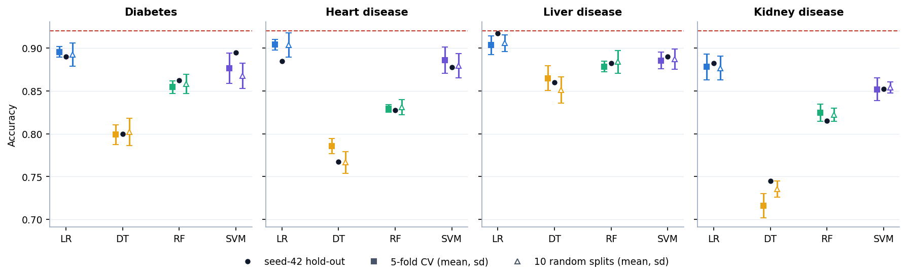
Figure 16: Accuracy on the seed-42 hold-out split, in 5-fold cross-validation and on ten random splits (error bars: one standard deviation; dashed line: 92% noise ceiling)
Logistic Regression has the best F1 on 10 of 10 splits for all four diseases, and the best or tied-best cross-validated accuracy. The diabetes row is the notable case: on the seed-42 split the SVM has the higher F1 (0.8636 against 0.8599), and train_models.py therefore saved the SVM; on cross-validation and on every one of the ten other splits Logistic Regression is better (CV accuracy 0.8955 against 0.8765; split accuracy 0.8925 against 0.8675). The difference on the chosen split is far inside the split-to-split standard deviation of about 0.013 to 0.015, so the selection picked a model that the other evidence does not support. Selecting on the same data that is then used to report the score also makes the reported figures slightly optimistic, a known source of bias in model selection [24]. A nested or separate validation split, as the base paper uses, would avoid it.

8.5 Over-fitting and Hyper-parameter Sensitivity
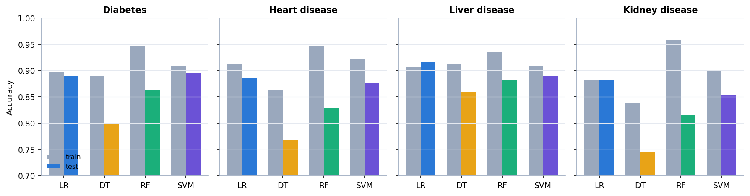
Figure 17: Training and test accuracy of the four algorithms for each disease
Random Forest fits the training rows to 93.6-95.9% but reaches only 81.5-88.3% on the test rows; its 200 trees of depth 8 fit the flipped labels. Logistic Regression's training and test accuracy are within about three points (heart 91.1% against 88.5%, the largest gap), which is what a model with few parameters on 1,600 rows should show.
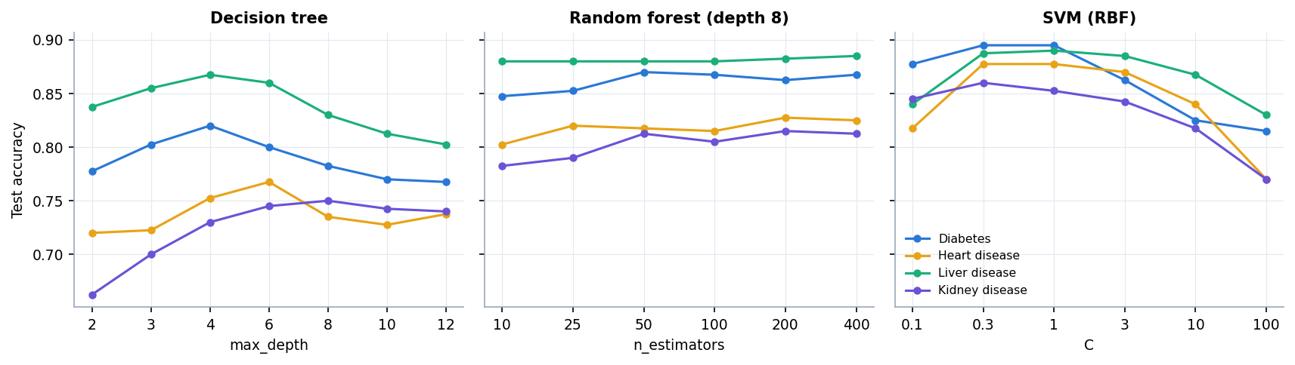
Figure 18: Test accuracy against decision-tree depth, forest size and SVM C, for the four diseases
The settings in train_models.py were never tuned and no grid search was run, so a sensitivity sweep shows how much was left on the table. Decision trees peak at depth 4 to 8 and decline beyond (diabetes 0.8200 at depth 4, 0.7675 at depth 12), random forests are flat beyond 50 trees, and the RBF SVM is best at C between 0.3 and 1 and falls to 0.7700-0.8300 at C = 100. The shipped settings (depth 6, 200 trees, C = 1) sit near the best values, so tuning would change the scores by a point or two, not more.

8.6 Decision-threshold Analysis
The application uses each model's own decision rule, which corresponds to a probability threshold of 0.5. The sweep below uses the predicted probability of the high-risk class of the served model on the test split (for the SVM this is the probability from Platt scaling, so its 0.50 row differs slightly from the predict result in Section 8.2).
Table 39: Effect of the decision threshold (served model, test split)
Disease | At 0.50: precision / recall / F1 | Best F1 threshold: F1 | Highest threshold with recall ≥ 0.90
Diabetes | 0.893 / 0.827 / 0.859 | 0.50: 0.859 | 0.20: P 0.656
Heart disease | 0.892 / 0.959 / 0.924 | 0.55: 0.926 | 0.60: P 0.911
Liver disease | 0.916 / 0.777 / 0.841 | 0.50: 0.841 | not reached (0.20-0.80)
Kidney disease | 0.893 / 0.912 / 0.903 | 0.50: 0.903 | 0.50: P 0.893

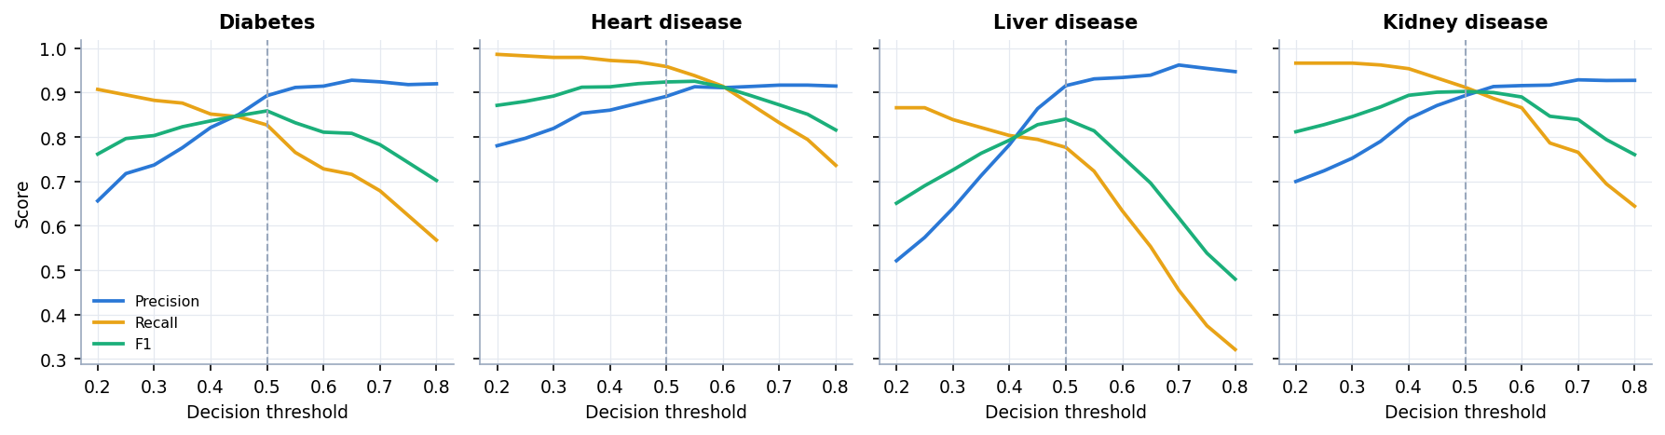
Figure 19: Precision, recall and F1 against the decision threshold for the four served models (dashed line: 0.5)
F1 is nearly flat around 0.5 for every disease; the best threshold is 0.55 for heart and 0.50 for the other three, so the default is reasonable. For a screening use, where missing a patient costs more than a false alarm, the threshold could be lowered: for diabetes recall reaches 0.907 at a threshold of 0.20, at the price of precision 0.656. For liver disease recall never reaches 0.90 in the range 0.20-0.80. The application does not let the user change the threshold; this is listed as future work.

8.7 Which Inputs Matter
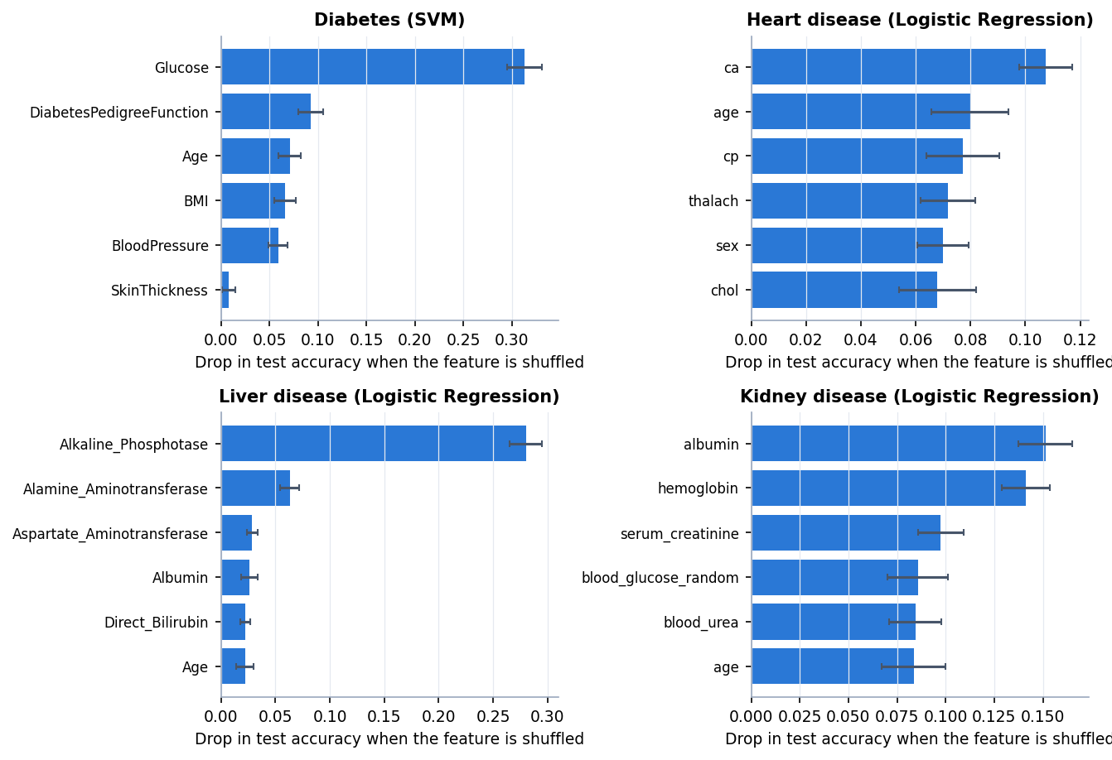
Figure 20: Permutation importance of the six strongest inputs for each served model (drop in test accuracy when the input is shuffled)
The three strongest inputs by permutation importance are, for each disease, diabetes: Glucose (0.313), DiabetesPedigreeFunction (0.092), Age (0.071); heart disease: ca (0.108), age (0.080), cp (0.077); liver disease: Alkaline_Phosphotase (0.280), Alamine_Aminotransferase (0.063), Aspartate_Aminotransferase (0.029); kidney disease: albumin (0.151), hemoglobin (0.141), serum_creatinine (0.097). They are the inputs that carry the largest weight in the risk rule inside generate_data.py, which is expected because the labels were built from that rule; the analysis confirms that the models recover it. It was run offline for this report. The application itself does not show which inputs drove a prediction, so the sixth objective is only partly met (Section 8.13).

8.8 Supplementary Check on Real Public Data
Because the main results rest on synthetic data, the same four algorithms with the same settings were also trained and cross-validated on public data sets with the matching columns: the Pima Indians Diabetes data [12], the Cleveland heart-disease data [14], the Indian Liver Patient data (ILPD) [16] and the chronic kidney disease data [15]. Missing values (Pima zeros treated as missing, and the blank cells counted in the table below) were filled with the median inside each fold; the check is a supplementary script and is not part of the application.
Table 40: Real data sets used in the supplementary check
Disease | Source | Rows | Positive / negative | Missing cells | Majority-class rate
Diabetes | Pima Indians Diabetes (NIDDK), 768 rows | 768 | 268 / 500 | 652 | 65.1%
Heart disease | UCI Heart Disease, Cleveland, 303 rows | 303 | 139 / 164 | 6 | 54.1%
Liver disease | UCI ILPD (Indian Liver Patient), 583 rows | 583 | 416 / 167 | 4 | 71.4%
Kidney disease | UCI Chronic Kidney Disease, 400 rows (12 of 24 attributes) | 400 | 250 / 150 | 541 | 62.5%

Table 41: (a) Algorithms trained and cross-validated on the real data (5-fold, repeated 3 times)
Disease | Model | Accuracy | F1 | ROC-AUC
Diabetes | LR | 0.765 ± 0.031 | 0.621 | 0.836
 | DT | 0.734 ± 0.040 | 0.609 | 0.762
 | RF | 0.759 ± 0.031 | 0.628 | 0.834
 | SVM | 0.758 ± 0.024 | 0.612 | 0.827
Heart disease | LR | 0.843 ± 0.042 | 0.822 | 0.909
 | DT | 0.761 ± 0.050 | 0.731 | 0.763
 | RF | 0.836 ± 0.052 | 0.814 | 0.911
 | SVM | 0.839 ± 0.033 | 0.818 | 0.900
Liver disease | LR | 0.718 ± 0.027 | 0.822 | 0.751
 | DT | 0.671 ± 0.033 | 0.777 | 0.681
 | RF | 0.706 ± 0.036 | 0.810 | 0.753
 | SVM | 0.712 ± 0.006 | 0.831 | 0.657
Kidney disease | LR | 0.976 ± 0.015 | 0.981 | 0.999
 | DT | 0.974 ± 0.014 | 0.979 | 0.972
 | RF | 0.988 ± 0.011 | 0.991 | 1.000
 | SVM | 0.982 ± 0.013 | 0.985 | 0.999

Table 42: (b) The shipped (synthetic-trained) models applied to every real record
Disease | Shipped model | Accuracy | Recall | ROC-AUC | Predicted positive | Majority baseline
Diabetes | SVC | 0.750 | 0.649 | 0.796 | 35.4% | 65.1%
Heart disease | LogisticRegression | 0.696 | 0.957 | 0.884 | 72.3% | 54.1%
Liver disease | LogisticRegression | 0.540 | 0.380 | 0.745 | 28.8% | 71.4%
Kidney disease | LogisticRegression | 0.823 | 0.716 | 0.992 | 44.8% | 62.5%

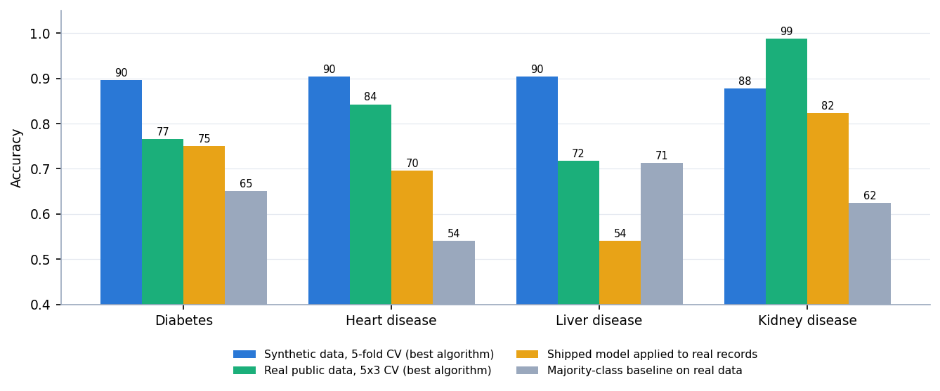
Figure 21: Accuracy on synthetic data (CV), on real data (CV) and of the shipped models on real records, with the majority-class baseline
Findings. (1) On real data the best algorithm reaches 76.5% for diabetes, 84.3% for heart disease, 71.8% for liver disease and 98.8% for kidney disease, against 87.8-90.4% in cross-validation on the synthetic data; the kidney set is almost separable, the others are much noisier than the synthetic data. (2) The shipped models transfer only partly: their ROC-AUC on real records is 0.796, 0.884, 0.745 and 0.992, so the ranking of risk carries over, but the 0.5 decision rule does not fit real populations. For liver disease the shipped model's accuracy of 54.0% is below the 71.4% majority-class baseline (it flags only 28.8% of patients, while 71.4% of the records are positive). (3) The heart codes (chest-pain type, slope, thalassemia) had to be recoded to the project's coding, and the thalassemia mapping is arbitrary. The more honest estimate of how this method behaves on patients is therefore the real-data table, and the application must not be used for clinical decisions.

8.9 Testing and Performance
Table 43: API checks (41 of 41 passed in scripts/api_tests.py)
Group | Passed | What is checked
Functional | 24 / 24 | Every endpoint, both classes, all four diseases; metadata matches the form fields
Consistency | 2 / 2 | API prediction equals a direct model.predict on 40 sampled rows; the same input twice gives the same output
Validation | 14 / 14 | Missing, empty, text, NaN, infinite and null values give 422; unknown disease 404; malformed JSON 422; wrong method 405
Sanity | 1 / 1 | An extreme low-risk and an extreme high-risk diabetes record are classified correctly
Smoke test | 27 / 27 | scripts/smoke_test.py: health, lists, report, datasets, samples and predictions for each disease, invalid input and unknown disease

Two observations are recorded but are not failures: the API accepts physiologically impossible values (a glucose of 100,000 mg/dL returns High Risk with 60.94%, an age of -5 returns High Risk with 74.61%), because the only range check is a warning in the web form. There is no pytest suite, no frontend test, no security test (the application has no sign-in) and no load test beyond the one below.
Table 44: Measured API latency on 127.0.0.1 (200 calls after 10 warm-up calls)
Request | Median (ms) | 95th percentile (ms) | Max (ms)
GET /api/health | 12.9 | 25.0 | 27.0
GET /api/diseases | 14.6 | 25.1 | 63.0
GET /api/diseases/diabetes | 16.4 | 26.9 | 29.8
POST /api/predict/diabetes | 13.5 | 24.9 | 27.4
POST /api/predict/heart | 14.4 | 25.0 | 26.2
POST /api/predict/diabetes (4 concurrent clients) | 5.1 | 25.1 | 29.5

Figure 22: Median and 95th-percentile latency of the API routes
A prediction takes about 14 ms at the median and about 25 ms at the 95th percentile; with four concurrent clients the service handled 416 requests per second. Windows timer resolution (about 15.6 ms) quantises single-call timings and the machine was under memory pressure from other programs while these were taken, so the values are upper bounds and a prediction takes well under 25 ms in practice. In process, fitting the four diabetes models takes 12 ms (Logistic Regression), 9 ms (Decision Tree), 304 ms (Random Forest) and 188 ms (SVM), and predicting one row takes 0.0001 to 0.0335 ms.

8.10 Comparison with the Base Paper
The base paper [1] diagnoses thyroid disease on a real data set, so its results are not comparable with this project's; the comparison is for context and is not a like-for-like comparison. The two differ in disease, data, class structure and evaluation protocol.
Table 45: Base paper compared with this project
Aspect | Base paper (Alam et al., 2026) | This project
Disease(s) | Thyroid status (Normal, Hypothyroid, Hyperthyroid), three classes | Diabetes, heart, liver and kidney disease, each a binary high-risk / low-risk task
Data | UCI thyroid data, 7,200 samples, 21 features, strongly imbalanced, real | Four synthetic CSVs of 2,000 rows each (8,000 rows); real data only in a supplementary check
Classifiers | SVC, Random Forest, Extra Trees, AdaBoost, CatBoost | Logistic Regression, Decision Tree, Random Forest, SVM
Evaluation | Nested cross-validation (5 outer folds, 3-fold inner grid search); full set and top-10 features | One 80/20 hold-out split with fixed settings, plus cross-validation and ten splits as extra checks
Imbalance | SMOTE tried and rejected (minority recall improved by under 2%) | Not applied; not needed on the synthetic class balance
Reported performance | Random Forest accuracy and F1 0.996-0.997, ROC-AUC 0.999-1.000; SVC accuracy 0.965-0.967, ROC-AUC 0.990-0.992 | Served models: accuracy 88.3%-91.8%, ROC-AUC 0.8455-0.9077 on synthetic data; 71.8-98.8% accuracy on real data
Explainability | SHAP and counterfactual explanations | None in the application (offline permutation importance only)
Scope | One disease, a modelling study | Four diseases behind one web interface, with a prediction API

The project reuses the base paper's idea of comparing several classical classifiers by held-out evaluation and extends the scope from one disease to four behind a single interface. It does not reproduce the thyroid experiment, and its lower figures on real data (71.8-98.8% accuracy) should not be read against the paper's 0.99+, which is for a different, much more separable task and uses nested cross-validation and tuning that this project does not.

8.11 Success and Failure Cases
• Success. The application predicts for all four diseases in a few milliseconds, the API handled every malformed request with a clear 422 or 404, and for a low-risk and a high-risk sample record of each disease the models agree with the label in most cases (screens in Section 8.12).
• Success. For every disease the served model is within about four points of the 92% accuracy that the label noise allows, so the pipeline recovers the rule the data were built from.
• Failure: missed patients. The diabetes model misses 29 of 162 high-risk test rows and the liver model 25 of 112; for a screening tool these false negatives are the costly error.
• Failure: false alarms. The heart model flags 34 of 108 low-risk rows. Screen 20 shows one: a record labelled low-risk is classified Positive (High Risk) with a displayed confidence of 99.53%.
• Failure: confidence is not correctness. The percentage shown is the model's probability for the class it predicted (50-100%), not the chance that the prediction is right; the false positive above has the highest confidence of any screen.
• Failure: transfer to real records. The shipped liver model scores 54.0% on real ILPD records, below the 71.4% majority baseline; the diabetes (75.0% against 65.1%), heart (69.6% against 54.1%) and kidney (82.3% against 62.5%) models stay above the baseline but far below their synthetic-data scores.
• Failure: no range validation. Impossible values such as glucose 100,000 are accepted by the API and classified.
• Failure: model choice. The diabetes model is an SVM although Logistic Regression is better on cross-validation and on ten of ten splits.

8.12 Output Screens
The screens were captured from the running application at 1440 x 900 (Chrome driven by Playwright, scripts capture_screens.py and capture_extra.py). The prediction screens use real rows drawn from the training CSV by the "Positive sample" and "Negative sample" buttons; the Datasets screen carries the application's own warning that the data are synthetic. Screens that do not show a prediction (landing, about, not-found) are in Appendix C.
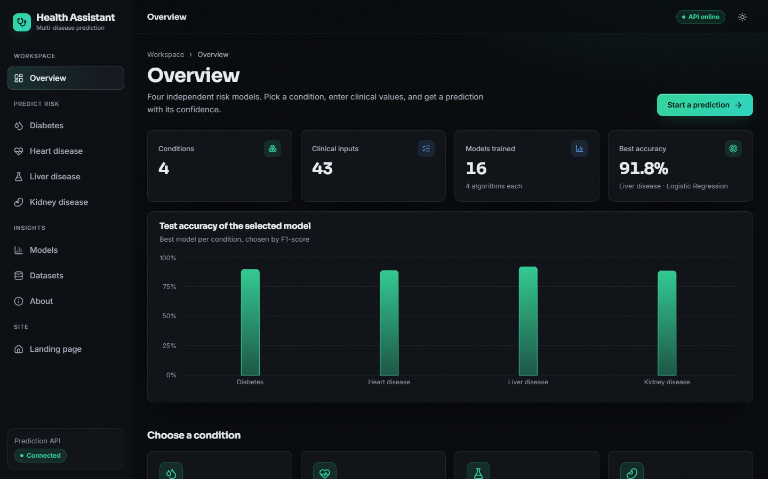  Figure 23: Overview page: four conditions, 43 clinical inputs, 16 models trained, best accuracy 91.8% (liver, Logistic Regression) and the test accuracy of the selected model for each condition | 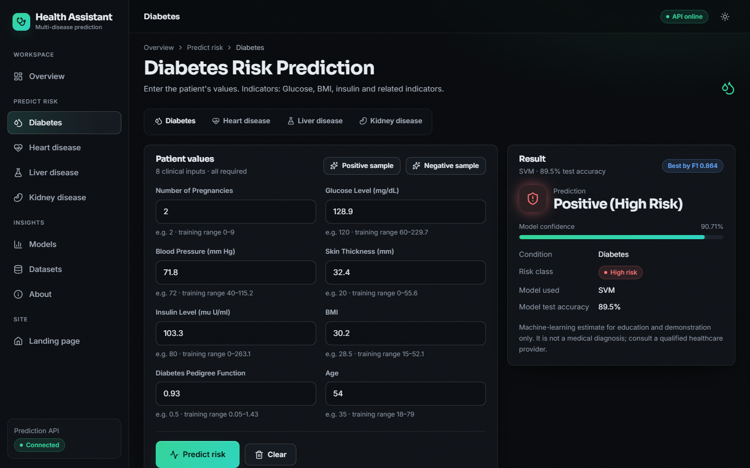  Figure 24: Diabetes prediction for a positive sample: Positive (High Risk), confidence 90.71%, SVM, test accuracy 89.5%

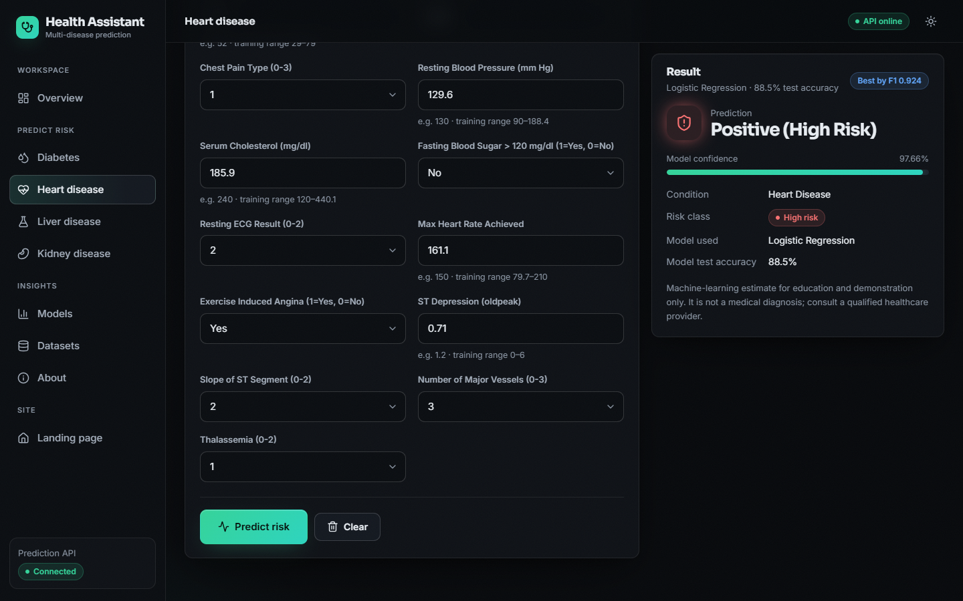  Figure 25: Heart disease prediction for a positive sample (Logistic Regression) | 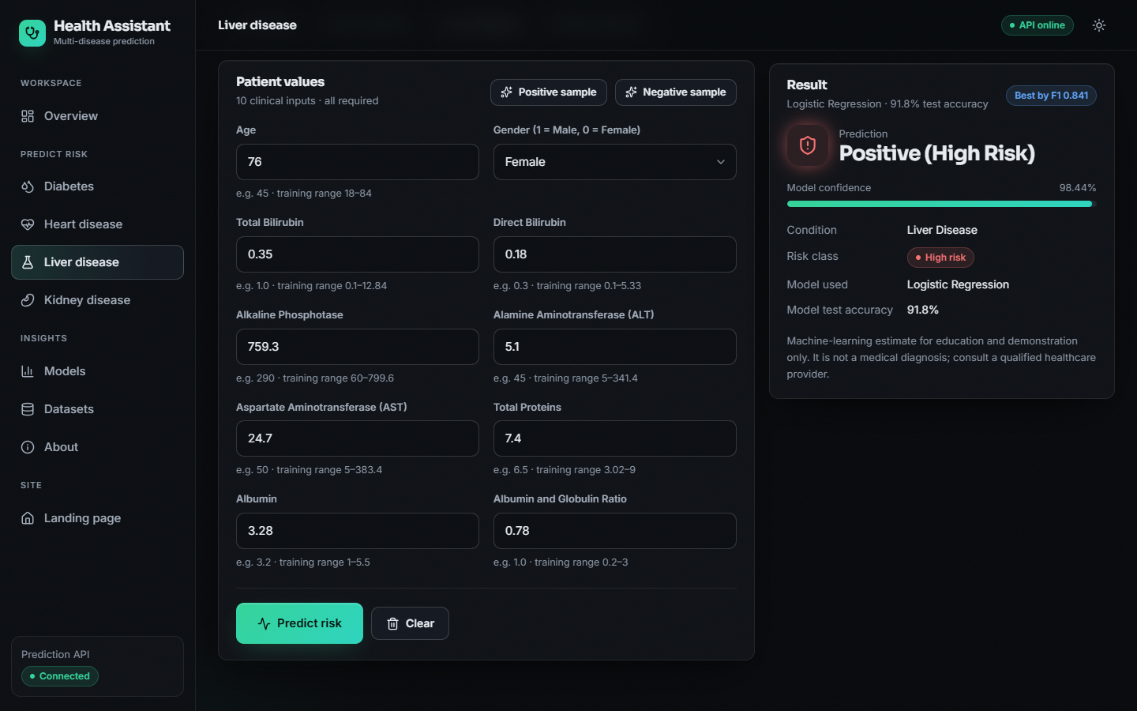  Figure 26: Liver disease prediction for a positive sample (Logistic Regression)

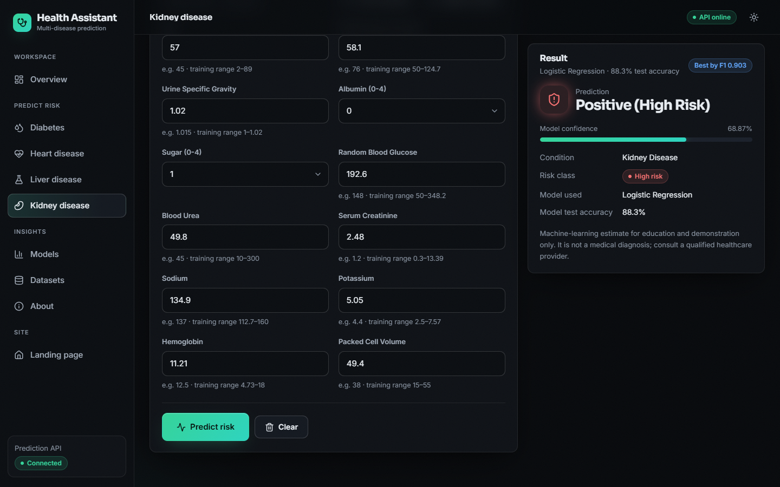  Figure 27: Kidney disease prediction for a positive sample (Logistic Regression) | 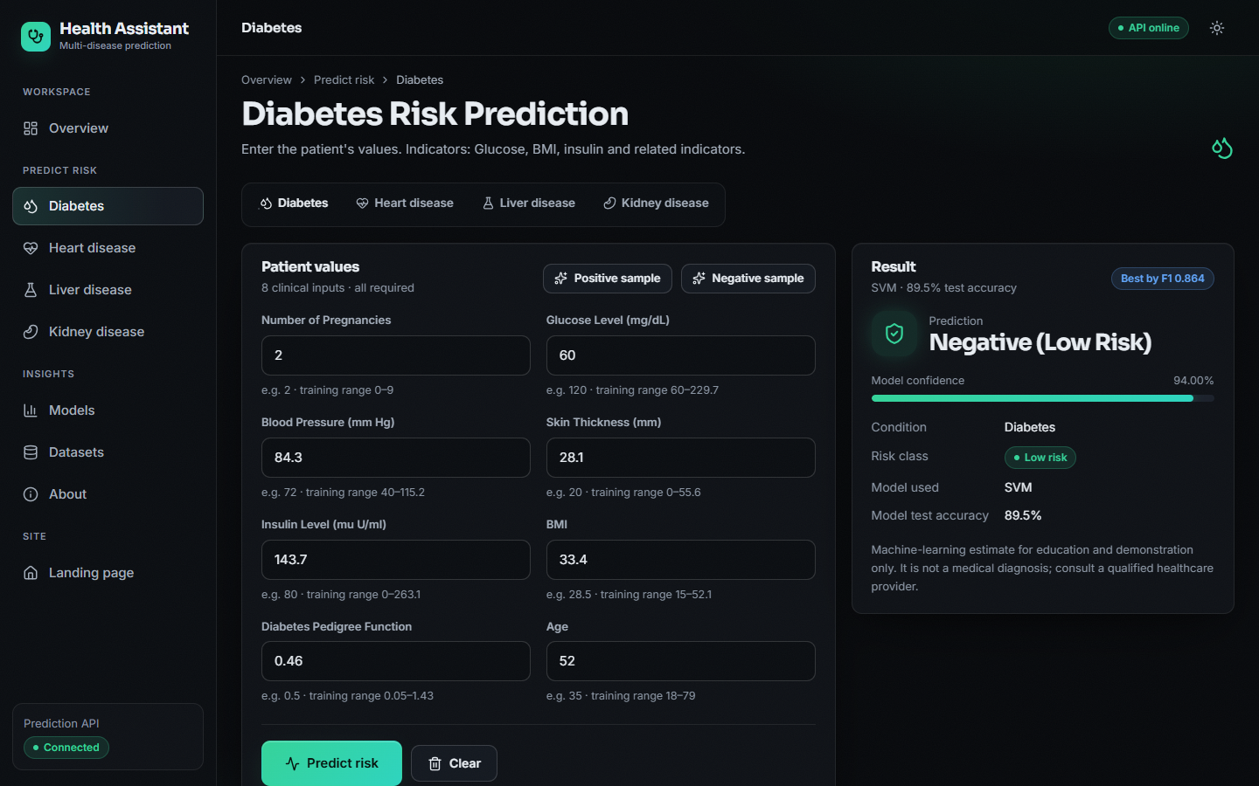  Figure 28: Diabetes prediction for a negative sample classified Negative (Low Risk)

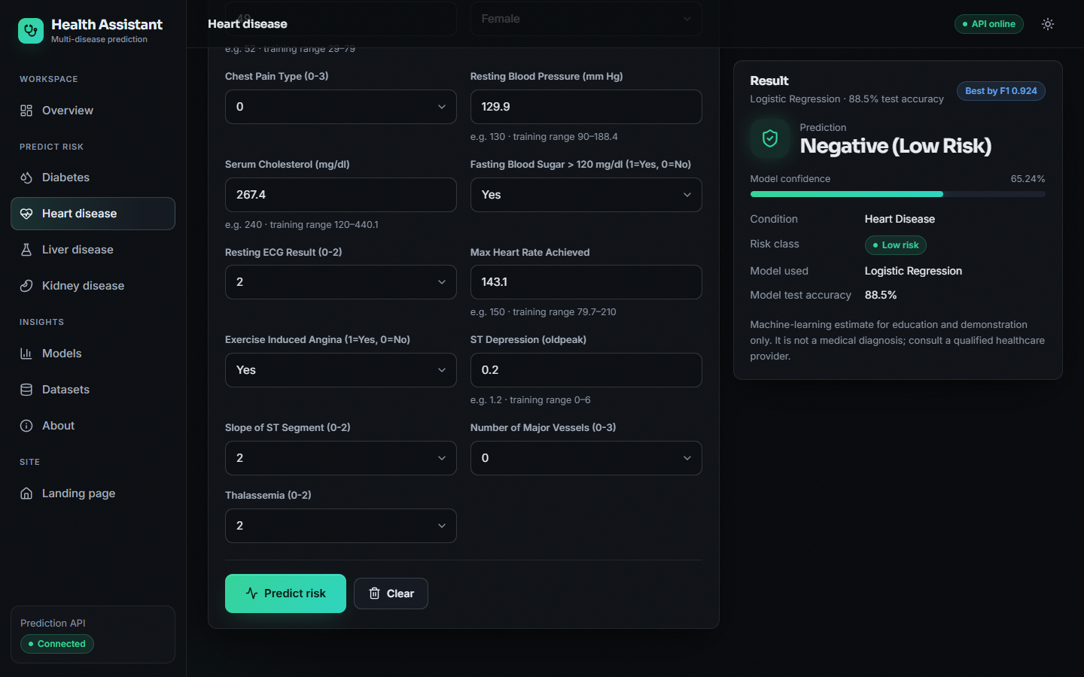  Figure 29: Heart disease prediction for a negative sample classified Low Risk | 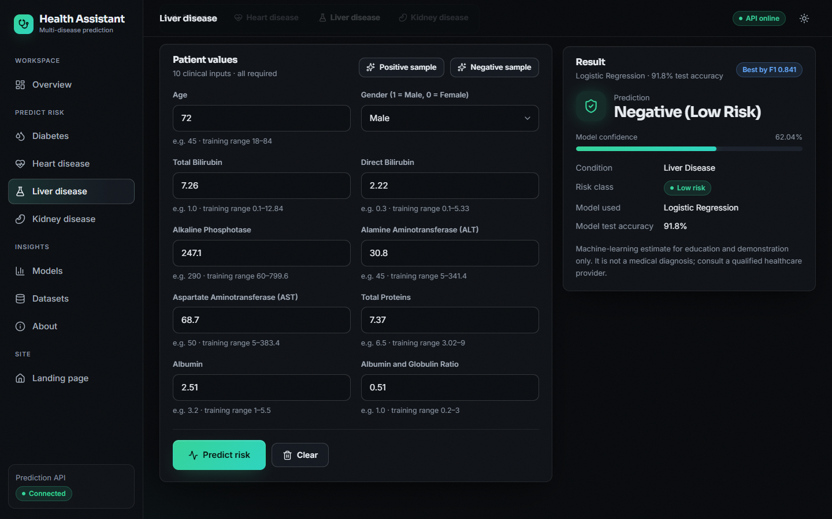  Figure 30: Liver disease prediction for a negative sample classified Negative (Low Risk)

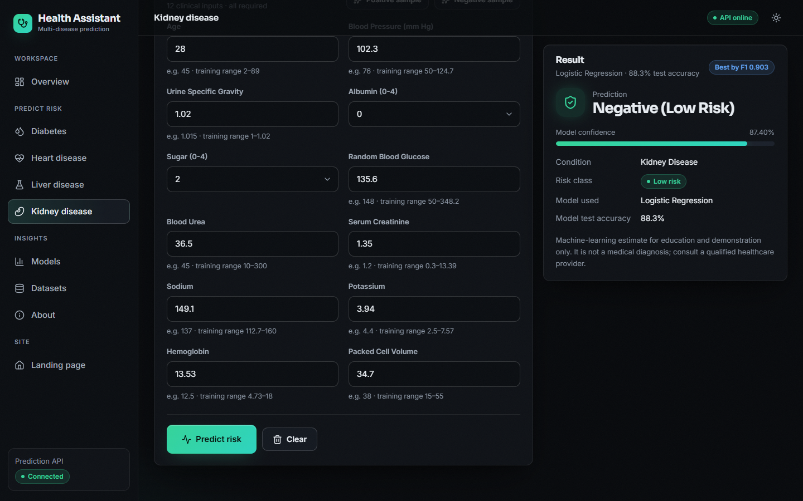  Figure 31: Kidney disease prediction for a negative sample classified Low Risk | 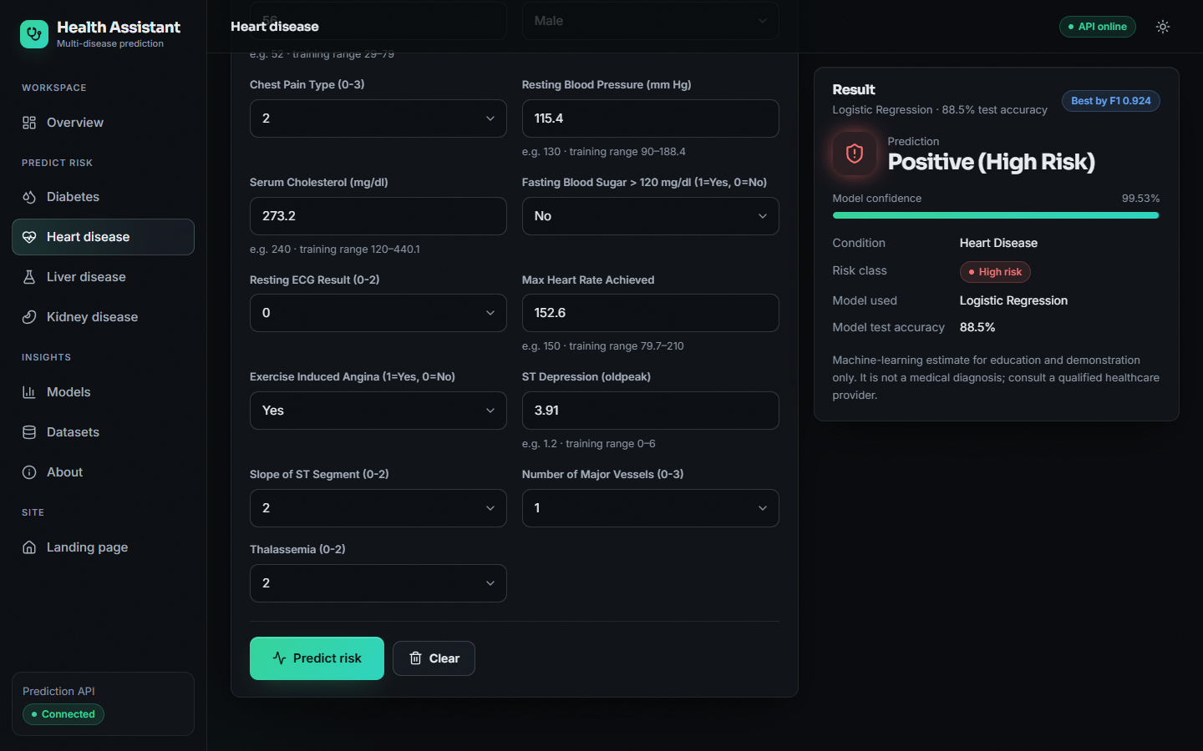  Figure 32: Failure case: a heart record labelled low-risk in the data that the model classifies Positive (High Risk) with 99.53% confidence

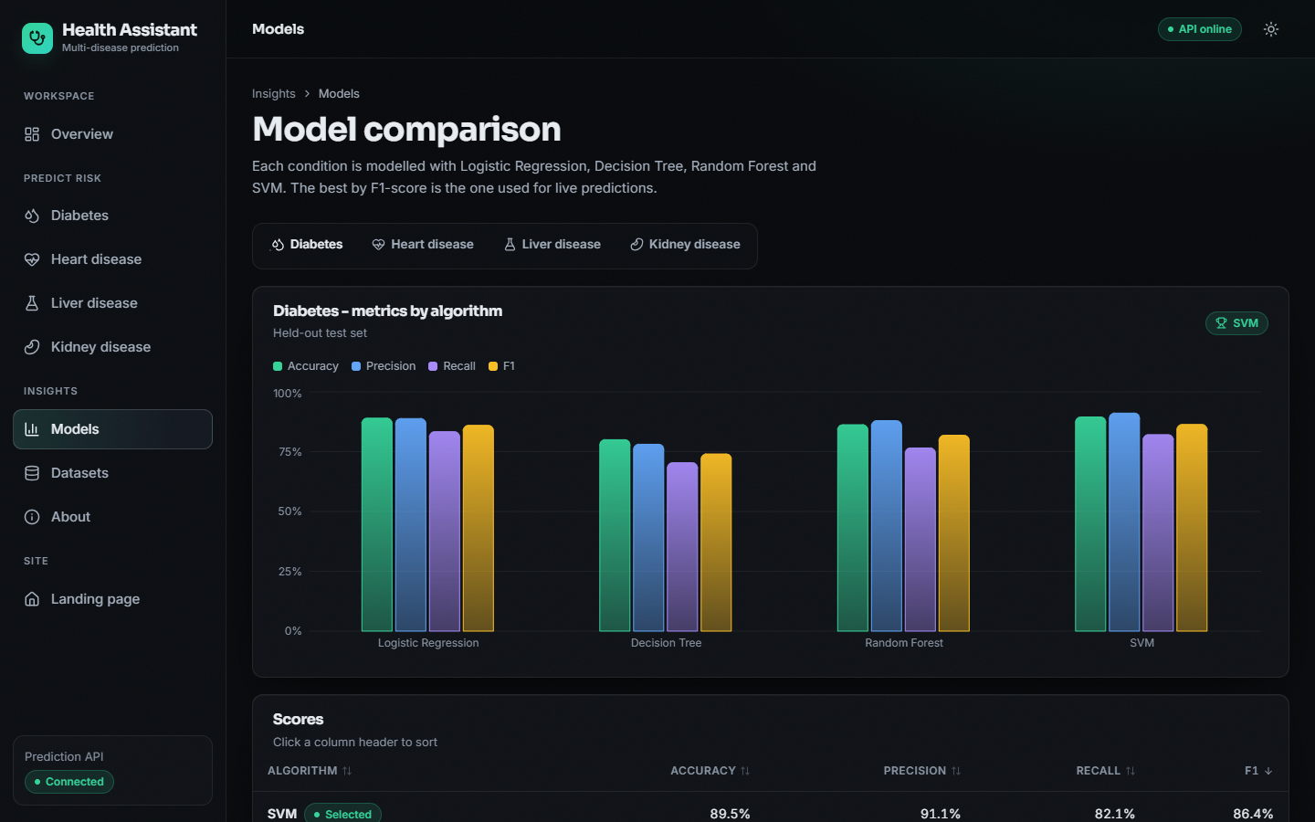  Figure 33: Models page: metric bars and sortable score table for the four algorithms (diabetes tab) | 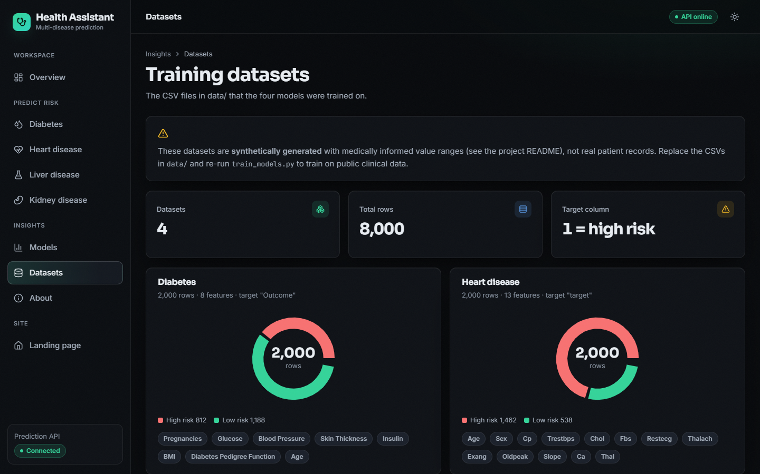  Figure 34: Datasets page: row counts and class balance of the four CSV files, with the warning that they are synthetic

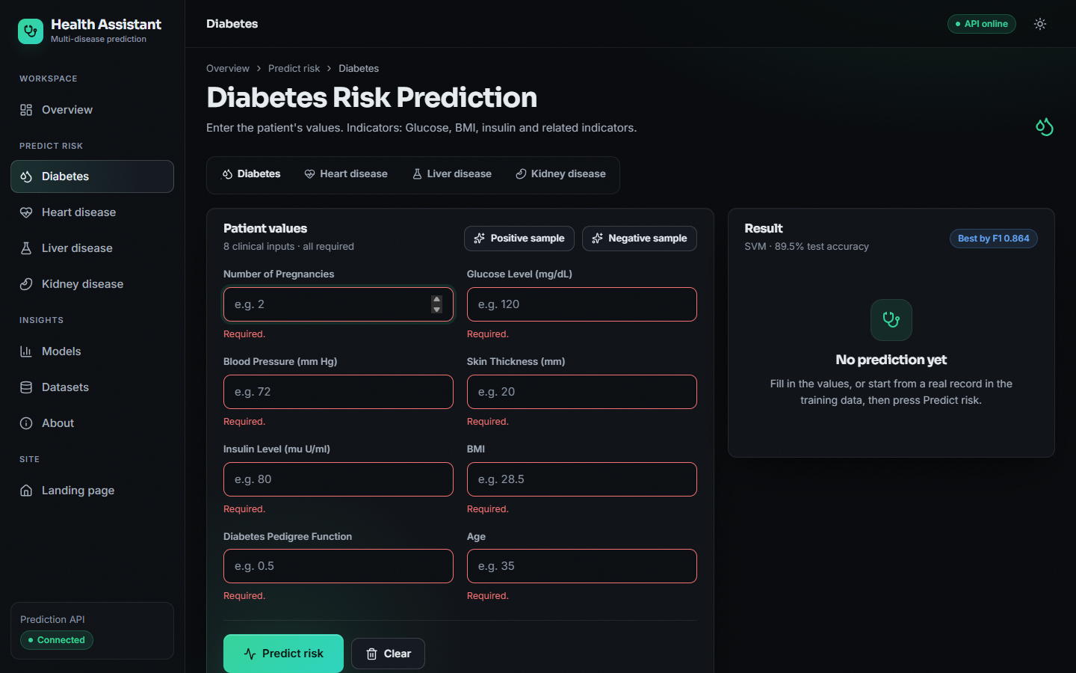  Figure 35: Validation: pressing Predict on an empty diabetes form marks all eight fields as required and does not call the API | 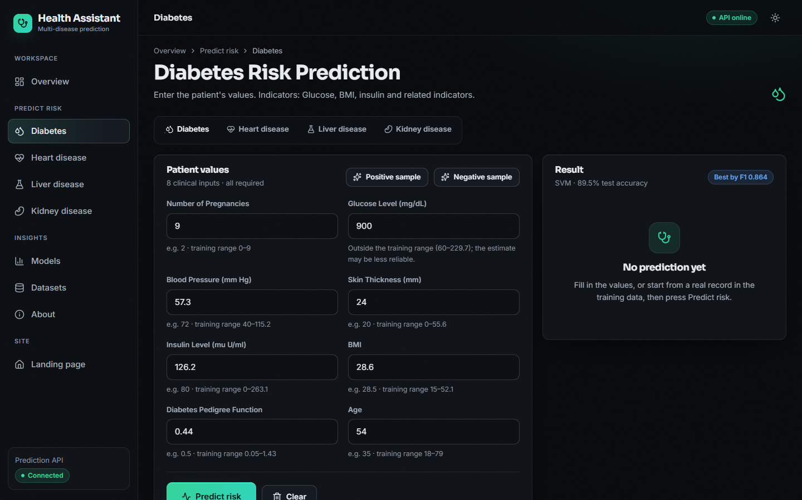  Figure 36: Out-of-range warning: a glucose of 900 mg/dL is outside the training range (60-229.7) and the form warns that the estimate may be less reliable

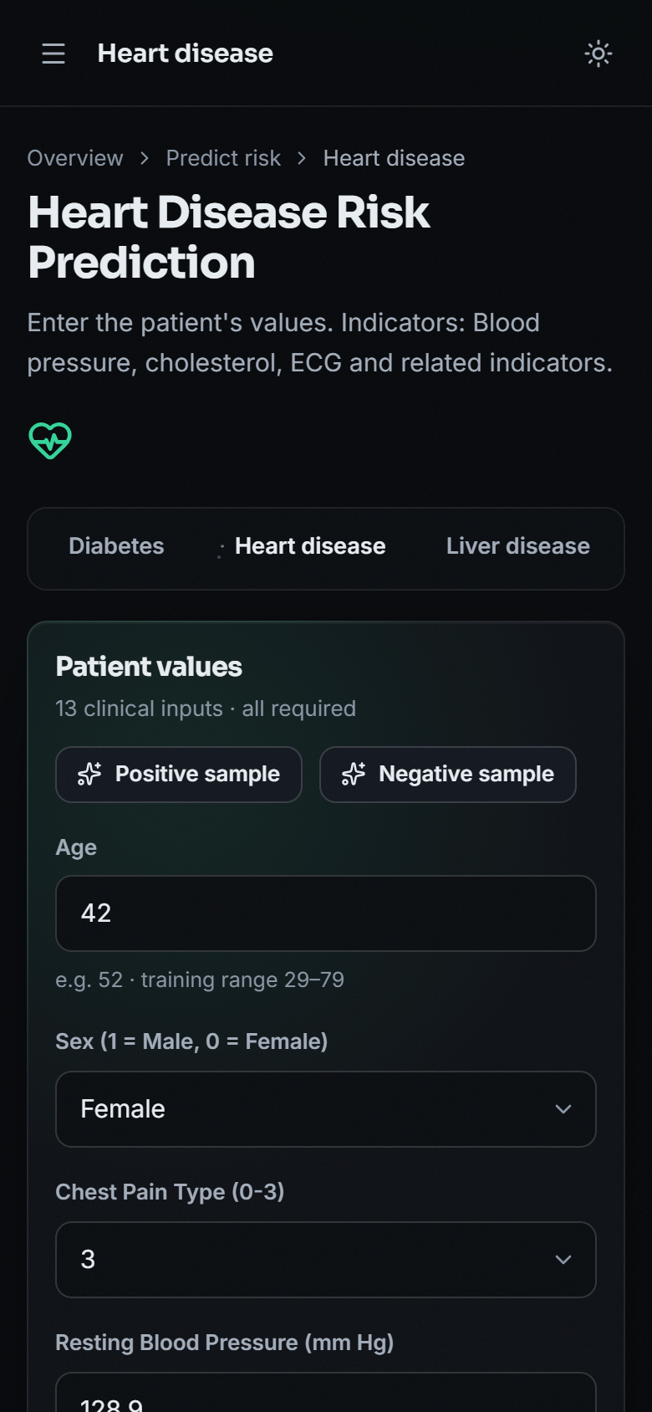
Figure 37: Phone layout (390 x 844 px): the heart form with a sample loaded and the sidebar collapsed into a menu

8.13 Objectives versus Outcomes
Table 46: Objectives of the project against what was measured
# | Objective | Status | Evidence
1 | Collect and clean benchmark datasets covering diabetes, heart disease, liver and kidney disorders. | PARTLY | Four datasets of 2,000 rows each exist, but they are synthetic (generated by generate_data.py), not benchmark data. Real benchmark data was used only in a separate supplementary check.
2 | Handle missing values, outliers and feature scaling through a common preprocessing pipeline. | PARTLY | All inputs pass through one StandardScaler step. The synthetic data contains no missing values or outliers, so no imputation or outlier handling was written.
3 | Train and compare Logistic Regression, Decision Tree, Random Forest and Support Vector Machine for each disease. | ACHIEVED | 16 models (4 algorithms x 4 diseases) were trained on the same split with fixed settings and compared.
4 | Select the best model per disease using accuracy, precision, recall and ROC-AUC. | PARTLY | Selection is by F1 on the test set. Accuracy, precision and recall are reported by the training script; ROC-AUC was not part of it and was measured afterwards in run_experiments.py.
5 | Serve the selected models behind a single interface that accepts one patient record. | ACHIEVED | A FastAPI + React application serves the four selected models through 7 API routes; 41 of 41 API checks passed. Each disease has its own form.
6 | Present a per-disease risk indication together with the parameters that drove it. | PARTLY | The risk class and the model's confidence are shown. The parameters that drove each prediction are not shown in the application; permutation importance exists only as an offline analysis.

Two further promises in the abstract are not met: the system does not produce "healthcare recommendations" and it does not perform feature selection. The result card shows only the class, the confidence and a not-a-diagnosis notice.

8.14 Discussion and Threats to Validity
• What the results support. The pipeline works end to end for four diseases; four classical algorithms can be compared fairly on one split; a linear model recovers a linear rule best; and an interface and API around the models respond in milliseconds.
• What they do not support. Any claim about accuracy on patients; a claim that Random Forest or SVM is better than Logistic Regression here; calibrated probabilities; or clinical usefulness.
• Data validity. The data are synthetic and the label is built from the same features the model sees, so the relationships are cleaner and more linear than in real data; the real-data check shows the gap.
• Statistical validity. Each test set has 400 rows (112 to 292 high-risk), so single-split differences of one to two points are noise; cross-validation and ten splits were added for that reason.
• Selection bias. The served model is chosen on the same test set that reports its score.
• Explanation validity. Importance was computed offline on the same data and mirrors the generator; it says nothing about clinical causes.
• Comparability. The base paper [1] and this project use different diseases, data and protocols; the metrics are not comparable.

CHAPTER 9: CONCLUSION

9.1 Summary of the Work
This project set out to replace one-disease-at-a-time screening tools with a single system that estimates the risk of diabetes, heart disease, liver disease and kidney disease from routine clinical values. It built a data generator, a training script that fits and compares Logistic Regression, a Decision Tree, a Random Forest and an RBF Support Vector Machine for each disease on standardised inputs and saves the model with the highest F1, a Flask application that loads the saved models, a FastAPI service with seven routes that reuses the same prediction code, and a React web interface with a prediction form for each disease, a model-comparison page, a dataset page and a not-a-diagnosis notice. Around these, the project added the measurements that the training script does not make: ROC-AUC, confusion matrices, cross-validation, repeated splits, threshold sweeps, permutation importance, a real-data check and API tests.
On the 400-row test sets of the synthetic data, the served models reach accuracy 89.5% (diabetes, SVM), 88.5% (heart disease, Logistic Regression), 91.8% (liver disease, Logistic Regression) and 88.3% (kidney disease, Logistic Regression), close to the 92% ceiling that the 8% label noise allows. Cross-validation and ten random splits show that Logistic Regression is the best model for every disease on every split, including diabetes, where the SVM was shipped on the strength of a single split; Random Forest and the Decision Tree fit the noisy labels and score lower. On real public data the same algorithms reach 76.5% (Pima diabetes), 84.3% (Cleveland heart), 71.8% (ILPD liver) and 98.8% (chronic kidney disease), and the shipped models transfer only partly: for liver disease their accuracy of 54.0% is below the 71.4% majority-class baseline.

9.2 Objectives Revisited
Table 47: Outcome against the six objectives
No. | Objective | Outcome | Evidence
1 | Collect and clean benchmark datasets covering diabetes, heart disease, liver and kidney disorders. | PARTLY | Four datasets of 2,000 rows each exist, but they are synthetic (generated by generate_data.py), not benchmark data.
2 | Handle missing values, outliers and feature scaling through a common preprocessing pipeline. | PARTLY | All inputs pass through one StandardScaler step.
3 | Train and compare Logistic Regression, Decision Tree, Random Forest and Support Vector Machine for each disease. | ACHIEVED | 16 models (4 algorithms x 4 diseases) were trained on the same split with fixed settings and compared.
4 | Select the best model per disease using accuracy, precision, recall and ROC-AUC. | PARTLY | Selection is by F1 on the test set.
5 | Serve the selected models behind a single interface that accepts one patient record. | ACHIEVED | A FastAPI + React application serves the four selected models through 7 API routes; 41 of 41 API checks passed.
6 | Present a per-disease risk indication together with the parameters that drove it. | PARTLY | The risk class and the model's confidence are shown.

Three objectives are met only in part, and the conclusions are written accordingly: the data are synthetic rather than benchmark data, there is no missing-value or outlier handling because the synthetic data contain none, ROC-AUC was not part of model selection, and the application does not show which parameters drove a prediction.

9.3 Key Findings
1. One interface for four diseases works. A single API and web application serve sixteen trained models; a prediction takes about 14 ms at the median on the project machine, and 41 of 41 API checks pass.
2. Synthetic accuracy measures the rule, not the patient. The generator's label rule is linear with 8% flipped labels, so about 92% is the best any model can do; the models reach 88-92% and a linear model is the right family.
3. The simple model is the best model. Logistic Regression has the best F1 on 10 of 10 splits for all four diseases, the highest cross-validated accuracy, and the smallest gap between training and test accuracy.
4. Model selection on one split can be wrong. The shipped diabetes model (SVM, F1 0.8636) is not supported by cross-validation, where Logistic Regression is better.
5. Real data are harder. Accuracy falls to 71.8-84.3% for three of the four diseases, and a model trained on synthetic data can fall below the majority-class baseline on real records.
6. A displayed confidence is not an accuracy. The shown percentage is the probability of the predicted class, and a false positive can be displayed with 99.53%.

9.4 Practical Applications
The system is suitable as a teaching and demonstration aid: it shows how four classical classifiers are trained, compared and served behind one interface, how a model is wrapped in an API and a web form, and how much the numbers depend on the data. With real, validated training data and the additions in Chapter 10 it could become a screening aid in settings with few specialists, helping a health worker decide whom to refer for a confirmatory laboratory test. It is not a diagnostic tool, it has not been validated on patients, and the application says so on every result.

9.5 Known Limitations
The limitations are discussed in full in the Scope and Limitations document; the main ones are:
• The training data are synthetic; the metrics are not clinical performance and cannot be compared with published results on real data.
• Selection of the served model uses the same 400-row test set that reports its score, with fixed settings and no tuning.
• No missing-value or outlier handling, no calibration and no per-prediction explanation; the application's confidence is the probability of the predicted class.
• No range validation: impossible values such as a glucose of 100,000 mg/dL are classified.
• No sign-in, database, audit log or stored history; no pytest suite, usability study, fairness analysis or external validation.

9.6 Concluding Remarks
The project shows that a multi-disease screening pipeline can be built from open-source parts, run on a desktop in seconds, and audited honestly: every number in this report can be regenerated by a script, and the places where the evidence is weak are stated. It follows the base paper [1] in comparing several classifiers by held-out evaluation and in treating interpretability as essential for clinical trust, but it does not reach the paper's rigour (nested cross-validation, real data, SHAP and counterfactual explanations). The next step, described in Chapter 10, is to repeat the evaluation on real patient data with proper validation before anyone relies on the output.

CHAPTER 10: FUTURE SCOPE
The work leaves several directions open. They are ordered by how much they would change the value of the system.
1. Train and validate on real data. Replace the synthetic CSVs by the public benchmark data (Pima, Cleveland, ILPD, chronic kidney disease) or, better, local clinical records, add median or model-based imputation and outlier handling inside the pipeline, and report the real-data results of Section 8.8 as the headline. This addresses the main weakness of the present work.
2. Nested cross-validation and tuning. Follow the base paper: choose hyper-parameters and the algorithm in an inner loop and report an outer-loop estimate, so that model selection no longer uses the reported test set. This would also settle the diabetes choice.
3. Explain every prediction. Add SHAP values and counterfactual "what would change the result" explanations, as in the base paper, and show the driving parameters on the result card; the offline permutation analysis of this report is a starting point.
4. Calibrate and expose the threshold. Apply Platt scaling or isotonic regression on a validation split so that the percentage can be read as a risk, show a reliability curve, and let the user choose the decision threshold for a screening or a confirmatory use.
5. Validate inputs clinically. Reject or flag physiologically impossible values on the server, not only in the form, and show units and reference ranges next to each field.
6. Recommendations and referral guidance. Generate the "healthcare recommendations" promised in the abstract from reviewed clinical rules, with wording approved by a clinician, and link each to a confirmatory test.
7. More conditions and one-record scoring. Add further diseases (for example thyroid, as in the base paper) and score one patient record against all conditions at once, with a combined summary and a missing-value policy for fields that were not measured.
8. Stronger models. Try gradient-boosted trees and calibrated linear models, keep Logistic Regression as the interpretable baseline, and compare with fairness across sex and age groups.
9. Production foundations. Add accounts with roles, an audit log, versioned model storage and a database; containerise the API and the web application; add a pytest suite, frontend tests and a load test.
10. Deployment and scalability. The measured API handled about 415 requests per second on one desktop with four clients, which is ample for a clinic. Beyond that, run several stateless workers behind a reverse proxy; the models are small pickle files.
11. Further research. Study how a screening aid changes referral behaviour in a rural health centre, how explanations affect trust, and whether models trained on one population transfer to another, which the liver result of this report shows to be the critical question.
The first four are the most important: they address the main weakness of this report (synthetic data), the main weakness of the model choice (selection on the reported test set), the main gap against the base paper (explanations) and the main weakness of the output (an uncalibrated confidence).

REFERENCES
[1] M. Z. Alam, R. Rahman, H. M. Sozib, H. Ahmed, A. Hossain, A. A. Sabeena, A. F. Tasnim, F. Ahmed, M. I. Sarkar, and T. I. Erdei, "Enhancing thyroid disease diagnosis with machine learning and counterfactual explainable AI," IEEE Access, vol. 14, pp. 80346-80370, 2026, doi: 10.1109/ACCESS.2026.3663497.
[2] R. Zannat, A. Al Shafi, and A. Muntakim, "Bridging the gap in Bangla healthcare: Machine learning based disease prediction using a symptoms-disease dataset," in Proc. Int. Conf. Elect., Comput. Commun. Eng. (ECCE), Chattogram, Bangladesh, Feb. 2025, doi: 10.1109/ECCE64574.2025.11012950 (arXiv:2601.12068).
[3] J. Al Nahian, A. K. M. Masum, S. Abujar, and M. J. Mia, "Common human diseases prediction using machine learning based on survey data," arXiv:2209.10750, Sep. 2022 (accepted in Bull. Elect. Eng. Informat.).
[4] V. Kamakshamma, G. M. Sumanth, K. R. G. N. K. Reddy, B. Pallavi, and C. S. Varshini, "Multi-disease prediction system using machine learning," in Proc. 1st Int. Conf. Res. Develop. Inf., Commun., Comput. Technol. (ICRDICCT), vol. 2. SCITEPRESS, 2025, pp. 116-127, doi: 10.5220/0013878600004919.
[5] A. Sun and F. Sun, "Prediction of diabetes using supervised classification," J. Emerg. Investigators, Mar. 2024, doi: 10.59720/23-062.
[6] M. A. Islam, M. Z. H. Majumder, and M. A. Hussein, "Chronic kidney disease prediction based on machine learning algorithms," J. Pathol. Inform., vol. 14, Art. no. 100189, 2023, doi: 10.1016/j.jpi.2023.100189.
[7] I. Straw and H. Wu, "Investigating for bias in healthcare algorithms: A sex-stratified analysis of supervised machine learning models in liver disease prediction," BMJ Health Care Inform., vol. 29, no. 1, Art. no. e100457, 2022, doi: 10.1136/bmjhci-2021-100457.
[8] A. Salekin and J. Stankovic, "Detection of chronic kidney disease and selecting important predictive attributes," in Proc. IEEE Int. Conf. Healthcare Informat. (ICHI), 2016, pp. 262-270, doi: 10.1109/ICHI.2016.36.
[9] T. Choudhury, A. Sar, A. Katal, S. Aich, and P. Joshi, "Kidney disease prediction by machine learning techniques," in Machine Learning for Disease Detection, Prediction, and Diagnosis. Singapore: Springer Nature, 2025, pp. 171-190, doi: 10.1007/978-981-96-4241-0_9.
[10] A. Thakur and A. Kumar, "Introduction to deep learning for disease prediction," in Machine Learning for Disease Detection, Prediction, and Diagnosis. Singapore: Springer Nature, 2025, pp. 33-66, doi: 10.1007/978-981-96-4241-0_3.
[11] M. Patil, N. Shinde, R. K. Sharma, S. Kadam, and S. Kashte, "Skin disease prediction using machine learning techniques," in Machine Learning for Disease Detection, Prediction, and Diagnosis. Singapore: Springer Nature, 2025, pp. 225-256, doi: 10.1007/978-981-96-4241-0_12.
[12] J. W. Smith, J. E. Everhart, W. C. Dickson, W. C. Knowler, and R. S. Johannes, "Using the ADAP learning algorithm to forecast the onset of diabetes mellitus," in Proc. Annu. Symp. Comput. Appl. Med. Care, 1988, pp. 261-265.
[13] R. Detrano, A. Janosi, W. Steinbrunn, M. Pfisterer, J. J. Schmid, S. Sandhu, K. H. Guppy, S. Lee, and V. Froelicher, "International application of a new probability algorithm for the diagnosis of coronary artery disease," Amer. J. Cardiol., vol. 64, no. 5, pp. 304-310, Aug. 1989, doi: 10.1016/0002-9149(89)90524-9.
[14] A. Janosi, W. Steinbrunn, M. Pfisterer, and R. Detrano, "Heart Disease," UCI Machine Learning Repository, 1989 (303 instances, 13 features), doi: 10.24432/C52P4X.
[15] L. Rubini, P. Soundarapandian, and P. Eswaran, "Chronic Kidney Disease," UCI Machine Learning Repository, 2015 (400 instances, 24 features), doi: 10.24432/C5G020.
[16] B. Ramana and N. Venkateswarlu, "ILPD (Indian Liver Patient Dataset)," UCI Machine Learning Repository, 2012 (583 instances, 10 features), doi: 10.24432/C5D02C.
[17] F. Pedregosa et al., "Scikit-learn: Machine learning in Python," J. Mach. Learn. Res., vol. 12, pp. 2825-2830, 2011.
[18] L. Breiman, "Random forests," Mach. Learn., vol. 45, no. 1, pp. 5-32, 2001, doi: 10.1023/A:1010933404324.
[19] C. Cortes and V. Vapnik, "Support-vector networks," Mach. Learn., vol. 20, no. 3, pp. 273-297, 1995, doi: 10.1007/BF00994018.
[20] D. W. Hosmer Jr., S. Lemeshow, and R. X. Sturdivant, Applied Logistic Regression. Hoboken, NJ, USA: Wiley, 2013, doi: 10.1002/9781118548387.
[21] S. M. Lundberg and S.-I. Lee, "A unified approach to interpreting model predictions," in Proc. Adv. Neural Inf. Process. Syst. (NIPS), vol. 30, 2017, arXiv:1705.07874.
[22] S. Wachter, B. Mittelstadt, and C. Russell, "Counterfactual explanations without opening the black box: Automated decisions and the GDPR," arXiv:1711.00399, 2017 (Harvard J. Law Technol., 2018).
[23] N. V. Chawla, K. W. Bowyer, L. O. Hall, and W. P. Kegelmeyer, "SMOTE: Synthetic minority over-sampling technique," J. Artif. Intell. Res., vol. 16, pp. 321-357, 2002, doi: 10.1613/jair.953.
[24] S. Varma and R. Simon, "Bias in error estimation when using cross-validation for model selection," BMC Bioinformatics, vol. 7, Art. no. 91, 2006, doi: 10.1186/1471-2105-7-91.
[25] D. Chicco and G. Jurman, "The advantages of the Matthews correlation coefficient (MCC) over F1 score and accuracy in binary classification evaluation," BMC Genomics, vol. 21, Art. no. 6, 2020, doi: 10.1186/s12864-019-6413-7.
[26] T. Saito and M. Rehmsmeier, "The precision-recall plot is more informative than the ROC plot when evaluating binary classifiers on imbalanced datasets," PLoS ONE, vol. 10, no. 3, Art. no. e0118432, 2015, doi: 10.1371/journal.pone.0118432.

APPENDIX A: IMPORTANT CODE
The listings are copied from the code base at build time, so they are exactly what runs. Only the most important parts are shown; the complete source is in 8.ProjectCode.

A.1 Data generation (generate_data.py)
The label noise function and the diabetes generator; the heart, liver and kidney generators follow the same pattern with their own risk scores.
def add_noise_labels(risk_score, noise=0.08):
"""Convert a continuous risk score into a binary label with some label noise."""
prob = 1 / (1 + np.exp(-risk_score))
flip = np.random.rand(len(prob)) < noise
labels = (prob > 0.5).astype(int)
labels[flip] = 1 - labels[flip]
return labels

def generate_diabetes(n=N):
age = np.random.randint(18, 80, n)
pregnancies = np.random.randint(0, 10, n)
glucose = np.random.normal(120, 30, n).clip(60, 250)
blood_pressure = np.random.normal(72, 12, n).clip(40, 130)
skin_thickness = np.random.normal(20, 10, n).clip(0, 60)
insulin = np.random.normal(80, 60, n).clip(0, 400)
bmi = np.random.normal(30, 7, n).clip(15, 55)
dpf = np.random.normal(0.47, 0.3, n).clip(0.05, 2.5)

risk = (
0.04 * (glucose - 120)
+ 0.06 * (bmi - 30)
+ 0.02 * (age - 40)
+ 1.5 * dpf
+ 0.03 * (blood_pressure - 72)
- 1.4
)
outcome = add_noise_labels(risk)

df = pd.DataFrame({
"Pregnancies": pregnancies,
"Glucose": glucose.round(1),
"BloodPressure": blood_pressure.round(1),
"SkinThickness": skin_thickness.round(1),
"Insulin": insulin.round(1),
"BMI": bmi.round(1),
"DiabetesPedigreeFunction": dpf.round(3),
"Age": age,
"Outcome": outcome,
})
return df

A.2 Training and model selection (train_models.py)
# (imports, the DISEASES feature lists and the output folder are omitted)
MODEL_BUILDERS = {
"Logistic Regression": lambda: LogisticRegression(max_iter=1000, random_state=RANDOM_STATE),
"Decision Tree": lambda: DecisionTreeClassifier(max_depth=6, random_state=RANDOM_STATE),
"Random Forest": lambda: RandomForestClassifier(n_estimators=200, max_depth=8, random_state=RANDOM_STATE),
"SVM": lambda: SVC(kernel="rbf", C=1.0, probability=True, random_state=RANDOM_STATE),
}

report = {}

for disease, cfg in DISEASES.items():
print(f"\n{'='*60}\nTraining models for: {disease.upper()}\n{'='*60}")
df = pd.read_csv(cfg["csv"])
X = df[cfg["features"]].values
y = df[cfg["target"]].values

X_train, X_test, y_train, y_test = train_test_split(
X, y, test_size=0.2, random_state=RANDOM_STATE, stratify=y
)

scaler = StandardScaler()
X_train_s = scaler.fit_transform(X_train)
X_test_s = scaler.transform(X_test)

results = {}
fitted_models = {}
for name, builder in MODEL_BUILDERS.items():
model = builder()
model.fit(X_train_s, y_train)
preds = model.predict(X_test_s)
acc = accuracy_score(y_test, preds)
prec = precision_score(y_test, preds, zero_division=0)
rec = recall_score(y_test, preds, zero_division=0)
f1 = f1_score(y_test, preds, zero_division=0)
results[name] = {
"accuracy": round(acc, 4),
"precision": round(prec, 4),
"recall": round(rec, 4),
"f1": round(f1, 4),
}
fitted_models[name] = model
print(f" {name:22s} | Acc: {acc:.4f} Prec: {prec:.4f} Rec: {rec:.4f} F1: {f1:.4f}")

best_name = max(results, key=lambda n: results[n]["f1"])
best_model = fitted_models[best_name]
print(f" --> Best model: {best_name} (F1={results[best_name]['f1']})")

joblib.dump(best_model, f"models/{disease}_model.pkl")
joblib.dump(scaler, f"models/{disease}_scaler.pkl")
joblib.dump(cfg["features"], f"models/{disease}_features.pkl")

report[disease] = {
"best_model": best_name,
"all_results": results,
"features": cfg["features"],
}

with open("models/training_report.json", "w") as f:
json.dump(report, f, indent=2)

print("\nAll models trained and saved to ./models/")
print("Summary written to models/training_report.json")

A.3 Model loading and the Flask prediction handler (app.py)
def load_bundle(disease):
model = joblib.load(os.path.join(MODELS_DIR, f"{disease}_model.pkl"))
scaler = joblib.load(os.path.join(MODELS_DIR, f"{disease}_scaler.pkl"))
features = joblib.load(os.path.join(MODELS_DIR, f"{disease}_features.pkl"))
return model, scaler, features

BUNDLES = {d: load_bundle(d) for d in ["diabetes", "heart", "liver", "kidney"]}

def handle_prediction(disease):
model, scaler, features = BUNDLES[disease]
fields = FIELD_META[disease]
result = None
probability = None
submitted_values = {}

if request.method == "POST":
try:
values = []
for feat in features:
raw = request.form.get(feat, "0")
submitted_values[feat] = raw
values.append(float(raw))
X = np.array(values).reshape(1, -1)
X_scaled = scaler.transform(X)
pred = model.predict(X_scaled)[0]
if hasattr(model, "predict_proba"):
proba = model.predict_proba(X_scaled)[0]
probability = round(float(max(proba)) * 100, 2)
result = "Positive (High Risk)" if pred == 1 else "Negative (Low Risk)"
except Exception as e:
result = f"Error: please check your inputs ({e})"

best_model_name = TRAINING_REPORT[disease]["best_model"]
best_acc = TRAINING_REPORT[disease]["all_results"][best_model_name]["accuracy"]

return render_template(
"predict.html",
disease=disease,
title=DISEASE_TITLES[disease],
features=features,
fields=fields,
result=result,
probability=probability,
submitted_values=submitted_values,
model_name=best_model_name,
accuracy=best_acc,
)

A.4 FastAPI service (backend/main.py)
The routes that return the disease list, the sample record, the prediction, the training report and the dataset summary.
@api.get("/api/diseases")
def diseases():
return [_summary(d) for d in BUNDLES]

@api.get("/api/diseases/{d}/sample")
def sample(d: str, outcome: int | None = None):
"""A real row from the training dataset, to pre-fill the form."""
_check(d)
df = DATA[d]
if outcome in (0, 1):
df = df[df[TARGETS[d]] == outcome]
row = df.sample(1).iloc[0]
feats = BUNDLES[d][2]
return {"values": {f: float(row[f]) for f in feats}, "label": int(row[TARGETS[d]])}

@api.post("/api/predict/{d}")
def predict(d: str, body: PredictBody):
_check(d)
model, scaler, features = BUNDLES[d]
values, missing = [], []
for f in features:
raw = body.values.get(f)
try:
v = float(raw)
if not math.isfinite(v):
raise ValueError
except (TypeError, ValueError):
missing.append(FIELD_META[d][f][0])
continue
values.append(v)
if missing:
raise HTTPException(422, "Please enter a valid number for: " + ", ".join(missing) + ".")

# same steps as app.handle_prediction
X_scaled = scaler.transform(np.array(values).reshape(1, -1))
pred = int(model.predict(X_scaled)[0])
probability = None
if hasattr(model, "predict_proba"):
probability = round(float(max(model.predict_proba(X_scaled)[0])) * 100, 2)
name, m = _best(d)
return {
"disease": d,
"title": TITLES[d],
"positive": pred == 1,
"result": "Positive (High Risk)" if pred == 1 else "Negative (Low Risk)",
"probability": probability,
"model": name,
"accuracy": m["accuracy"],
}

@api.get("/api/report")
def report():
return REPORT

@api.get("/api/datasets")
def datasets():
out = []
for d, df in DATA.items():
t = TARGETS[d]
pos = int((df[t] == 1).sum())
out.append(
{
"key": d,
"title": TITLES[d],
"rows": int(len(df)),
"positive": pos,
"negative": int(len(df)) - pos,
"target": t,
"features": BUNDLES[d][2],
"synthetic": True,
}
)
return out

A.5 Form validation and submission (frontend/src/pages/Predict.jsx)
function validate(fields, values) {
const errors = {}
for (const f of fields) {
const raw = String(values[f.name] ?? '').trim()
if (raw === '') errors[f.name] = 'Required.'
else if (!Number.isFinite(Number(raw))) errors[f.name] = 'Enter a number.'
}
return errors
}

const submit = async (e) => {
e?.preventDefault()
const errs = validate(info.fields, values)
setErrors(errs)
if (Object.keys(errs).length) {
document.getElementById(`f-${info.fields.find((f) => errs[f.name]).name}`)?.focus()
return
}
setRun({ status: 'loading', data: null, error: null })
try {
const payload = Object.fromEntries(info.fields.map((f) => [f.name, Number(values[f.name])]))
const data = await api.predict(info.key, payload)
setRun({ status: 'done', data, error: null })
toast({ tone: 'success', title: data.result, message: `${info.title.replace(' Risk Prediction', '')} · confidence ${data.probability?.toFixed(1)}%` })
requestAnimationFrame(() => {
resultRef.current?.focus({ preventScroll: true })
resultRef.current?.scrollIntoView({ block: 'nearest', behavior: 'smooth' })
})
} catch (error) {
setRun({ status: 'error', data: null, error })
}
}

A.6 Real-data recoding and metrics (scripts/real_data_check.py)
How the real records are mapped to the project's coding before the shipped models are applied, and the metric helper used by the supplementary check.
def recode_for_shipped(d, X):
"""Map real-data coding to the coding the synthetic CSVs (and so the shipped models) use."""
X = X.copy()
if d == "heart":
X["cp"] = X["cp"] - 1 # Cleveland 1-4 -> 0-3
X["slope"] = X["slope"] - 1 # 1-3 -> 0-2
X["thal"] = X["thal"].map({3: 0, 6: 1, 7: 2}) # arbitrary ordinal; thal carries no weight in the generator
return X

def mets(y, pred, score):
return {"accuracy": float(accuracy_score(y, pred)), "precision": float(precision_score(y, pred, zero_division=0)),
"recall": float(recall_score(y, pred, zero_division=0)), "f1": float(f1_score(y, pred, zero_division=0)),
"roc_auc": float(roc_auc_score(y, score))}

APPENDIX B: INSTALLATION AND USER GUIDE

B.1 Prerequisites
• Windows 10 or 11 (the project was built and measured on Windows 11); Python 3.11 with pip (3.9 or later is accepted by the README); Node.js 18 or later with npm (Node 24 was used); a current browser (Chrome was used for all screens).
• About 1 GB of free disk space for the Python environment and the frontend/node_modules folder, and about 500 MB of free memory while the app runs.
• Internet access for the first run only, to install packages. The trained models and the data are already in the project folder.

B.2 One-command start
Open the folder 8.ProjectCode and double-click run.bat, or run it from a terminal. It creates the venv environment and installs requirements.txt on the first run (the pinned scikit-learn 1.8.0 is required because the models were saved with that version), installs the frontend packages, starts the API and the web application in two windows, and opens the browser.
cd 8.ProjectCode
run.bat

:: API: http://127.0.0.1:8303 (interactive docs at /docs)
:: Web app: http://127.0.0.1:5303
:: Original Flask pages (optional): venv\Scripts\python app.py -> http://127.0.0.1:5000

The ports are read from .env (BACKEND_PORT=8303, FRONTEND_PORT=5303, VITE_API_URL=http://127.0.0.1:8303). The API accepts browser requests only from localhost:5303 and 127.0.0.1:5303. A manual start is:
python -m venv venv
venv\Scripts\pip install -r requirements.txt
venv\Scripts\python -m uvicorn backend.main:api --port 8303

cd frontend
npm install
npm run dev # http://127.0.0.1:5303
npm run build # production build into frontend/dist

B.3 First five minutes
1. Open http://127.0.0.1:5303 and press Open app (there is no sign-in).
2. On the Overview page read the four conditions, the number of models trained and the test accuracy of the selected model of each condition.
3. Choose a condition in the left menu, for example Diabetes. The form shows eight inputs with an example value and the range seen in the training data.
4. Press Positive sample or Negative sample to fill the form with a real row of the training CSV, or type your own values. Every field is required; a value outside the training range shows a warning but is still accepted.
5. Press Predict risk. The result card shows Positive (High Risk) or Negative (Low Risk), the model's confidence, the model used and its test accuracy. The label of a sample is not a promise: the model may disagree with it.
6. Open Models to compare the four algorithms by accuracy, precision, recall and F1 (sortable table), and Datasets to see the size and class balance of each CSV and the warning that the data are synthetic.
7. Use the sun icon at the top right to switch between the dark and light themes.

B.4 The pages
Table 48: Pages of the web application
Page | Address | What it does
Landing | / | Introduction, how it works, the conditions and headline numbers
Overview | /app | Four conditions, models trained, best accuracy, accuracy chart, links to the forms
Predict | /app/predict/diabetes (also heart, liver, kidney) | Input form, sample buttons, validation, result card
Models | /app/models | Metric bars and a sortable score table for the four algorithms of each condition
Datasets | /app/data | Rows, class balance and feature list of the four CSV files; synthetic-data warning
About | /app/about | What the project does, tech stack and medical disclaimer
Not found | any other address | A message with a link back to the application

B.5 Calling the API directly
curl http://127.0.0.1:8303/api/diseases
curl "http://127.0.0.1:8303/api/diseases/diabetes/sample?outcome=1"
curl -X POST http://127.0.0.1:8303/api/predict/diabetes ^
-H "Content-Type: application/json" ^
-d "{\"values\": {\"Pregnancies\": 2, \"Glucose\": 128.9, \"BloodPressure\": 71.8, \"SkinThickness\": 32.4, \"Insulin\": 103.3, \"BMI\": 30.2, \"DiabetesPedigreeFunction\": 0.93, \"Age\": 54}}"

B.6 Reproducing the numbers in this report
venv\Scripts\python generate_data.py :: regenerate data/*.csv (seed 42)
venv\Scripts\python train_models.py :: retrain, rewrite models/*.pkl and training_report.json
venv\Scripts\python scripts\run_experiments.py :: ROC-AUC, CV, ten splits, thresholds, importance -> docs/experiments/results.json
venv\Scripts\python scripts\real_data_check.py :: real-data check -> docs/experiments/real_data_results.json
venv\Scripts\python scripts\api_tests.py :: 41 API checks and latency (API must be running)
venv\Scripts\python scripts\smoke_test.py :: 27-check smoke test (API must be running)
python scripts\make_figures.py :: charts -> docs/figures
python scripts\capture_screens.py :: screens 01-12 (app must be running)
python scripts\capture_extra.py :: screens 13-19

Re-running generate_data.py and train_models.py overwrites the shipped data and models; because the generator uses a fixed seed the files should be reproduced, but check the new training_report.json before replacing models that a running service has loaded.

B.7 Troubleshooting
Table 49: Common problems
Problem | What to do
Prediction fails with an error about predict_proba or a pickle | The environment has a different scikit-learn version; install the pinned requirements.txt (scikit-learn 1.8.0) in a fresh venv
The web page says it cannot reach the prediction API | Start the API (run.bat starts both) and check that port 8303 is free and that .env matches
A port is already in use | Change BACKEND_PORT and FRONTEND_PORT in .env (and VITE_API_URL) and restart; keep the web port at 5303 or add it to the API's CORS list
npm install fails | Check the Node.js version (18 or later) and the internet connection; delete frontend/node_modules and retry
Requests take about two seconds each | Use 127.0.0.1 instead of localhost (IPv6 name resolution on some Windows machines)
The result disagrees with the sample's label | Expected for some rows: the label contains 8% deliberate noise and the model is not perfect (see the failure case in Chapter 8)

APPENDIX C: ADDITIONAL SCREENS
These screens complete the set in Chapter 8: the landing page in both themes and its how-it-works section, the About page with the medical disclaimer, and the not-found page. All are real captures of the running application at 1440 x 900, taken with scripts/capture_screens.py.
  Figure 38: Landing page (dark theme) |   Figure 39: Landing page (light theme)

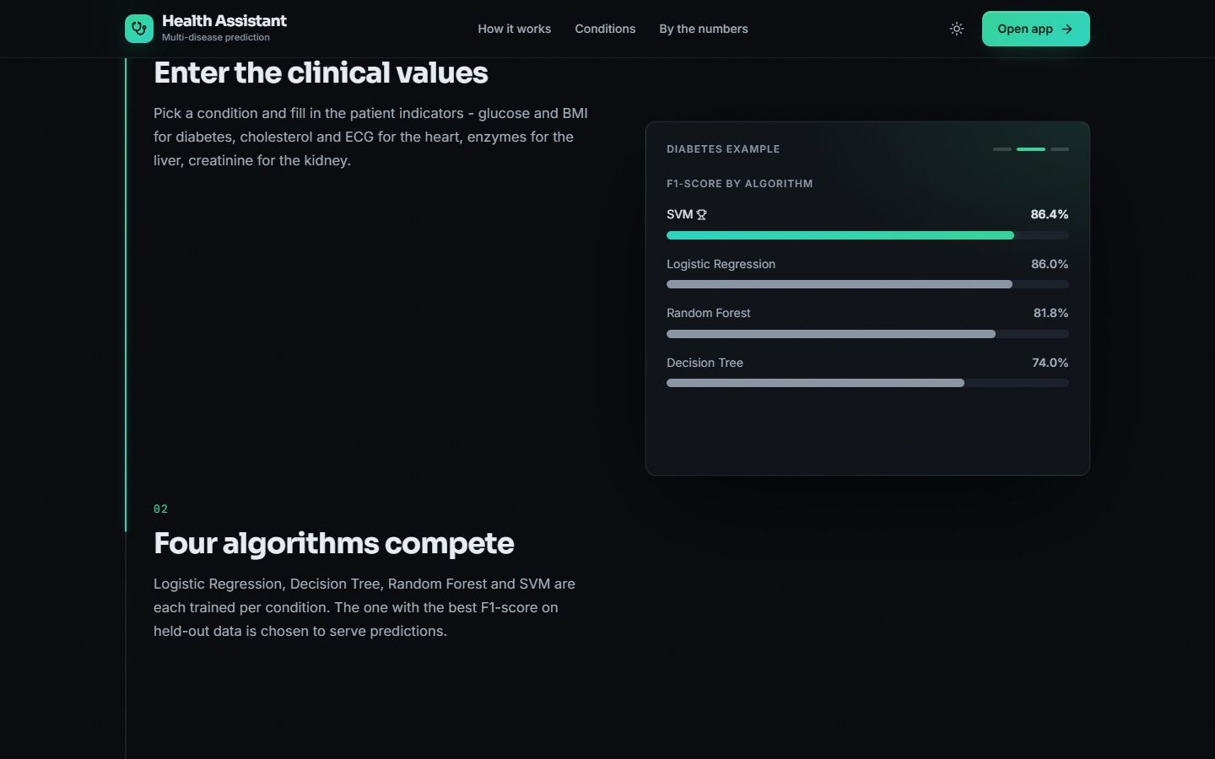  Figure 40: Landing page, how-it-works section: the F1-score of the four algorithms for the diabetes example, with SVM marked as the selected model | 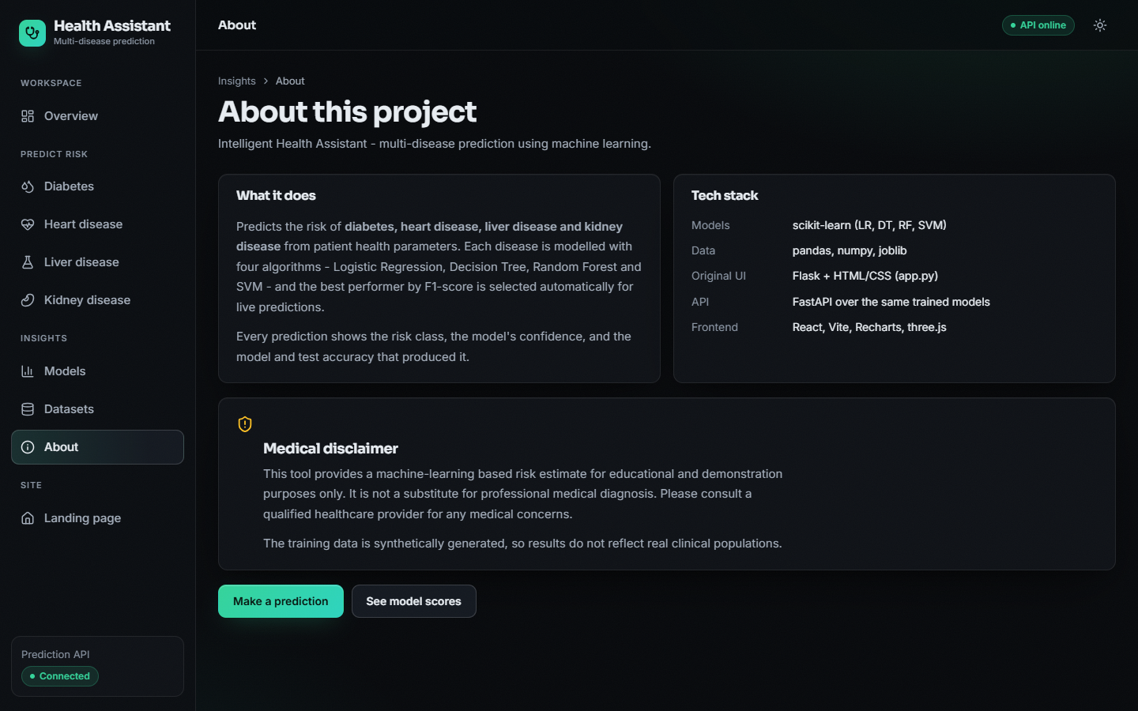  Figure 41: About page: what the system does, the tech stack and the medical disclaimer, which states that the training data are synthetically generated

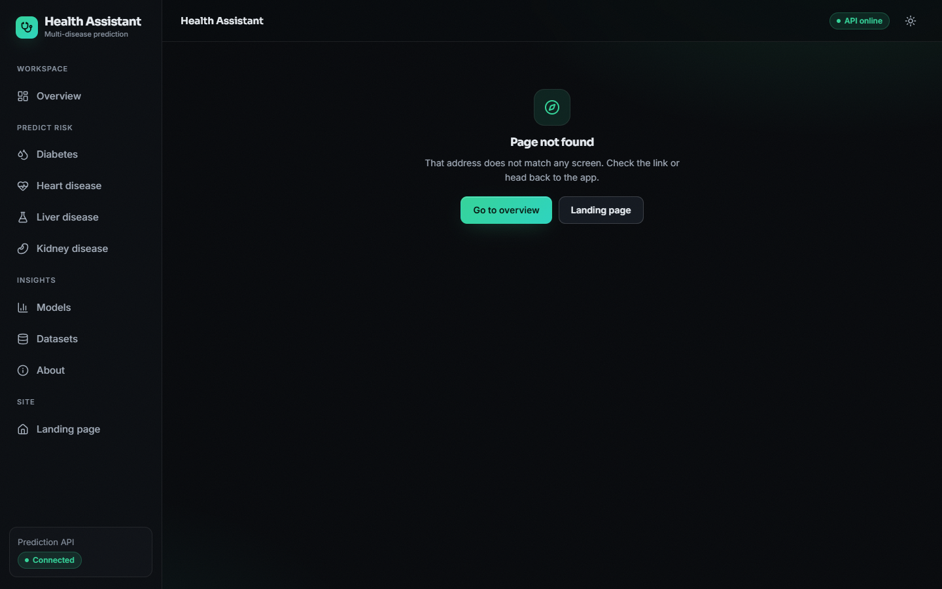
Figure 42: Not-found page shown for an address that does not exist

